

**Hardware Shop Management System**

**for**

**New Silver Line Traders-Galle**

# CCU3603 - Individual Project 2

# Final Report

**Bachelor of Information Technology (Honours) Degree**

**ESOFT Metro Campus**

**School of Computing**

# Declaration

**Module:** CCU3603 **Deadline**: 28-04-2023

**Student Declaration**

I hereby, declare that I know what plagiarism entails, namely, to use another’s work and to present it as my own without attributing the sources in the correct way. I further understand what it means to copy another’s work.

1. I know that plagiarism is a punishable offence because it constitutes theft.
2. I know what the consequences will be if I plagiaries or copy another’s work in any of the assignments for this program.
3. I declare therefore that all work presented by our group for every aspect of our program, will be our own, and where we have made use of another’s work, we will attribute the source in the correct way.
4. I acknowledge that the attachment of this document signed or not, constitutes a binding agreement between ourselves and ESOFT.

I declare that this project is my own work and has not been submitted in any form for another degree or diploma at any university or other institution of tertiary education. Information derived from the published or unpublished work of others has been acknowledged in the text and a list of references is given.

……………………………….. ……………28.04.2023…………

***Signature*** ***of the student*** ***Date:***

# Acknowledgement

In preparation of individual project for 3rd year, I had to take the help and guidance of some respected persons, who deserve my deepest gratitude. First of all, I would like to show my gratitude to Mr. Sinan, chairperson of New Silver Line Traders (Pvt) Ltd who gave me approval to provide technical solutions for exist problem in the company.

As the completion of this gave me much pleasure, I would like to show my gratitude to Mr Kelum De Silva the supervisor of individual project, who gave me good guidelines for final report throughout frequent consultations.

My heartfelt thanks to my parents and family members for their continuous support, corporation and encouragement, which made this project a success as well as a reality.

Also, I would like to thank my friends who supported me as well as motivated me to fulfil the project before the deadline. I would like to thank all the supporters who have helped me with their valuable feedbacks and guidance has been helpful in various phase of the completion of the project.

# Abstract

Hardware Shop Management System for New Silver Line Traders (Pvt) Ltd is the individual project which focus Management System for the day-to-day operation. Their current processes are manual and mostly based on paper work, which is inefficient and time consuming. So, there should be a proper mechanism to manage their day-to-day activities. Technology has a solution in terms of management system. The Hardware Shop Management System can address this issue and increase the efficiency and the effectiveness of this process.

The ultimate expectation of the project is provided technical solution for the exists manual record keep methodology’s difficulties. Based on this entire project has been categorized into modules as Employee Management, Salary Calculation, Billing System, Stock Management.

First module consists the overall introduction regarding project and the Silver Line Traders, then completed tasks have been categorized as requirement gathering, diagrams, UI, implementation, test case table. In comparison to the other methodologies and their benefits Rational Unified Process (RUP) was identified as the most suitable, flexible and advantageous methodology for the development.

The system was developed using Python programming language with PyCharm IDE. SQL Server Management Studio was used as the database tool for designing the database. Wondershare Edraw Max was used to draw the diagrams. Additionally, Adobe Xd also used for the designing.

# Table of Contents

CCU3603 - Individual Project 2 i

Final Report i

Declaration ii

Acknowledgement iii

Abstract iv

Table of Contents v

List of Figures x

List of Tables xiii

List of Acronyms xiv

Background xv

Chapter 1 - Introduction 1

1.1 Organization 1

1.2 Motivation 1

1.3 Scope 2

1.4 Objectives of the project 3

1.5 The Structure of the Dissertation 3

1.6 Project Framework 4

Chapter 2 - Literature Review 5

2.1 Domain 5

2.1.1 Studies, approaches, and fact 5

2.1.2 Similar System Studies. 8

2.1.3 Comparison Table 12

2.1.4 Algorithms 13

2.1.5 Research Gap 15

2.2 Technical 16

2.2.1 Tools and technologies (API, libraries) 16

Chapter 3 - Analysis 22

3.1 Analysis of the current system 22

3.2 Requirement 24

3.2.1 User/ Client requirement 24

3.2.2 System requirements 25

3.2.2.1 Functional Requirements 25

3.2.2.2 Non-Functional Requirements 27

3.2.2.3 Software Requirements 28

3.2.2.4 Hardware Requirements 28

3.2.3 Existing Systems 29

3.3 Feasibility Study 30

3.3.1 Time Feasibility 30

3.3.2 Cost Feasibility 31

3.3.3 Scope Feasibility 31

3.3.4 Technical Feasibility 32

3.3.5 Economic Feasibility 32

3.4 Methodology and Planning artifact 33

3.4.1 Methodology 33

3.4.2 Planning 35

Chapter 4 - Design 38

4.1 Alternate Solution Evaluation 38

4.1.1 Standalone 38

4.1.2 Distributed 39

4.1.3 Web Based 39

4.1.4 Customized Solution 39

4.2 Object Oriented Design/ Other Design 40

4.3 Diagrams 40

4.3.1 Use Case Diagram 40

4.3.2 Class Diagram 42

4.3.3 ER Diagram 43

4.4 Database Design 44

4.5 Module Structure 45

4.6 User Interface Design 46

4.6.1 User Familiarity 46

4.6.2 Consistency 46

4.6.3 Responsiveness 47

4.6.4 Simplicity 47

Chapter 5 - Implementation 48

5.1 Implementation Environment 48

5.1.1 Hardware Requirements 48

5.1.2 Software Requirements 48

5.2 Development Tools 49

5.2.1 PyCharm (PC) 49

5.2.2 SQL Server Management Studio 18 50

5.2.3 Adobe Xd 50

5.3 Major Code Segments 51

5.3.1 Database Connection 51

5.3.2 Login Method 53

5.3.3 Reset Password 54

5.3.4 Inventory Dashboard 57

5.3.5 Sales Static Report 58

5.3.6 Email Salary Payment 59

5.3.7 Cart in Billing System 61

5.4 Reused Components 62

Chapter 6 - Evaluation 63

6.1 Software Testing 63

6.2 Techniques of Software Testing 64

6.2.1 Black Box Testing 64

6.2.2 White Box Testing 65

6.3 Types of Testing 65

6.3.1 Unit Testing 65

6.3.2 Integration Testing 66

6.3.3 Acceptance Testing 66

6.3.4 Regression Testing 67

6.4 Test Plan and Test Cases 68

6.5 User Evaluation 71

6.6 End User Feedback 76

Chapter 7 - Conclusion 80

7.1 Conclusion 80

7.2 Critical Evaluation 80

7.3 Limitations 81

7.4 Future Work 82

7.5 Lesson Learnt 82

References 83

Appendices 85

Appendix A - SYSTEM DOCUMENTATION 85

Appendix B - DESIGN DOCUMENTATION 86

Appendix C - USER DOCUMENTATION 96

Appendix D - MANAGEMENT REPORTS 103

Appendix E - TEST RESULTS 107

Appendix F – CODE LISTING 119

Appendix G – SYSTEM EVALUATION FORM 150

Appendix H – CLIENT CERTIFICATE 155

Appendix I – INDIVIDUAL PROJECT 1 LOG SHEET 156

GLOSSARY 158

INDEX 159

# List of Figures

Figure 1-Structure of the System xv

Figure 2-Project Architecture 4

Figure 3-Manual File System 23

Figure 4-Gusto logo 29

Figure 5- ABC Inventory 29

Figure 6-QuickBooks Logo 29

Figure 7-Sage50 Logo 30

Figure 8- RUP Phases 34

Figure 9-Time Plan 35

Figure 10-Test Plan Table 37

Figure 11-Object Oriented Design 40

Figure 12-Use Case Diagram 41

Figure 13-Class Diagram 42

Figure 14-ER Diagram 43

Figure 15-Database Design 44

Figure 16-Module Structure 45

Figure 17-User Familiarity UI 46

Figure 18-Product Page Consistency. 46

Figure 19-Inventory Consistency 46

Figure 20-Simplicity-UI 47

Figure 21-PyCharm 49

Figure 22-SSMS 50

Figure 23-Adobe Xd 50

Figure 24-Database Connection 51

Figure 25-Databsase Connection-Login Function 52

Figure 26-Login Method 53

Figure 27-Forgot Password 56

Figure 28-Inventory Dashboard 57

Figure 29-Sales Graph Data 58

Figure 30-Send Email 60

Figure 31-Manage Cart 61

Figure 32-Product-Black Box Testing 64

Figure 33-Save Button- Black Box Testing 64

Figure 34-OTP-Black Box Testing 64

Figure 35-Employee Graphical view- Unit Testing 66

Figure 36-Internal User Evaluation Response 73

Figure 37-External User Evaluation Response 75

Figure 38-User Feedback 76

Figure 39-User Feedback Statistical Data 79

Figure 40-Appendix B- Use Case Diagram for Employee Management 86

Figure 41-Appendix B- Use Case Diagram for Billing System 89

Figure 42-Appendix B- Use Case Diagram for Inventory Management 91

Figure 43- Appendix B- Activity Diagram for Salary Management 93

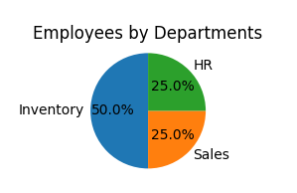 Figure 61 – Management Report – Employees by Departments 103

Figure 62 – Management Report - Employees by Designation 103

Figure 63-Management Report – Basic Salary on Designation 104

Figure 64- Management Report – Individual Monthly Salary Report 104

Figure 65-Management Report - Employees Salary Report 104

Figure 66- Management Report - Supplier Report 104

Figure 67-Management Report - Product Report 105

Figure 68- Management Report - Sales Report 105

Figure 69- Management Report - View Employee Report 106

# List of Tables

Table 1- Comparison Table Existing & Developing System 12

Table 2-Non-Functional Requirements 27

Table 3-Software Requirements 28

Table 4-Hardware Requirements 28

Table 5- Test Plan 71

Table 6-System Requirement 85

Table 7-Use Case Description for Add Employee 87

Table 8-Use Case Description for Delete Employee 88

Table 9-Use Case Description for Update Employee 88

Table 10-Use Case Description for Generate Bill 90

Table 11-Use Case for Delete Bill 90

Table 12-Use Case for Supplier Management 92

Table 13-Use Case for Product Management 92

Table 14-Test Results-Login Authentication 107

Table 15-Test Results-Employee Management Admin View 108

Table 16-Test Results- Salary Management 111

Table 17-Test Results-Supplier Management 112

Table 18-Test Results-Product Management 114

Table 19-Test Results-Billing System 115

Table 20-Test Results- Category Management 117

# List of Acronyms

1. UI- User Interface
2. DBMS- Database Management System
3. RUP-Rational Unified Process Modeling
4. DB- Database
5. Pvt Ltd - Private Limited.
6. HRMS-Human Resource Management System
7. ER-Entity Relationship
8. SDLC-Software Development Life Cycle
9. UML-Unified Modeling Language
10. ID-Identity
11. NIC-National Identity Card
12. PC-Personal Computer
13. TC-Test Case
14. POS- Point of Sale
15. GPS- Global Position System
16. RUBS- Ratio Utility Billing System
17. API – Application Programming Interface
18. SMTP -Simple Mail Transfer Protocol
19. ODBC -Open Database Connectivity
20. Numpy - Numerical Python
21. CRM – Customer Relationship Management
22. CAC- Customer Acquisition Cost
23. CLU – Customer Lifetime Value
24. OTP – One Time Password
25. OOP – Object Oriented Programming
26. SQL – Structured Query Languge

# Background

Most of the contemporary Information systems are based on the Database technology as a collection of logically related data, and DBMS as a software system allowing the users to define, create, maintain and control access to the database. The process of constructing such kind of systems is not so simple. It involves a mutual development of application program and database. The application program is actually the bridge between the users and the database, where the data is stored. Thus, the well-developed application program and database are very important for the reliability, flexibility and functionality of the system. The so defined systems differentiate to each other and their development comprises a great variety of tasks to be resolved and implemented. [1]

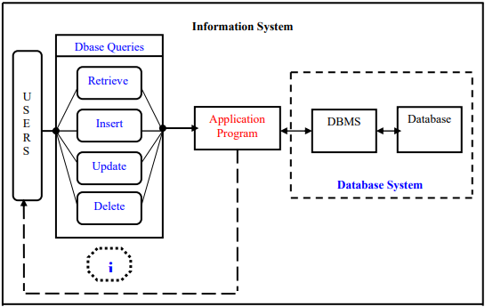

Figure 1-Structure of the System

In the employee management module Admin is allowed to manage employee details including insert, retrieve, update, save and delete records. Employee can view and get report of that. Entire Shop Management based on DBMS to manage Stock, Billing, Salary and Employees. This is responsible for storing data of the staff within organization and generating reports upon request.

“Organizations depend on Information Systems in order to stay competitive. Productivity, which is crucial to staying competitive, can be increased through better Information Systems.”

This system consists program and a database. The program performs the basic operations upon the database as retrieving, inserting, updating and deleting data. Additional functionality is a goal of a further module development. It is a kind of strategy to start the development from designing and constructing the database, as this structure will determine the further structure of the program. The logical database model responds to the given task and cover the basic requirements. The Interface of the program is user-friendly, and the program is as easy for use as it is possible. Both controls and forms logically and functionally related within the program and fully respond to the structure of the database. [2]

Accuracy is one of the primary responsibilities of any business owner or company leader. This is true in all types of organizations, including small business, corporations and charitable organizations. Having a set of records that accurately reflects day-to-day business affairs is one way to ensure that meet any legal compliance standards for industry. [3]

# Chapter 1 - Introduction

## **1.1 Organization**

New Sliver Line Traders (Pvt) Ltd is Spare Parts & Electrical Goods Company which is in No, 54, Hiribura Cross Road, Galle. This company currently doing most of managements as manual. It means employee salary calculations; stock details are some of the procedures that proceed as manual. Due to lack of speed of exist process the owners of the company decided to move computerized shop management system which provides the solution for the exist methodology on secure way. Therefore, Hardware Shop Management System should consist Stock Management System, Employee salary Calculation, Billing System, Human Resource Management. Therefore, this new system developed will definitely increase the productivity by reducing redundant paper work. Further the client can maintain and manage their day-to-day activities in a well-structured, efficient and effective manner.

## **1.2 Motivation**

Currently ‘New Silver Line Traders’ relies on manual system for its day-to-day operations necessitating a great deal of paper work. A good quality service to customers and future improvements are not possible with this. The following problems were identified in the existing manual system.

* There’s no proper mechanism for manage employee details because the process is conduced as paper-based methodology.
* There’s no methodology to get report for management details.
* Less reliability due to the manual procedures.

Provide solutions to this exist problem is worth solving. Because computerized system increases the speed of the process than manual documentation as well as it provides reliable service to the company. Using a system to these day-to-day operations it serves time and reduces cost of the company. According to the given clarification this Hardware Shop Management system provides worth solution than exist speed of procedure.

This real problem scenario became as motivation to conduct this project. Providing software solution for the real-world problem is ultimate expectation of this project.

## **1.3 Scope**

The scope is the most important thing to bear in mind when deciding on system development. Few important systems are not integrated along with this project, since they are a separate system which will not be directly dealing with Payroll System, New Attendance Management such as face recognition or finger print system etc. And also, by considering the time constraints, the scope of the project was determined. Additional website and their respective details are not included, since which may need an additional amount of time to implement and test the system.

The system consists of management of employee, sales and stock details which is daily used for the operation in the shop. And also, the owners of the New Silver Line Traders suggested that not necessary to implement finger print or any attendance separate system due to few employees are working there and due to the time period of the academic project.

According to the limitations the scope of the system including;(Main Categories- 8 modules)

* Employee Management
* Salary Calculation
* Stock Management including product, supplier, sales report details etc.
* Billing System

## **1.4 Objectives of the project**

The main objective of this system is to provide a proper systematic way to manage, administer and monitor day to day activities and to increase the efficiency and effectiveness of the operations of this hardware shop. Further including;

1. To learn about requirement gathering from real client.
2. To provide efficient, secure system with expected quality as a solution.
3. To deliver working software system according to project development life cycle
4. To manage details of stock, product, employee etc.
5. To increase the productivity of day-to-day procedure.
6. To generate the reports.

## **1.5 The Structure of the Dissertation**

This Dissertation provides the Introduction, Analysis, Design, Implementation and Evaluation Conclusion stages of this Hardware Shop Management System.

* Analysis- This explains the nature of current system, provides outline of an existing similar system and requirements and gathered the requirements needed.
* Design- This explains the selected solution description and justification relevant design diagrams, and user interfaces of the system.
* Implementation- This explains the hardware and software requirements, tools and techniques used for the development, code features and reused existing codes of the system.
* Evaluation- This chapter explains how test plan and test cases are prepared and how the system is evaluated on internal and cliental environments.
* Conclusion- This explains the future work to enhance the system and lesson learnt from the overall project.

## **1.6 Project Framework**

The project architecture is client server architecture. Client sends the request operations to logic server. Server to receive and process those requests and send to database server. Database server receive service requests and manipulate the database and then return results for logic server. Business logic server receives the results from database server and return it to the client.

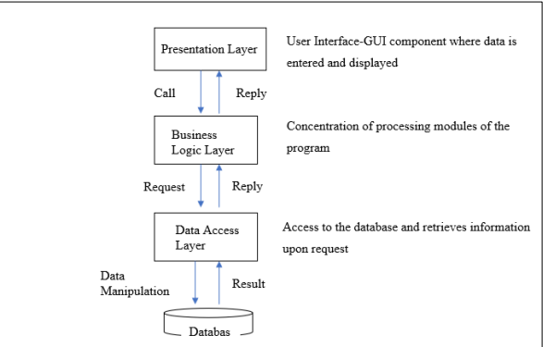

Figure 2-Project Architecture

# Chapter 2 - Literature Review

A literature review is an essential part of the project. It involves the systematic identification, analysis, and interpretation of relevant scholarly sources related to Hardware Shop Management. The goal of a literature review is to provide a comprehensive understanding of the current state of knowledge in the field and identify gaps or areas where further research is needed.

A literature review typically includes a synthesis and analysis of relevant literature such as peer-reviewed journal articles, books, conference proceedings, and other scholarly sources. It also involves critical evaluation of the quality and relevance of the sources, which helps to establish the credibility of the project. It helps to situate the project within the broader context of the field, demonstrate the knowledge of the existing literature, and provide a foundation for the project design and methodology.

## **2.1 Domain**

### **2.1.1 Studies, approaches, and fact**

“Organizations depend on Information Systems in order to stay competitive. Productivity, which is crucial to staying competitive, can be increased through better Information Systems.” [1] A management system for a shop typically refers to a set of processes and tools that are used to manage and optimize the operations of the shop. This can include various aspects of the business, such as inventory management, sales tracking, employee management, and customer service.

Inventory management is a key function of a management system within the organization. It is a pillar of logistics and supply chain management in the system of material management. Warehouse inventories may be required to meet customer or humanitarian needs, depending on the organizational goals. Inventory management is essential to the efficiency of operations and the effectiveness of an organization.

This study examines inventory management theories and practices in light of people's ever-increasing needs.

Demand is a critical variable in the inventory control system, and its characteristics affect inventory treatment. Important demand characteristics include its level of certainty, which could be deterministic (i.e., known with certainty) or stochastic/Bayesian (i.e., known but uncertain), and its structural dependency (i.e., independent or dependent). [4]

The deterministic independent and dependent natures of demand are examined in this review along with their relative effects on inventory control in business operations. Supply chain management, deterministic demand model, independent inventory demand, and dependent inventory demand are some of the keywords associated with inventory management.

Since the primary role of inventory management is to maintain a desired stock level of defined products or items [119], the role of inventory in operations management cannot be overemphasized. History has shown that organizations that have neglected or failed to consider the importance of inventory management have lived to regret it. According to Tanthatemee and Phruksaphanrat [114], inventory management helps to improve customer service and to cope with demand uncertainty. Demand uncertainty is a potential challenge that results in high inventory levels and high carrying costs, which can lead to higher prices and low customer satisfaction, and thus a less profitable business [5]

When studies about the employee management to find the approach and what factors have been used to provide technical solutions can be explained as follows.; An employee management system is a software application used by businesses to manage their employee data and streamline various HR processes. This type of system can include a range of features, such as payroll management, time and attendance tracking, benefits administration, performance management

To provide efficient service to the customers the easiest way is using Sales management system. It depends on the organizational scope, financial requirements and the resource capabilities. For small scale business it is professional way to use general system but for large scalable uses comprehensive POS.

The DBMS is a really powerful set of tools, enabling users to operate easily with data into a database as: Inserting, Updating, Deleting and Retrieving data. It prevents unauthorized access to the database and maintains the consistency of the stored data. The DBMS also restores the data in case of hardware or software failure and reduces the loss of data in this way [6]

The shop management existing procedure approaches with the standard flow in the industry.

1. Exploring the available development environments and techniques- There is a lot of programming environments available to be used for such kind of elaborations. The point is to choose such an environment that we will be able to operate with in a convenient and easy way. This is more or less optional and individual process, that depends on the developer’s experience as well.
2. Database Analyzing- It concerns all of the demands, put upon the database content and its functionality. The database should be designed and implemented in a way that the user would expect it to be.
3. Database design and Implementation- This step is tightly related with the previous one as it is completely determined by the requirements, analyzed and discussed in step2.
4. Program’s Structure- Analyzing The application program as an interface between the users and the database should be an accurate “reflection” of the database on the screen; hence a well analyzed and defined structure is needed.
5. GUI- Constructing After analyzing the program’s structure and defining what it should consist of, a graphical representation of this stuff is needed in order to enable the user to interact with the data.
6. Bringing all the stuff together the next step that should be taken is connecting the program with the database and performing the necessary functionality upon all of the controls.
7. Tests- To ensure that everything works properly and as it has been expected, test performance has to be done upon the system’s functionality

### **2.1.2 Similar System Studies.**

**Employee Management**

There are plenty of employee management similar systems around the globe. Some of them are ‘gusto, workday, Connecteam etc. The integrated employee administration software from Connecteam. It provides everything require, even while on the go, to quickly and effectively manage frontline staff. The best part of Connecteam is that can select and pay for only the feature sets require. These feature sets are categorized into three hubs: communications, business operations, and HR & Skills.

And also, Connecteam is renowned for its first-rate customer service, simple user interface, and high degree of customizability, allowing to adapt the platform to precisely meet company's requirements. Key features of Connecteam In app chat, knowledge base, employee scheduling, time management, GPS tracking, training. The advantages of using this system are Intuitive and easy to use, all in one solution, great customer support, and it is budget friendly.

Connecteam’s operations tools make managing daily operations easy and efficient. The main features include:

* Task management: Easily create tasks and assign these to employees to complete on the job. Attach relevant task information, forms, or checklists and maintain a clear overview of your team’s progress on each task in real-time.
* Scheduling: Build optimal employee work schedules based on your team’s submitted availability and registered qualifications. Use templates, drag and drop, recurring shifts, and other time-saving options. The system also flags discrepancies to help you avoid scheduling mistakes.
* Time clock: Employees can clock in and out from shifts with one tap and ensure they’re exactly where they need to be with GPS time stamps and geofencing capabilities. Work hours are automatically recorded on digital timesheets for your review and further payroll processing.
* Forms & checklists: Create customizable forms and checklists for every task. Share these directly with the relevant employees or add them to shifts. Receive and review team members’ entries in real time. [7]

**Inventory Management**

Not only will inventory management software assist in better tracking and organizing the facility, but it will also support in lowering hardware costs. Companies can easily control orders, sales, and deliveries through the software, and they can handle issues like product overstocking or outages. There are many existing software are used to manage the inventory system including ‘Netsuite, ecomdash, Cin7 etc’. Cin7 easily syncs online sales channels, POS systems, and third-party integrations to offer a comprehensive inventory interface.

This automated inventory platform syncs the physical and online channels to create a more efficient order processing. All this makes it good for everyone from startups to bigger brands. Features of Cin7;

* Multi-channel support
* Integrations for WooCommerce, Shopify, Magento, eBay, Amazon, and more
* Flexible inventory methods
* Accurate profitability and costs tracking
* Inventory planning
* Higher stock visibility

Fishbowl is the finest inventory control software for growing brands and enterprise customers. Better inventory administration is made possible by its seamless integration with Quickbooks.

This program is made specifically for automating accounting. Users can make and share work orders for a range of tasks using the work order system. Fishbowl provides a variety of training and support tools for the setup procedure, such as starting-up videos, web tutorials, in-house experts, and more.

* Multi-channel inventory syncing
* Integrations for WooCommerce, Shopify, Amazon, and more
* Inventory costing
* Inventory tracking
* Forecasting
* Centralized inventory database

**Sales Management**

Software for billing and invoicing offers a variety of features that are essential for generating revenue, the ultimate objective of all wealthy businesses. These billing solutions all have the ability to streamline and automate the invoice and billing process, even though their range of capabilities may differ or they may be tailored to different industries or sizes of businesses. Customers can be difficult to collect payments from, so making the billing process easier and raising the likelihood of timely payments is always advantageous.

Users of billing software can create an invoice that will ultimately be sent to a customer in order to gather payment. For users searching for simple, straightforward invoice layouts, billing solutions frequently provide pre-built invoice templates. For businesses interested in developing unique invoices that can be labeled and customized to meet a company's needs, they might also provide an invoice creator. Users have the option to print and send the invoice after it has been created, but in today's business world, online invoicing is more popular. As the example ‘Hubspot, Nutshell, Freshsales’ etc. The benefits of these systems are ‘Exceed Sales Target, Promote Teamwork, Save Time’

Advanced billing software can be configured to fit the requirements of different industries, not only specific clients. For example, telecommunication service providers prefer more complex telecom billing software due to their customer type and pricing variations. On the other hand, energy & utility companies typically have an advanced customer lifecycle and deal with industry transformations. They require functions like seamless integrations with smart meters or ratio utility billing system (RUBS). All this just calls for an advanced utility billing software solution. [8]

The key characteristics of such systems are simplicity, usability and security. For professional service companies, connecting time tracking and billing is critical because they frequently bill hourly. Providing insights into the amount of time an employee put into a specific project and how much they earned for the company based on that time tracking is a crucial business process. Often, time and billing capabilities are combined in professional services automation (PSA) software, which can send invoices directly from the tool. [9]

**Supplier Management**

For a variety of factors, every business requires an efficient supply chain management system. One benefit of the software is that it ensures that deliveries do not uselessly interrupt the steady flow of stock into the company. This is necessary to prevent production processes from stopping permanently, which might have an impact on customer service.

Additionally, the software is necessary to keep good relations with your company's suppliers. They are committed to giving you the best service they can thanks to their excellent belief. Some of the examples for these are E2open, SAP SCM, Logility, Perfect Commerce, Oracle SCM, Infor SCM, JDA SCM, Manhattan SCM, Epicor SCM, Dassault Systemes SCM, Descartes SCM, Highjump SCM, IFS, Watson Supply Chain, BluJay SCM are some of the examples of best Supply Chain Management Software.

Software for supply management essentially controls the flow of data, supplier relationships, transactions, and other related activities in the supply chain. The software is based on supply chain principles, which are an essential component of any business. It may be involved in all processes from the product development stage to the logistics, tapping into activities such as warehousing, transportation, and inventory management.

Malina Ngai, CEO of A.S. Watson for Asia & Europe, said, “Supply chain is the backbone for us to deliver a seamless O+O customer experience. During the pandemic, we were able to quickly adjust our global operations to handle the surge of online orders through activating fulfilment in over 50%, and pick-up in almost 100% of our 16,000 physical stores.” Consumers could choose between multiple delivery options, including delivery within 30 minutes. Going forward, A.S. Watson will continue to focus on further strengthening its O+O platform strategy. This remains important in today’s volatile and complex world, according to the CEO. “We will further accelerate our supply chain transformation to support our growth, specifically in warehousing capacity and automation technologies, last-mile delivery experience, AI in inventory management and demand forecasting. And we are keen to build international partnerships with companies who have expert experience, products and solutions in supply chain,” concluded Ngai. [10]

### **2.1.3 Comparison Table**

|  |  |
| --- | --- |
| Existing Systems | Hardware Shop Management System |
| Have integrated time clock, scheduling, task management, form data within a single platform which known as complex to focus. | Since the system is for small scalable business, has been focus on form-based information management with cost friendly implementation. |
| Large scalable businesses usually have more extensive operations with multiple locations, larger warehouses, and a higher volume of inventory. As a result, they require sophisticated inventory management systems that can handle large amounts of data and transactions. | Have one location, smaller warehouse, and lower inventory volumes, making their inventory management needs less complex. So, have focus simple UI system that everyone can use. |
| Deal with complex inventory management needs, such as managing multiple suppliers, tracking inventory across multiple warehouses, and handling large volumes of orders. | Have the advantage of being nimbler and more flexible in their inventory management strategies. They can quickly adjust their inventory levels and reorder products based on changing customer demand or market trends. |
| Large scalable businesses tend to have a more formalized sales strategy that is aligned with their overall business objectives. They may use technology tools such as CRM software to manage their sales pipeline and track customer interactions | Due to fewer resources to devote to sales activities implemented simple operation. It means have focused billing process for the shop, print invoice, generate report and save bulk data based on the client’s requirement. |
| Businesses tend to measure sales performance using a range of metrics, such as CAC, CLV, and sales conversion rates. | Focus more on revenue growth. Due to has few employees in the shop they require single platform including key features. |
| More likely to invest in technology solutions to automate and streamline supplier management, such as supplier portals, e-sourcing tools, and spend analytics. | Requires cost effective solution. Mostly they focus supplier category, supplier quantity and product quantity to analyze them. |

Table 1- Comparison Table Existing & Developing System

### **2.1.4 Algorithms**

Algorithms written in Python or any other language are most commonly written in a step-by-step manner that clearly defines the instructions a program needs to run. However, there is no defined standard as to how should write algorithm, there are basic shared code constructs between languages that we often use to create an algorithm, such as loops and control flow.

Algorithms are written to solve problems and overcome challenges in development, so confirming that a problem is well defined is important to writing a solution. Oftentimes, there may be multiple solutions to a given problem and many algorithms may be implemented at once as a way of helping the program find the best solution available. Popular some algorithms are;

* Searching
* Sorting
* Graph Algorithms
* Tree Traversal

**Searching Algorithms**

The searching algorithms are used to search or find one or more than one element from a dataset. These types of algorithms are used to find elements from a specific data structure. Searching Algorithms are designed to check for an element or retrieve an element from any data structure where it is stored. Based on the type of search operation, these algorithms are generally classified into two categories including linear search and interval search.

Linear searching techniques are the simplest technique. In this technique, the items are searched one by one. This procedure is also applicable for unsorted data set. Linear search is also known as sequential search. It is named as linear because its time complexity is of the order of n O(n).

Linear Search (Array A, Value x, Length n)START

Step 1: Set i to 0

Step 2: if i > n, then go to step 7

Step 3: if A[i] = x, then go to step 6

Step 4: Set i to i + 1

Step 5: Go to Step 2

Step 6: Return index (i)

Step 7: Print 'Not Found'

STOP [11]

When the list is sorted, we can use the binary search technique to find items on the list. In this procedure, the entire list is divided into two sub-lists. If the item is found in the middle position, it returns the location, otherwise jumps to either left or right sub-list and do the same process again until finding the item or exceed the range. There are two types of binary search: recursive and iterative method.

**Sorting Algorithms**

Sorting is an essential tool in any Pythonista’s toolkit. With knowledge of the different sorting algorithms in Python and how to maximize their potential, to implement faster, more efficient apps and programs importance of sorting are;

* Searching: Searching for an item on a list works much faster if the list is sorted
* Distribution: Analyzing the frequency distribution of items on a list is very fast if the list is sorted. For example, finding the element that appears most or least often is relatively straightforward with a sorted list.
* Selection: Sorted data makes it simpler to choose things from a list based on how they relate to the other items. For instance, it is much simpler to determine the median value of the list or the kth-largest or smallest value when the values are arranged in ascending or descending order.
* Duplicate values: When a list is sorted, it is very easy to find similar values on the list.

### **2.1.5 Research Gap**

There are many hardware shop administration software options at the market, in terms of currently used standard systems. However, it’s conceivable that some of these systems won’t work for New Silver Line Traders (Pvt)Ltd’. ‘s particular requirements. Managing a hardware shop can be a challenging task, and implementing a software system to aid in this task can bring its own set of challenges. Some of the challenges that may be faced when implementing a hardware shop management system software include:

* Data Entry Accuracy: Entering data into the system can be challenging and time-consuming, and the accuracy of the data entered can be critical to the success of the system. It is essential to train staff members to ensure that they are entering data correctly, and to have a system in place for verifying the accuracy of the data.
* Inventory Management: Hardware shops have a large number of items in stock, and keeping track of inventory can be a significant challenge. A software system can aid in inventory management, but it requires a lot of effort to keep the system up-to-date with the current inventory levels.
* Employee Training: Employees may require training on how to use the software system, and this can take time away from other tasks. Training should be comprehensive, and ongoing support should be available to ensure that employees can use the system effectively.
* Integration with Existing Systems: If the hardware shop already has existing systems in place, such as a point-of-sale system, integrating the new hardware shop management system software with these systems can be a challenge. The new system should be designed to work with existing systems seamlessly.
* Security and Privacy: A hardware shop management system software may contain sensitive information about customers, suppliers, and employees, and it is essential to ensure that this information is kept secure and private. The system should have robust security features to prevent unauthorized access to sensitive data.
* Cost: Implementing a hardware shop management system software can be expensive, and the hardware shop may need to allocate a significant budget for this purpose. Additionally, ongoing maintenance and support costs may also need to be considered.

Implementing a hardware shop management system software can be a significant undertaking, and it is essential to plan carefully and address these challenges effectively to ensure the success of the system. This Hardware Shop Management System for New Silver Line Traders implemented based on their requirements. Since it is small scalable business and limited number of functionalities are supposed to use with cost effective. Keep track of the product, suppliers, sales details within a system would be more efficient to them. Based on that simple UI- based system is required to implement. In order to provide secure access have been given separate login credentials for related departments.

## **Technical**

### **2.2.1 Tools and technologies (API, libraries)**

**IDE**

PyCharm is an IDE (Integrated Development Environment) that helps integrate, debug, and compile your code, which is also how you define an IDE. PyCharm is developed by JetBrains and comes with many handy features (that comes later in this blog), many developers prefer this IDE around the world, with almost 33% of the total python developers using this, other popular IDEs are VS Code (24%), Sublime Text (6%), Atom (3%) and more. [12]

Frameworks that can be used with PyCharm are;

* Django: This Python backend development framework is used. Django places limitations on how the project can be developed.
* Flask: Another backend development framework is Flask. It is more adaptable and enables developers to write code in their own style.
* Maya: This allows for remote script execution and debugging.

The advantages of using this tool are;

* Import assistance can allow importing missing libraries from another part of the project.
* Code completion allows to complete the names of classes, methods, parameters, and other variables depending on the context.
* PyCharm comes with many plug-ins that can be used to enhance the project.
* It has a huge community that can help in case to find any difficulty.

**Libraries**

A library is a previously put together collection of codes that can be used repeatedly, cutting down on time. It is comparable to a physical library that houses reusable resources, as the name implies. On the basis of the fact that every library has a root source, Python founded a number of open-source libraries.

* **Pandas**
  + The Panda is a BSD-licensed open-source utility. The data science field makes extensive use of the library. They are primarily employed for data analysis, manipulation, and cleanup. Panda enables the simple processes of modeling and data analysis without the need to switch to another language, such as R.
  + The user has to type “pip install pandas” in the command line or type “conda install pandas” if an anaconda has been already installed in the system. Once the installation is done, it can be imported to the IDE by typing the command “import pandas as pd”.
  + It is used for tabular data, statistical data, un label data.
* **Numpy**
  + NumPy is the most used open-source packages offered by python. It supports large matrices and multidimensional data and has inbuilt mathematical functions for easy computation. The name “NumPy” defines “Numerical Python”. It can be used in linear algebra, random number capability, etc., and can act as a multi-dimensional container for generic data. Python NumPy Array is an object defining N-dimensional array in the form of rows and columns.
  + It is convenient, efficient and faster.
* **Pyodbc** 
  + The library named pyodbc to connect python to SQL. This will give us the ability to use the dynamic nature of Python to build and run queries like SQL. These two languages together are a formidable force in our hands. These together can take your code to the pinnacle of automation and efficiency.
  + The bridge between SQL and Python. This makes access easy to ODBC (Open Database Connectivity) databases. ODBC was developed by SQL Access Group in the early ’90s as an API (Application Programming Interface) to access databases. These DBMS (Database management Systems) are compliant with ODBC.
  + Use pyodbc.connect function for the same. This function needs a connection string as a parameter. The connection string can be defined and declared separately.
* **Smtplib**
  + The Simple Mail Transfer Protocol can be used to transmit emails using Python's built-in smtplib module (SMTP). For SMTP, smtplib employs the RFC 821 protocol. SMTP client session object, which is used to transmit emails to an internet machine, is defined by the smtplib module.
  + parameters of SMTP function:
    - 1.host: It is the hostname of the machine which is running your SMTP server. Here, we can specify the IP address of the server or localhost. It is an optional parameter.
    - 2.port: If you are providing host argument, then you need to specify a port, where SMTP server is listening. Usually, this port would be 25.
    - 3.local_hostname: If the SMTP server is running on your local machine, we can mention the hostname of the local machine.
    - The sendmail() method of the SMTP object is used to send the mail to the desired machine.
    - Syntax: smtpObj.sendmail(sender, receiver, message)
    - sender: A string with the address of the sender.
    - receiver: A list of strings, one for each recipient.
    - message: A message as a string formatted as specified in the various RFCs. [13]
* **OS**
  + The OS module in Python is a part of the standard library of the programming language.
  + The functions OS module provides allows to operate on underlying Operating System tasks, irrespective of it being a Windows Platform, Macintosh or Linux**.**
  + There are different modules are used in this library to make the application more interactive.

**Framework**

There are numerous GUI frameworks for Python, but only Tkinter is included in the core module. Tkinter has a number of advantages. The same code runs on Windows, macOS, and Linux because it is cross-platform. Since Tkinter uses native operating system components to render visual elements, applications created with it appear as though they exist on the platform being used to run them.

Compared to other frameworks, Tkinter is comparatively easy to use and lightweight. This makes it an appealing option for creating GUI applications in Python, particularly for those where a modern sheen is unnecessary and building something cross-platform and functionally sound rapidly is the top priority.

Several important Tkinter concepts:

* Work with widgets
* Control the application layout with geometry managers
* How to make the applications interactive
* How to use five basic Tkinter widgets: Label, Button, Entry, Text, and Frame

**Database**

Microsoft SQL Server Management is an advanced development environment that enables us to configure, manage and administrate SQL Server database engines. SSMS is very popular and widely used by the database developers and administrators because of the following advantages:

* Cost-free
* Advanced user experience
* Various add-in options
* Easy installation

Popular SSMS components are;

* **Object Explorer** – It can be used to view and manage all of the objects in one or more instances of SQL Server.
* **Template Explorer** – The template explorer can be used to build and manage files to speed up the development of queries and scripts.
* **Solution Explorer** – It can be used to build and manage the administration items such as scripts and queries.
* **Visual Database Tools** – SSMS includes visual designers to build transact-SQL queries, tables and diagramming databases.
* **Query And Text Editors** – Management studio language editors can be used to interactively build and debug scripts and queries.

SSMS tips to be used are as follows;

* SQL server management studio is a standalone product; it can be used with any version of SQL Server. It does not require any specific version of SQL Server as such.
* To improve the readability, use more comments. Large codes tend to reduce readability. It allows to use “–” in front of any line to comment it out.
* Always make sure that have checked the Auto recover option that have in tools>options>environment>Auto recover to minimalize the data loss in case of an unexpected shutdown.
* Save the queries in the text format for any future references.

# Chapter 3 - Analysis

System analysis is one of the main phases in the software development life cycle. System analysts will help to get an overall image of the system and will be able to produce a high-level description of the system through this phase. Main objectives of this phase are what functionalities system should provide, required performance of the system. Before analyzing the system, first the requirements should be gathered by using the fact-finding techniques, such as interviews, observations, sample documentations etc. [14]

## **Analysis of the current system**

Hardware Shop Management System for New Silver Line Traders (Pvt) Ltd is the individual project which focus Management System for the day-to-day operation. Their current processes are manual and mostly based on paper work, which is inefficient and time consuming.

In the current system employers keep list of employee details in a manual file but that consists of only employee name, joined date, home address, contact no, basic salary only. They included those details within a table. if an employee resigns from the shop simply, they draw red line on employee’s name line. For the employee salary calculation also, they maintain a book where only employee name, salary, date included when they give salary employee has to sign Infront of his name. every month this process is continuously happens. If they want to check previous details only proof is that particular book. When consider about the stock management the supplier details and product details they have only supplier names and number of stocks they provided. They don’t have a system to monitor available stock. When a customer purchase items after that they provide a receipt. For that they have assign an employee who has to write product name and amount in that bill and calculate using a calculator. Likewise manual system is ongoing currently.

According to the manual system it consists of many difficulties;

* Security – It doesn’t provide secure record keeping. Because anyone can go through the physical files and get sensitive details. If any issues occur such as theft, fire entire records will be damaged and no any records will be protected. Therefore, high data protection threat is in this situation.
* Accessibility- since these are manually maintaining records anyone can go through the files. Manual records cannot be protected by passwords or any other security mechanism. Although it has stored on safe place it isn’t guarantee that data is protected.
* Maintainability- manual files cannot maintain standard level. As the example, if an employee resigns from the shop the employer marks a red line on that employee’s name. therefore, it seems mess. And also, it requires many files one after another.
* Redundancy- it supposed to use particular employee’s details again and again. As the example in the employee details each an employee records available and also in salary details again write the employee’s name each month so high data redundancy in current system.
* Report generation- if needs to provide a report separate report should have to write manually. Because all the records are in paper files.

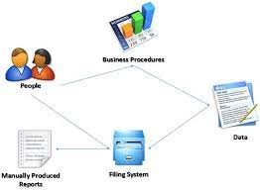Likewise, many difficulties are happening in current system. In order to avoid these drawbacks and to increase the efficiency, productivity security has proposed computerized management system where all the data store in a system and provide secure access to gain all the benefits.

Figure 3-Manual File System

## **Requirement**

In software engineering, a requirement refers to a statement that describes a desired functionality or behavior of a software system.

### **User/ Client requirement**

[The](https://www.lawinsider.com/dictionary/client-requirements) materials or information which is required from the Client in order for the Company to provide the Services, as set out in the Order Form, or as subsequently becomes necessary from time to time in the course of providing the Services. It describes that client expectations or the expected solutions for the existing problem. In this Hardware shop manual file system has many difficulties. To provide technical solution some of required client’s expectations are;

* Provides computerizing management system.
* Admin user should be able to monitor employee details, add employee, update or delete employee, generate reports.
* Based on each employee’s performance salary will be calculated and receipt can be shared via email. Salary list of employees should be able to generate based on that should have to provide reports.
* The stock details consist of supplier information, product and sales information.
* Employee can provide billing receipt when customer purchase items.
* The admin should have access for each module and have to monitor the process.
* The system should provide secure login for each process.

### **3.2.2 System requirements**

System requirements are the configuration that a system must have in order for a hardware or software application to run smoothly and efficiently. Failure to meet these requirements can result in installation problems or performance problems. [15]

System requirements consists of functional requirements, non-functional requirements, software and hardware specifications.

### **3.2.2.1 Functional Requirements**

“In Software engineering, a functional requirement defines a function of a system or its component. A function is described as a set of inputs, the behavior, and outputs.” [16]

Total **Eight** modules consist with main categories Following are the functional requirements identified through the system analysis based on categories;

* **Employee Management:**
  + Admin User can add employee, update employee, remove employee from the shop management system
  + Employee information consist of Personal Information, Professional Information and Contact Information
  + Each entry fields are clearly should be validated. As the example when enter employee Id system should check whether it is new id or old id if it is new id should be 12 numbers and if it is old id should be 10 lengths with the end letter ‘V’.
  + Each employee list can view in a table and the file can saved as a report.
  + Employee user can view employee information
  + Once enter correct username and password are allowed to login to the system.
* **Salary Calculation:**
  + Employer can calculate the salary of each employee based on the performance.
  + Employee name, department, id, basic salary, email should be able to retrieve from employee management.
  + Admin can view each salary records by searching month, employee id or reference number
  + Salary receipt can send via email and it is allowed to save as pdf document for report purpose.
* **Inventory Management:**
  + The system displays total product, total employee, total supplier, total product category available in the stock.
  + Supplier details consists of supplier no, company name, description, contact no, contract duration. It is allowed to add, update remove the supplier. Each supplier details can save as table.
  + Product details consists of category, sub category, supplier, product code, name, price, quantity, status. It can add, update or remove from the system.
  + Supplier information retrieve from supplier module.
  + The system shows sales report including all the billing information.
* **Billing System:**
  + Sales person can login to the billing system. When customer purchase items systems add to card and provide bill. Bill can save as report and generate pdf format.
  + The admin can manage entire sales report which can view as table data and can edit the sales details.

Each eight modules categorize into main four category. Each eight modules have unique user interfaces connected with database. These total functionalities are called as **‘Hardware Shop Management System’**

### **3.2.2.2 Non-Functional Requirements**

“In systems engineering and requirements engineering, a non-functional requirement is a requirement that specifies criteria that can be used to judge the operation of a system, rather than specific behaviors. They are contrasted with functional requirements that define specific behavior or functions.” [17]

|  |  |
| --- | --- |
| Requirements | Description |
| Usability | Refers how easy to use system to customers. Easily determine what is feature and what it can do. Easy navigation, flexible search options, eye catching interfaces and color patterns are the main key techniques where usability requirement is achieved. |
| Security | To protect sensitive data (employee details, salary, billing, passwords) security system needs database storage |
| Accuracy | Lack of accuracy in data causes major problem in the system. Accuracy of the data should be ensured in order to apply validation techniques for login validation, tracking and database integrity. |
| Speed | It determines how fast responds to commands. Speed also involves assessing system’s ability to manage an increasing workload as user use different applications at the same time. |
| Respond | Refers how fast respond to certain user’s action under certain workload. This explains how much a certain user must wait before the target operation happens. Get maximum 2 seconds to navigate each page and displays information. |
| Reliability | Should Provide reliable service via system. It means entire functions should work properly. |

Table 2-Non-Functional Requirements

### **3.2.2.3 Software Requirements**

|  |  |
| --- | --- |
| Requirements | Description |
| Operating System | **Edition**-Windows 10 Pro operating system is used for developing the system Type- 64-bit operating system Version-20H2 |
| Database | **Microsoft SQL Server Management Studio-18** SSMS provides tools to configure, manage and administer instances of Microsoft SQL Server, it brings together a range of graphical and visual design tools and rich script editors to simplify working with SQL Server. |
| IDE | **PyCharm**-dedicated python IDE provides wide range of essential tools for python development. The system is developed using this IDE |

Table 3-Software Requirements

### **3.2.2.4 Hardware Requirements**

|  |  |
| --- | --- |
| Requirements | Description |
| Processor | Intel(R) Core (TM) i5-2450M CPU @ 2.50GHz 2.50 GHz is required to develop. |
| RAM | Minimum 8.00GB capacity RAM is suitable to store entire data |
| Device | Any types of devices (Desktop, Laptop) can be used. Dell, Hp, Samsung, etc (Any manufacturing devices are suitable to the successful implementation) |
| Router | 4G-LTE wireless network router for laptop, network cable is needed for PC (Any manufacturing router is allowed) |

Table 4-Hardware Requirements

### **Existing Systems**

There are a number of open source and proprietary software available in the market for this purpose. A few of them are listed below.

#### **Gusto**

Gusto is an easy-to-use, all-in-one HR platform that helps small businesses handle payroll, employee benefits, hiring, onboarding, time and attendance, and compliance. Gusto provides services to small businesses, cafes, clinics, legal firms, and boutiques. The logo of gusto has attached here.

Figure 4-Gusto logo

#### **ABC Inventory**

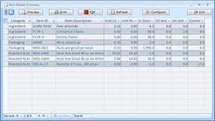ABC inventory software is a type of inventory management software that uses the ABC analysis method to categorize inventory items based on their value and importance. It can also generate reports on inventory turnover, stock levels, and other important metrics.

Figure 5- ABC Inventory

#### **QuickBooks**

Software application developed and marketed by Intuit. It is designed to help small and medium-sized businesses manage their financial data, such as income and expenses, invoices, bank transactions, and payroll. QuickBooks Desktop is a locally installed version of the software. QuickBooks include invoicing, inventory management, payroll processing, time tracking, expense tracking, and financial reporting

Figure 6-QuickBooks Logo

#### **Sage 50**

Software suite designed for small and medium-sized businesses. It offers a range of features to help manage finances, including accounts payable and receivable, inventory management, payroll processing, and financial reporting.

Figure 7-Sage50 Logo

## **Feasibility Study**

A feasibility study is an assessment that determines the likelihood of a proposed project being successful, such as a new product line or technical system. The study analyzes the project's relevant factors, such as technical, economic and legal considerations, to assess whether the project is worth an investment. The study can also identify potential issues and problems that could arise from pursuing the project.

Feasibility studies also help companies with new business development, including determining how it will operate, potential obstacles, competition, market analysis and the amount and source of financing needed to grow the business. [18]

### **Time Feasibility**

A time feasibility study is a type of feasibility study that concentrates on figuring out how long it will take to complete a specific activity. The goal of this study is to determine whether or not the project can be finished in the desired amount of time. According to this project it was started from 2022.07.31 to 2023.04.19. Two semesters have been allocated for this academic project. At the first stage allocated for analyzing phase. Half of the project implemented including employee management, salary management, user interfaces were completed by October 2022. The remaining implementations, database connectivity and finalizations are allocated at last phase until April 2023(all attached in time plan). According to time planning this project is capable enough to complete the project as estimated.

### **Cost Feasibility**

Cost feasibility is the evaluation of a project's or idea's ability to be carried out within the constraints of the allocated budget or financial means. It entails a thorough analysis of all of the project's costs, including those for materials, labor, equipment, and other expenditures.

In this project no any financial resources were used therefore no any cost consuming.

### **Scope Feasibility**

“The Project Scope pertains to the work necessary to deliver a product. Requirements and deliverables define the project scope, and it is critical that the stakeholder is in agreement with the information discussed in the proposed plan”. [19]

The system consists of management of employee, sales and stock details which is daily used for the operation in the shop. And also, the owners of the New Silver Line Traders suggested that not necessary to implement finger print or any attendance separate system due to few employees are working there and due to the time period of the academic project (Two Semesters- 09 months)

According to the limitations the scope of the system including;(Main Categories- 8 modules)

* Employee Management
* Salary Calculation
* Stock Management including product, supplier, sales report details etc.
* Billing System

This provides the capability of provide efficient, secure system with expected quality, managing the stock details, product, employee etc, increasing the productivity of day-to-day procedure, generate the reports.

### **Technical Feasibility**

Technical feasibility refers to the assessment of whether a proposed project or solution can be successfully implemented using existing technology, resources, and skills. It involves evaluating the project's requirements, identifying potential constraints, and determining whether the necessary technology, hardware, software, and expertise are available or can be obtained within a reasonable timeframe and budget.

According to this project the technical requirements for implementing the system are windows or any operating systems, normal desktop server and 4G clear network connection and computer resource. When identifying the constraints need to proper maintenance and employee awareness guidance sessions. Because this is very first time that convert into manual into computerized system therefore need proper consultations while launch the system. This system has been created within 09 months of period time and have implemented as simple as form procedures therefore no need to require technical experts to use the system as soon as launch the system.

According to the above technical review this project is capable enough to implement hardware shop management system.

### **Economic Feasibility**

Economic feasibility is a term used to describe the ability of a project, venture, or business to be financially viable and profitable. It involves analyzing the costs and benefits associated with a particular endeavor to determine if it makes economic sense to pursue it.

Due to zero costs of implementing Hardware Shop Management System and simple technical usage doesn’t concern the profit and revenue increasing and manage financial aspects in this system. Due to small scalable business and initial stage of comprised system using company doesn’t expect cost consuming applications. Therefore, this simple system is feasible enough to implement including all requirements.

## **Methodology and Planning artifact**

### **Methodology**

In Iterative model, using simple set of software requirements the development process starts and iteratively enhances the evolving versions of the software until reaching the complete system which is implemented and ready to be deployed. According to software development life cycle the methodology which is going to implement the project is Agile Software Development Methodology. Agile SDLC module does divide entire project into sub modules to develop. Each Iteration is included;

1. Planning
2. Analyzing
3. Architectural Design
4. Coding
5. Testing
6. Delivery
7. Feedback

Entire agile methodology step consists following phases;

1. Concept
2. Inception
3. Iteration
4. Release
5. Maintenance
6. Retirement

Rational Unified Process (RUP) has been selected for the proposed system. This is an iterative software development process framework and it supports objects-oriented development, because of this we selected this. At the initial stage client, does not have a clear idea about system requirements, so it may likely to be changed.

Further system has been divided into modules such as Employee Management, Salary Calculation, Billing System, Stock Management, Supplier Management etc. Each module has developed incrementally and iteratively. So, RUP is the most appropriate System Development Life Cycle (SDLC) Methodology.

In here adapt their process to the project and customer needs. Demonstrate dummy version of software and gather customer feedback. RUP works closely with client to collect their feedback. It is iterative incremental model. The steps of RUP as follows;

* Inception Phase
* Elaboration Phase
* Construction Phase
* Transition Phase

Identifying the requirements, project planning is the first Inception Phase. After requirement analyzation modeling comes under Elaboration Phase. Revise use case modeling. Based on the designing development is carrying out as Construction Phase. Once develop the system it releases to the client which is called as Transition Phase. Update the documentation based on the customer feedback beta testing will be carrying out. Then update the project continuously will happen.

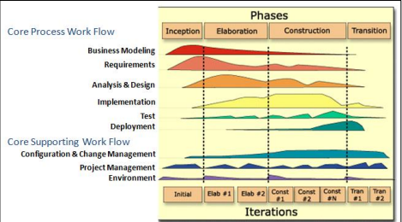According to the above clarification the first step planning phase which consider the prioritized project requirement gathering and divide into separate modules. First has to define the requirement and should discuss with client about opportunities, time bound based on collected information should evaluate technical and economic feasibility. Once collect it then has to show all using diagrams and start working on development. To gather requirement there are many techniques to use including use demo framework, questionnaire, interview, discussion etc. Based on that can draw wireframes and can keep continuous interaction with the client while getting feedback.

Figure 8- RUP Phases

### **Planning**

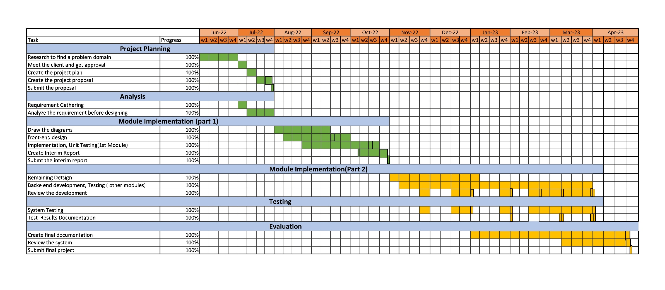Hardware Shop Management System was started from 07th of June 2022 and it’s ended up with 27th of April 2023.

Figure 9-Time Plan

|  |  |  |  |
| --- | --- | --- | --- |
| **Tasks** | **End of Start** | **End of Date** | **progress** |
| Research to find a problem domain | 07-Jun-2022 | 30-Jun-2022 | 100% |
| Identify a problem, meet the client and get approval | 01-Jul-2022 | 08-Jul-2022 | 100% |
| Create the project plan | 09-Jul-2022 | 15-Jul-2022 | 100% |
| Create the project proposal & review | 17-Jul-2022 | 30-Jul-2022 | 100% |
| Submit the proposal | 31-Jul-2022 | 31-Jul-2022 | 100% |

|  |  |  |  |
| --- | --- | --- | --- |
| **Tasks** | **End of Start** | **End of Date** | **Progress** |
| Requirements Gathering | 01-July-2022 | 08-July-2022 | 100% |
| Analyze the requirements understand overview of system | 09-July-2022 | 31-July-2022 | 100% |
| Draw the diagrams (Employee Management, Billing System, Salary Management) | 01-Aug-2022 | 14-Sep-2022 | 100% |
| front-end designing | 08-Aug-2022 | 30-Sep-2022 | 100% |
| Employee Management Implementing | 23-Aug-2022 | 22-Oct-2022 | 100% |
| Collect feedback, Create Interim Report | 03-Oct-2022 | 27-Oct-2022 | 100% |
| Submit the Interim Report | 28-Oct-2022 | 28-Oct-2022 | 100% |
| Stock Management, Product Management, Category, Supplier Management, Database, Bill Report Designing, Modify Login Design (Completed All Designing) | 06-nov-2022 | 07-Jan-2023 | 100% |
| Backend development- connect each module with database, add additional functions, modify previous functions (Completed development) | 12-Nov-2022 | 31-March-2023 | 100% |

|  |  |  |  |
| --- | --- | --- | --- |
| Review the development, collect feedback and modify the implementation (Changed the codes and finished the development) | 24-Nov-2022  18-Dec-2022  25-Jan-2023  22-Feb-2023 | 30-Nov-2022  07-Jan-2023  10-Feb-2023  02-April-2023 | 100% |
| System Testing (Up to completed developed System) | 24-Nov-2022  18-Dec-2022  25-Jan-2023  22-Feb-2023 | 30-Nov-2022  07-Jan-2023  10-Feb-2023  02-April-2023 | 100% |
| Test Results Documentation (Screenshots Profs) | 25-Jan-2023  02-Mar-2023  27-Mar-2023 | 31-Jan-2023  07-Mar-2023  02-April-2023 | 100% |
| Review the final system & documentation | 05-Mar-2023 | 26-Apr-2023 | 100% |
| Submit final project documentation | 27-Apr-2023 | 27-Apr-2023 | 100% |

Figure 10-Test Plan Table

This project duration is 09 months period of time. one months were allocated for problem identification and proposal submission. Four months were allocated for interim progress which means completed work up within four months. In the viva panel made suggestions to implement further based on those modification completed the system. Four-month periods were allocated for final implementation and evaluation. Since this is academic project two semesters were allocated for the individual project.

# Chapter 4 - Design

There are various system design approaches used by designers. Such as structured design, prototyping, Rapid Application Development and object-oriented design. Object-oriented design is the widely-used approach in modern software designing. The work has done in one project can be easily reused and integrated into other applications. It is also easy to write codes, and easy to understand and will contain few errors.

## **Alternate Solution Evaluation**

### **Standalone**

Standalone software refers to a computer program that can run on a computer without requiring any additional software or programs to be installed. This means that the software is self-contained and can perform its functions without any dependencies on other applications or software components.

Standalone software can be installed directly onto a computer's hard drive or other storage device, and can be used without an internet connection or network access. Examples of standalone software include Inventory Management, Billing System etc.

Standalone software can also refer to software that is designed to be used as a single application or tool, rather than as part of a larger suite or system. In this sense, standalone software can be thought of as a self-contained solution to a specific problem or need, rather than a component of a larger system. By considering these facts I have implemented standalone system in this project

### **4.1.2 Distributed**

Software runs on multiple computers within a network, where each portion of a software stored on a server or cloud and communicate with each and other, when needed. In a distributed software system, different parts of the application are typically hosted on different machines, which communicate with each other over a network. These machines can be located in different geographic locations, and can be managed by different organizations. Examples of distributed software systems include cloud-based applications. Developing and managing distributed software systems can be challenging, as it requires a deep understanding of distributed computing concepts and techniques. Developers must be skilled in areas such as network programming, concurrency, distributed algorithms, and fault tolerance. Additionally, testing and debugging distributed software can be difficult, as issues may arise from interactions between different components running on different machines.

### **4.1.3 Web Based**

Web-based software refers to any software application that is accessed and used through a web browser or web-based interface, rather than installed and run directly on a local computer or device. This type of software is hosted on a remote server and can be accessed and used from any device with an internet connection.

### **4.1.4 Customized Solution**

In this situation, although there are many open-source systems are used based on the requirements I have used standalone system with unique functionalities.

## **Object Oriented Design/ Other Design**

Object-oriented design is concerned with developing an object-oriented model of a software system to implement the identified requirements. The main goal of this design approach is defining objects define objects and establishing relationship between classes by sending and receiving messages. [20]

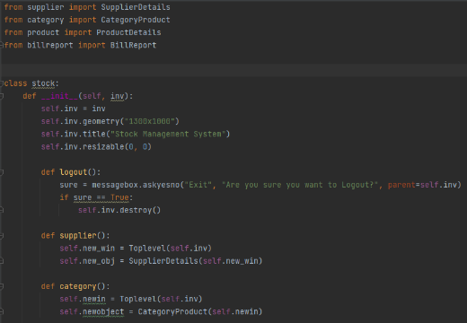In this project have uses for classes and objects. As the example Inventory management consists of supplier management, product management, categories, sales report management. In this case each above modules have implemented on individual pages and integrated those objects in main class of inventory management page. This makes code line efficiency and integrity.

Figure 11-Object Oriented Design

## **Diagrams**

### **Use Case Diagram**

Use case diagram shows the user’s interaction with the system in a simplest way, where which user interact with which use case. This diagram can identify the different users of the entire system. For Hardware Shop Management System I have attached below overview system procedure as use case with main four users. Core backend procedure is maintained by Admin. Apart from that other functionality including sales, inventory, employee management are divided among the departments. Since this is small scale business practically most of key factors are maintained by the shop owners.

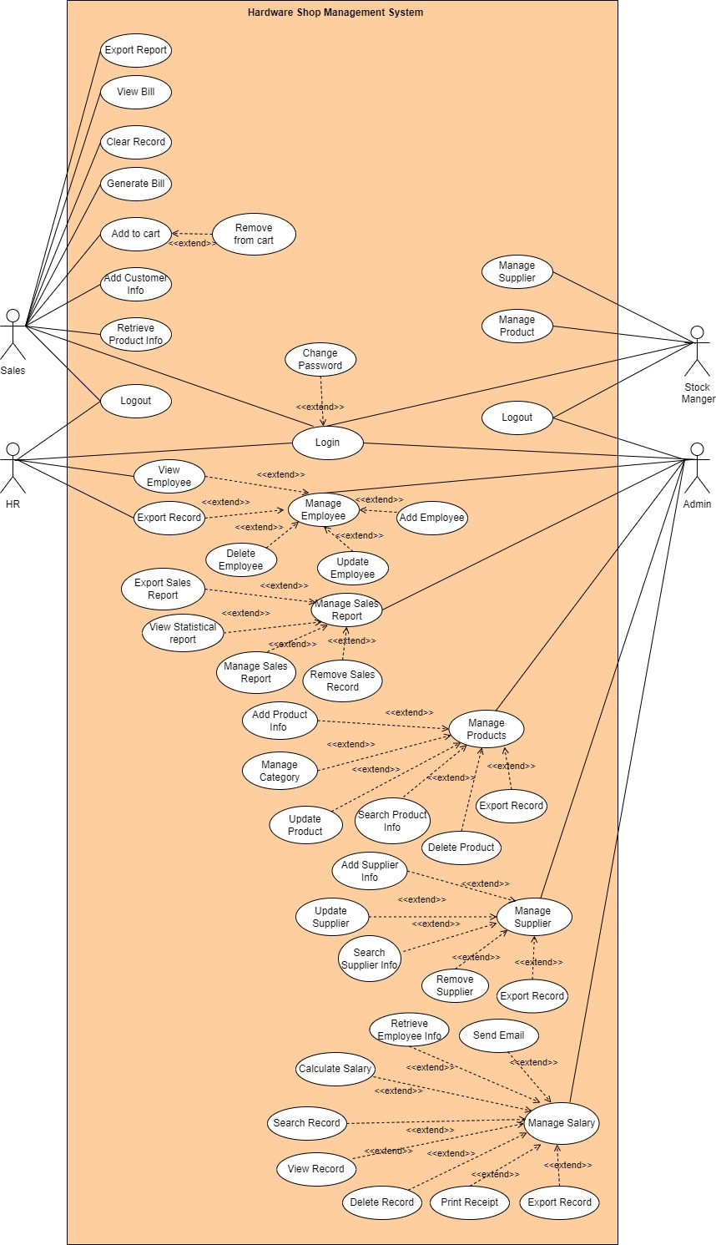

Figure 12-Use Case Diagram

### **Class Diagram**

Class diagram is a type of static structure diagram, which describes the structure of a system by displaying the system’s classes, their attributes, operations and the relationships among them.

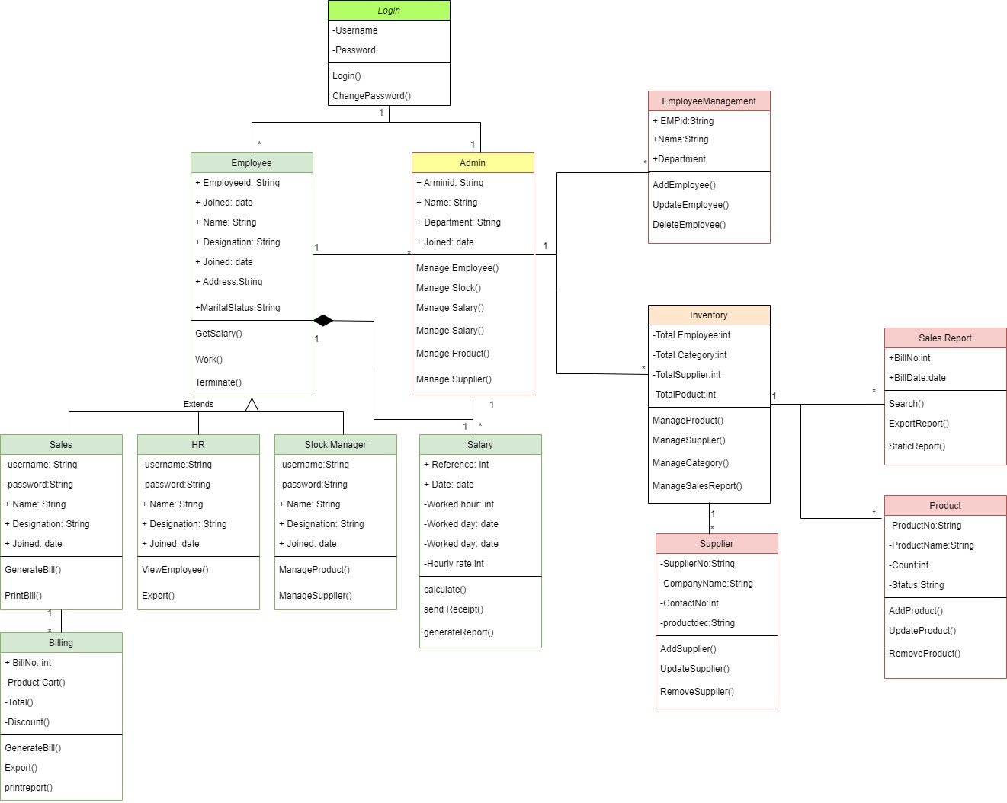

Figure 13-Class Diagram

### **ER Diagram**

A graphical representation that depicts relationships among people, objects, places, concepts or events within an information technology (IT) system.

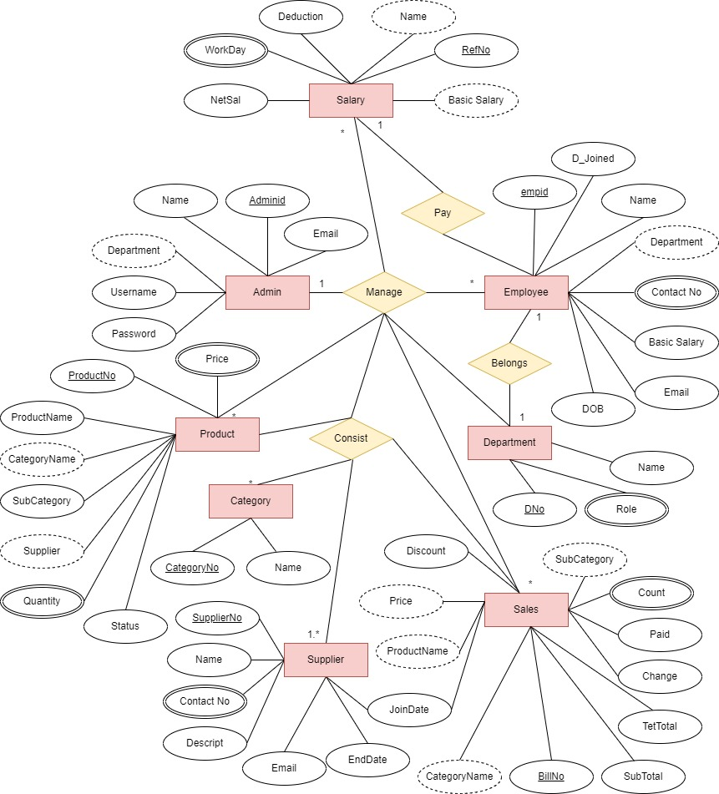

Figure 14-ER Diagram

## **Database Design**

Database design is the process of producing a detailed data model of a database. [21]

There are mainly three phases in the database design conceptual design, logical design and physical design.

Figure 15-Database Design

The above design is simple proposed structure for the system.

## **Module Structure**

In general, a module is a self-contained unit of functionality that can be easily added, removed, or updated without affecting the rest of the application. A standalone application typically consists of several modules, each responsible for a specific aspect of the application's functionality. All the module store in local server

1. Main module: This is the entry point for the application and contains the code that initializes and starts the application. It may also contain code for handling command-line arguments, setting up the application environment, and other global tasks.
2. User interface module: This module is responsible for displaying the application's user interface and handling user interactions. It may include submodules for different types of user interface components, such as forms, menus, or dialogs.
3. 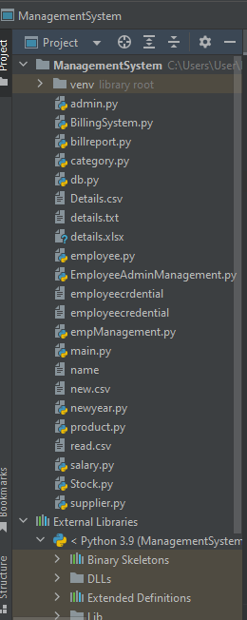Data access module: This module is responsible for accessing and manipulating data stored by the application. It may include submodules for different types of data storage, such as databases, files, or network services.

Figure 16-Module Structure

1. Business logic module: This module contains the application's core logic and algorithms. It may include submodules for different types of business logic, such as data validation, processing, or analysis.
2. Utility module: This module contains general-purpose utility functions and classes that can be used by other modules. It may include submodules for different types of utility functions, such as string manipulation, date/time processing, or file handling.

(Relevant codes have added below chapters)

## **User Interface Design**

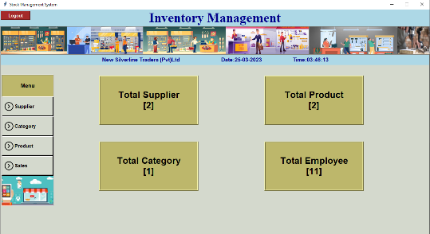Interaction between user and the system is mainly achieved by interfaces. There by interface of a system plays a major role in human computer interaction. This should be user friendly with proper color combination and well-organized flow between pages. This system has own unique design. When it does the design principles have considered are;

### **User Familiarity**

The user interface should be easy to use and understand. This is achieved by cutting down unwanted options and links to an interface. As the example in Inventory Manage have only added Supplier module, product module, category module and sales report module. On which only the needed options are added and unwanted options are removed, with matching color combination and with simplicity. The following image is proof the user familiarity.

Figure 17-User Familiarity UI

### **Consistency**

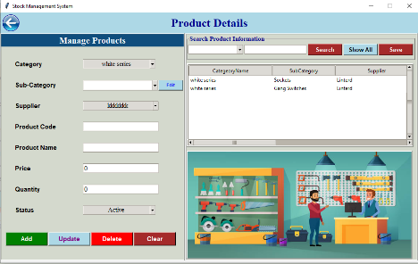The interface should ensure the consistency flow wherever possible. The given pictures show the interface between two pages and its consistency by their unique consistent design.

Figure 18-Product Page Consistency.

Figure 19-Inventory Consistency

When click on Product menu it connects with Product details page.

### **Responsiveness**

All the UI have been designed with flexible responsiveness. There are different end user skills since this project is for small scale business not everyone familiar with computerized system. Therefore, each components connected each other correctively. This has focused one of the design principles which is responsiveness. Each page should load correct time.

### **Simplicity**

Simplicity is a design principle that suggests that designs should be as simple as possible, without sacrificing functionality or usability. This means that designers should strive to eliminate unnecessary elements from their designs, and focus on creating a clean, straightforward user experience. In this project I have added simple design with three clicks rule.

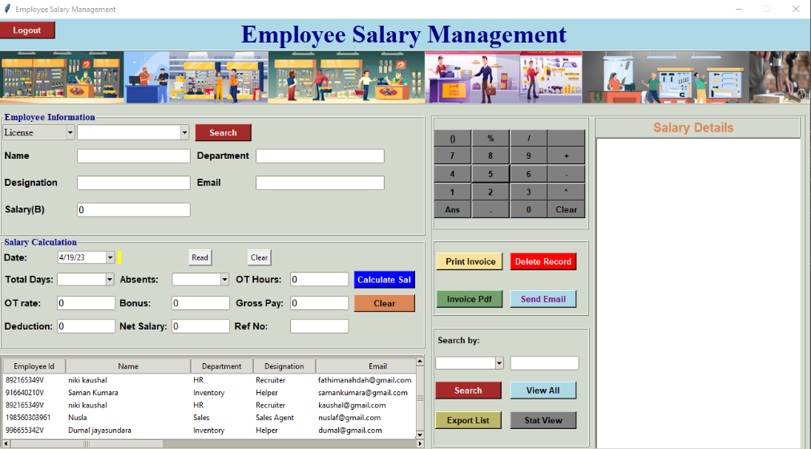

Figure 20-Simplicity-UI

Entire system’s UI designs including main menu, login, Employee Management, Salary Management, Inventory Management with Product, Supplier, Category and Sales Management, Billing System have been attached in the Appendix Design Documentation Section.

# Chapter 5 - Implementation

Implementation phase is transforming developed design into a workable system. This phase is the major phase, where all the system functionalities are actually coded and tested. When coding the system, comments are used on appropriate places in order to understand and modify the system in future. Codes are written by following standards and best practices, means well-structured and written in a way, it could be reused for future developments.

## **Implementation Environment**

### **Hardware Requirements**

* Processor - Intel(R) Core (TM) i5-2450M CPU @ 2.50GHz 2.50 GHz is required to develop.
* RAM – Minimum 4.00GB / 8.00GB capacity RAM is suitable to store entire data.
* Device - Any types of devices (Desktop, Laptop) can be used. Dell, Hp, Samsung, etc (Any manufacturing devices are suitable to the successful implementation).
* Router - 4G-LTE wireless network router for laptop, network cable is needed for PC (Any manufacturing router is allowed)

### **Software Requirements**

* Windows 10 Pro – 64bit
* PyCharm
* SQL Server Management Studio-18

## **Development Tools**

### **PyCharm (PC)**

PyCharm is an Integrated Development Environment (IDE) used primarily for Python development. The Community Edition of PyCharm is a free and open-source version with many features that make it a popular choice for developers. Here are some of its key features:

* Code Editor: PyCharm Community Edition comes with a powerful code editor that includes features such as syntax highlighting, code completion, and code inspections.
* Debugger: PyCharm provides a debugger that allows users to step through code, set breakpoints, and inspect variables.
* Version Control Integration: PyCharm integrates with version control systems like Git, SVN, and Mercurial.
* Refactoring: PyCharm has a range of refactoring tools to help improve the quality of the code, such as renaming, extracting methods, and introducing variables.
* Unit Testing: PyCharm comes with built-in support for unit testing frameworks like unittest, pytest, and doctest.
* Code Templates: PyCharm has a collection of code templates that can be used to quickly create new Python files and classes.
* Code Navigation: PyCharm allows users to easily navigate the codebase with features like Go to Definition and Find Usages.
* Project Management: PyCharm provides tools to manage the projects, such as the ability to create new projects, manage dependencies, and run scripts.
* Code Analysis: PyCharm includes tools for code analysis, such as code inspections, code duplication detection, and PEP8 compliance checking.
* Code Documentation: PyCharm allows to easily generate documentation for the code using tools like restructured Text and Sphinx.

Figure 21-PyCharm

### **SQL Server Management Studio 18**

SQL Server Management Studio or SSMS is, perhaps, the most famous product for managing Microsoft SQL Servers and any SQL infrastructure. Many experts consider it the most useful management tool of all.  Some of the key features are;

* Object Explorer

Figure 22-SSMS

* Query Editor
* Template Explorer
* Query Execution Plan
* Table Designer
* Database Designer
* Query and View Designer
* Generate and Publish Scripts Wizard
* Backup and Restore
* SQL Server Security Management
* Activity Monitor
* XEvent Profiler [22]

### **Adobe Xd**

It is a powerful and user-friendly tool used for designing user interfaces. Key features of this are;

* Repeat Grid
* Prototype and Animation
* Components
* Responsiveness
* Content Aware Layout

Figure 23-Adobe Xd

## **Major Code Segments**

### **Database Connection**

Following code segment is used in order to establish a connection to database. In this project I used python tkinter framework and SSMS for database. By considering object oriented and modularization, I have added connection string on separate file which is **‘db.py’** in **the class of ‘Database’**. This module has import in whenever connection string is used. This reduced the code lines and increase efficient running. Import the file as**’ from db import Database’.** And then created object with the class name to integrate connection**’ db=Database ()’.**

Following is database connection code segment;

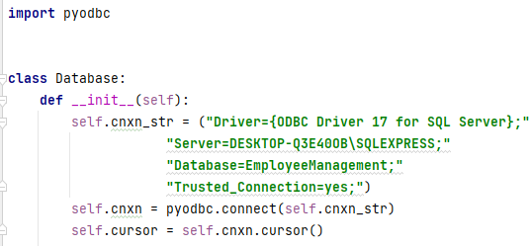

Figure 24-Database Connection

This connection integrated with each file as needed. The below code is for Login function database connection with object.



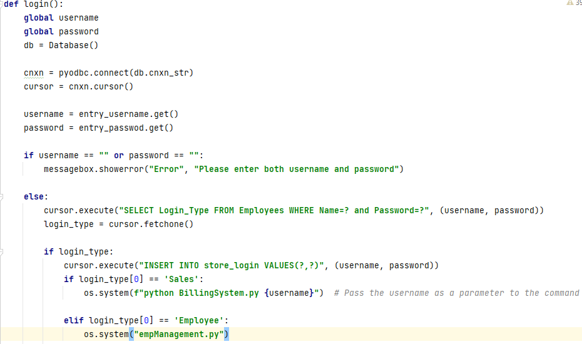

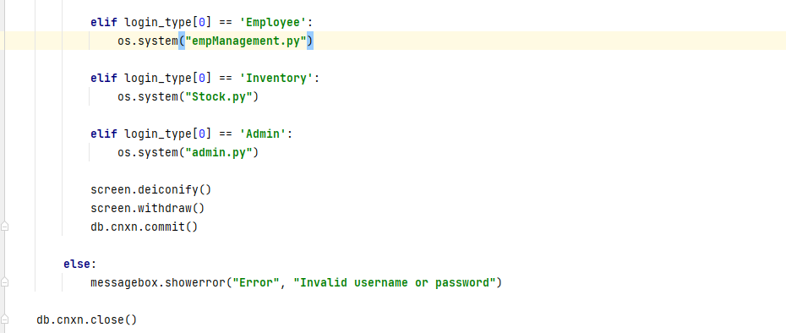

Figure 25-Databsase Connection-Login Function

### **Login Method**

When click on the login button it validates whether have added correct credentials. If the credentials are unmatched, it displays error message. If forgot the password can change the password by clicking ‘forgot password? Link. First, I have added login function below.



Figure 26-Login Method

### **Reset Password**

If user forgot the password, it is allowed to change the password by providing email. It verifies whether entered email match with the username and send verification OTP code to email, new password and confirm password should be same. When forgot password the user has to provide email then through the system. Once verified the OTP system directs to the password change page. Then the user is allowed to change password.

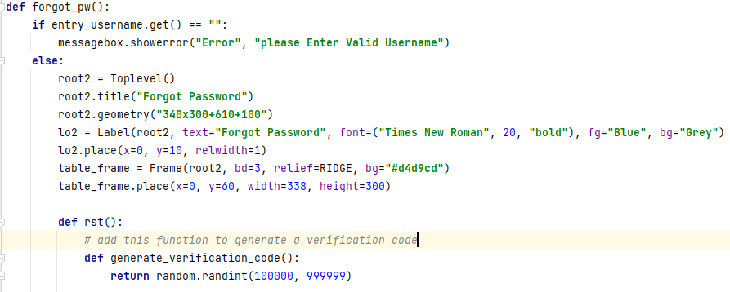

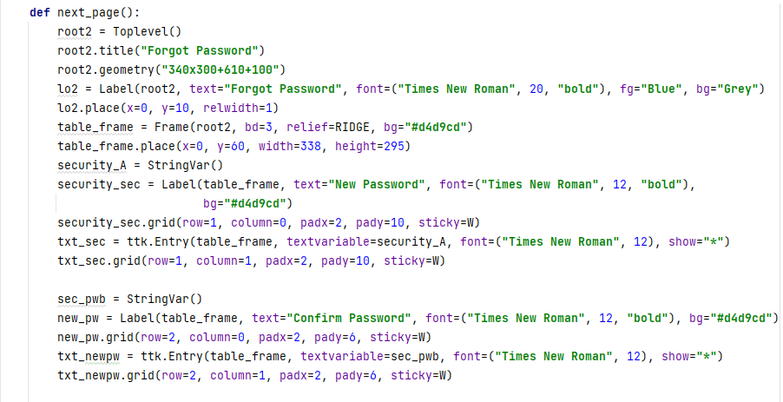

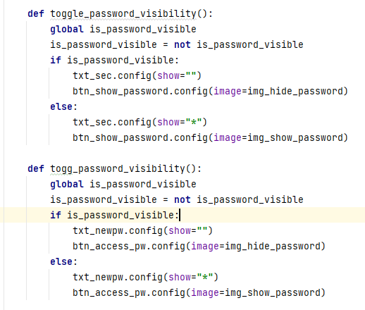

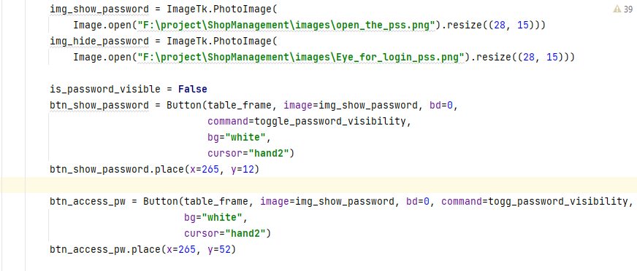

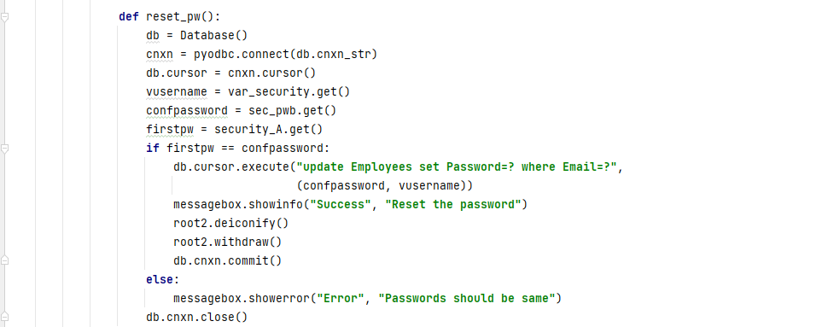

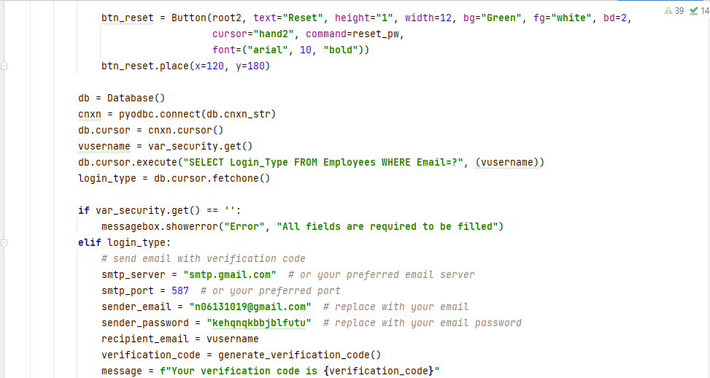

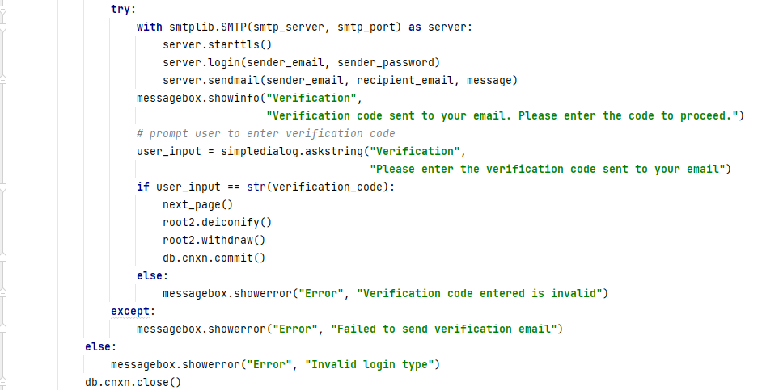

Figure 27-Forgot Password

### **Inventory Dashboard**

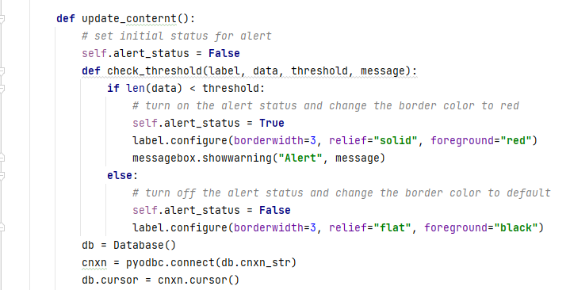In the inventory management page dashboard displays the summarization of database. In here displays total number of suppliers, product, category and employees. It makes easy to admin to get aware about total information and to get actions based on that.

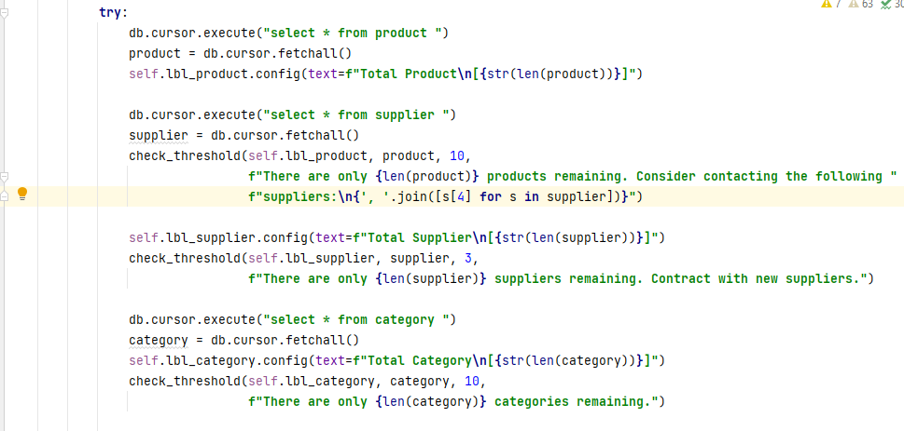

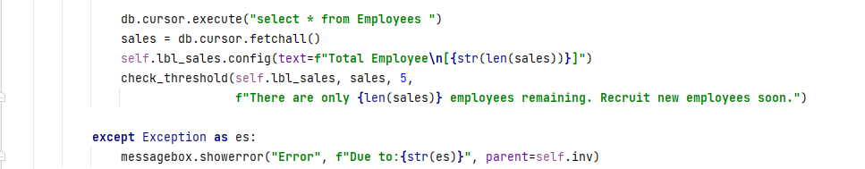

Figure 28-Inventory Dashboard

### **Sales Static Report**

In this section it shows the total sales on particular day as a graph data. Once admin filter the selected date within tree view table admin can view this as a graph data, if needed. It can print, save and can edit the view of graph. To view this admin has to click on next page button.

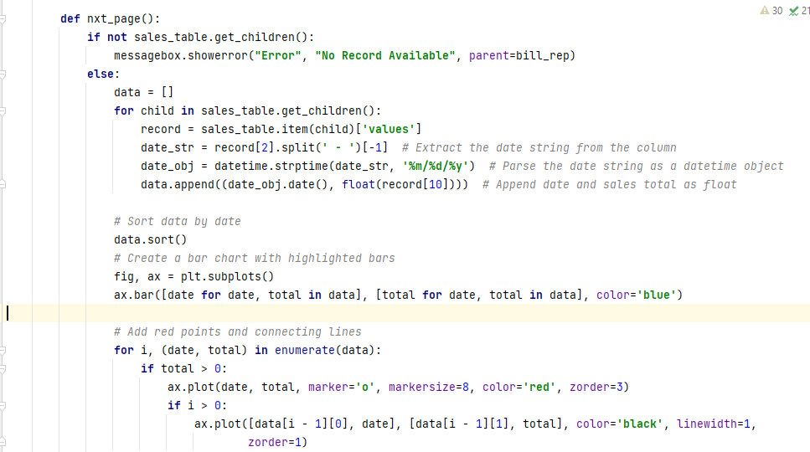(Apart from this report there are six reports for salary management, suppliers, total product, employee management based on department, designation and basic salary- All have been attached in appendix section)



Figure 29-Sales Graph Data

### **Email Salary Payment**

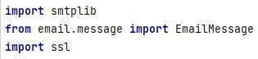Management can send salary automated slip via email to selected employee. Once select employee details, if click on send button displays receiver’s employee email id which is selected employee’s email then click on send button automatically send email through the system. In here I have imported email library to connect emails.

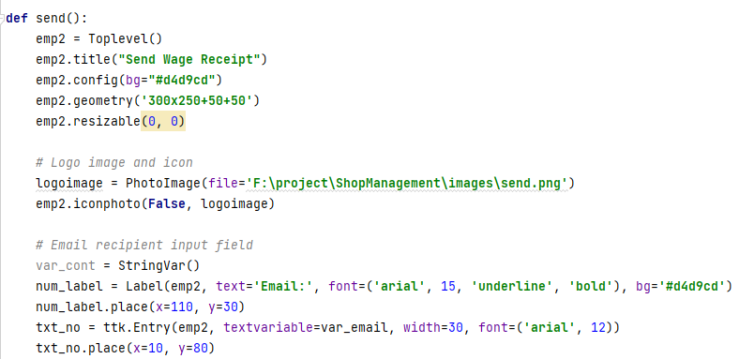

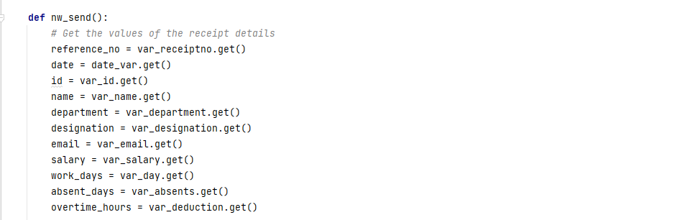

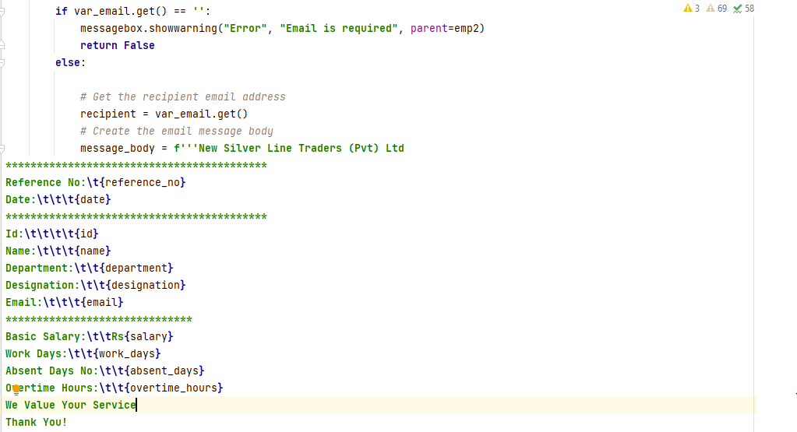

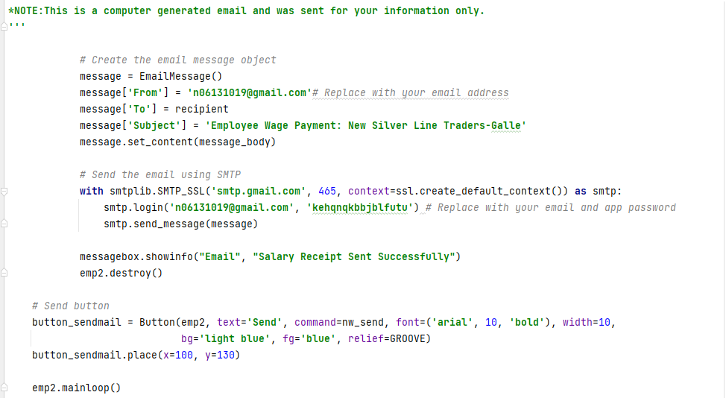

Figure 30-Send Email

Apart from these sending emails to supplier code has been attached appendix section which is similar as this.

### **Cart in Billing System**

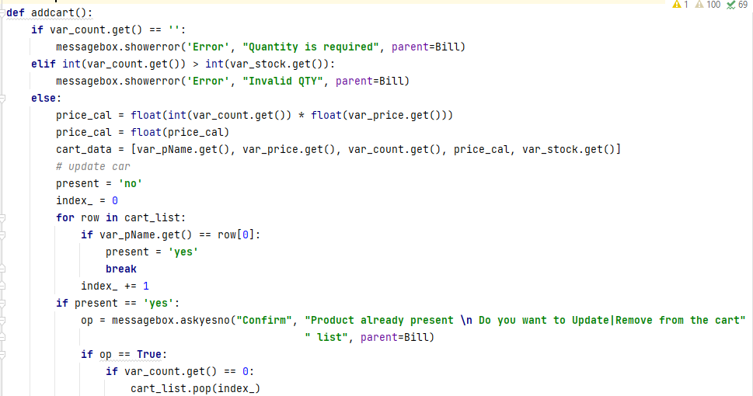Sales employee has to add all products that are purchased by the customer to the cart and it’s updated with number of items that are purchased. If the customer doesn’t want to purchase an item sales employee can remove the selected item from the cart, if it is before the phase of the print the bill.

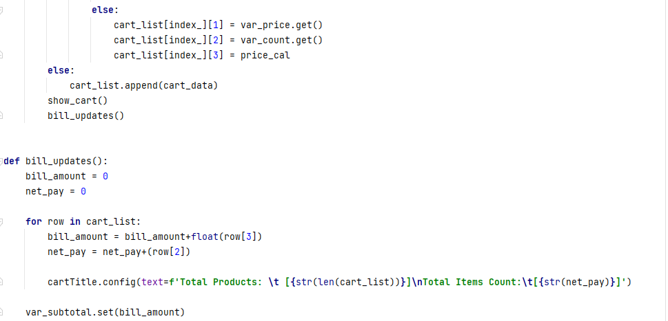

Figure 31-Manage Cart

The above codes are some of major code segments. The remaining implementations have attached in appendix section.

## **Reused Components**

While developing the system, most of tasks are completed by referring internet and using some reusable components to save time and resources. Few of them are listed below.

* Python Image Module. – provides a class with the same name which is used to represent a PIL image. The module provides a number of functions to load image from files and to create images.
* OS Module- provides facility to establish the interaction between the user and the operating system. These is used to perform OS based tasks and get information. This OS comes under python’s standard utility modules.
* Database Module- This method relies on “**pyodbc**” library to set up the Python SQL Server Integration. The pyodbc library provides Python developers with easy access to ODBC (Open Database Connectivity) databases. Therefore, it can implement the method given in this section to set up Python ODBC integrations with any platforms such as MS Access, MySQL, IBM Db2, etc. [23]
* Send Email - [Python](https://realpython.com/installing-python/) comes with the built-in [smtplib](https://docs.python.org/3/library/smtplib.html) module for sending emails using the Simple Mail Transfer Protocol (SMTP). smtplib uses the [RFC 821](https://tools.ietf.org/html/rfc821) protocol for SMTP. There are two ways to start a secure connection with your email server:
  + Start an SMTP connection that is secured from the beginning using SMTP_SSL()
  + Start an unsecured SMTP connection that can then be encrypted using. starttls() [24]
* Data Visualization, Graphical Plotting - A Python matplotlib script is structured so that a few lines of code are all that is required in most instances to generate a visual data plot. The matplotlib scripting layer overlays two APIs:The pyplot API is a hierarchy of Python code objects topped by *matplotlib.pyplot* An OO (Object-Oriented) API collection of objects that can be assembled with greater flexibility than pyplot.This API provides direct access to Matplotlib’s backend layers.  [25]

# Chapter 6 - Evaluation

Evaluation is a systematic determination of a subject's merit, worth and significance, using criteria governed by a set of standards. It can assist an organization, program, project or any other intervention or initiative to assess any aim, realizable concept/proposal, or any alternative, to help in decision-making; or to ascertain the degree of achievement or value in regard to the aim and objectives and results of any such action that has been completed. The primary purpose of evaluation, in addition to gaining insight into prior or existing initiatives, is to enable reflection and assist in the identification of future change. [26]

## **6.1 Software Testing**

Software testing done throughout the system development. In other words, we can say it is a verification and validation process.

Verification is the process to make sure whether the units or modules or system as a whole work according to the conditions imposed at the start development.

Validation is the process to make sure whether the functionalities of the system satisfy against the requirements at the end of the development. Also, can say, to make sure the system is developed as customer requirements.

## **Techniques of Software Testing**

### **6.2.1 Black Box Testing**

Black box testing is a testing technique where the internal part (codes) of the system is ignored and only focuses on the output generated by the system against expected result. I have tested only front-end parts whether it is interconnected as expected. In here focus whether relevant validations text is displayed on the screen as needed. It doesn’t expect back-end connectivity only result is enough. Some of back-end testing below;

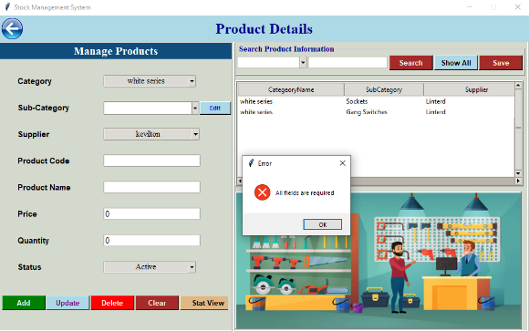

wanted to test when I click on Add button with empty entry fields whether it displays error message. Yes, it is working as expected.

Figure 32-Product-Black Box Testing

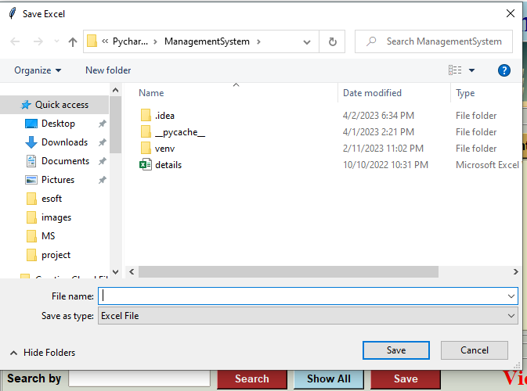

wanted to test when I click on save button in employee management whether it displays file saving window. The outcome is as expected.

Figure 33-Save Button- Black Box Testing

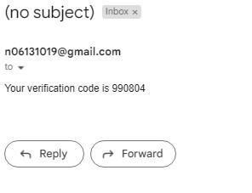

wanted to test after providing Email whether receive OTP verification code when changing password. The output is this I received as expected.

Figure 34-OTP-Black Box Testing

### **White Box Testing**

White box testing is technique where we consider the internal part (codes) of the system and test the output generated against the codes and expected results. White box testing done through correct path checking, data flow testing, loop testing, output validation. have done each and every method for back-end code testing. For OTP verification when enter email to change password, changed the code and checked that how output was because security validation is highly expected. Likewise, each module is tested.

## **Types of Testing**

### **Unit Testing**

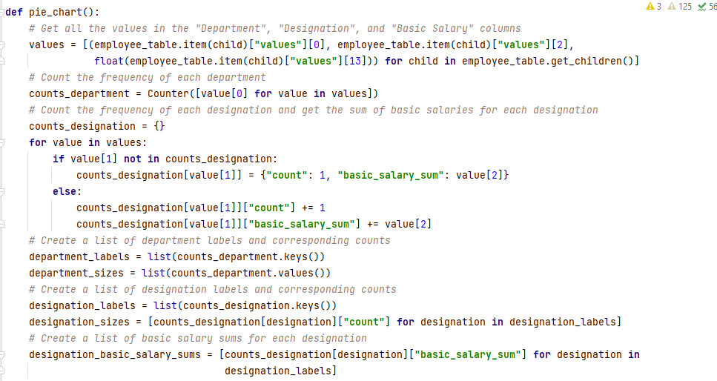Unit testing is the testing of an individual unit of a module which has implemented generating output as expected against given input. Each module has tested as soon as complete parallel unit. As the example in Employee Management to check whether display the graphical visualization as charts when clicking on the image button. In order to get exact output had to tried many times each code lines by changing simple code unit.

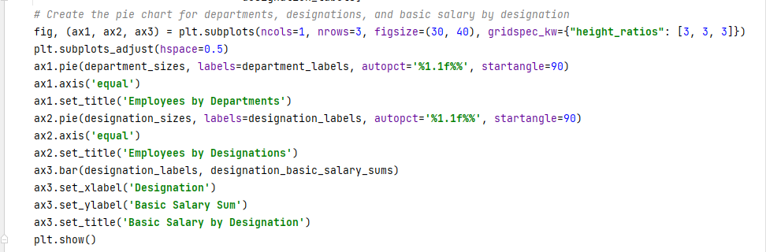

Figure 35-Employee Graphical view- Unit Testing

### **Integration Testing**

Integration testing is testing whether the group of integrated modules are functioning properly and works as expected or produce expected output. The purpose of this level of testing is to expose defects in the interaction between these software modules when they are integrated Integration Testing focuses on checking data communication amongst these modules. As the example in inventory management dashboard, it should be connected with supplier management, product management and sales management. In order to do that has used OOP concepts and modules have interconnected.

### **Acceptance Testing**

Acceptance testing is testing done by the client in order to make sure he is getting the product meets the requirements and works as the client expected. In this project has collected evaluation feedback.

### **Regression Testing**

Regression testing is testing after making some modifications to the system, modules or units to make sure that the modification is working correctly and not causing any negative impact or imposing other modules to produce unexpected results.

fig, (ax1, ax2, ax3) = plt.subplots(ncols=1, nrows=3, figsize=(8, 15), gridspec_kw={"height_ratios": [2, 2, 1]}, sharex=True)

At the beginning had used the above code for employee salary graphical representation but it was shown error. Therefore had to modify this section in the modified code was ;

*# Create a line chart for each employee*fig, ax = plt.subplots()

Due to above change salary chart is perfectly displays as expected. And also, when considering the database connection function used ‘def __int__(self):’ for define the method. I t had error due to wrong definition of the function. According to regression testing modified the code to get correct outcome. The modified correct code is below;

**import** pyodbc  
  
  
**class** Database:  
 **def** __init__(self):  
 self.cnxn_str = (**"Driver={ODBC Driver 17 for SQL Server};"  
 "Server=DESKTOP-Q3E40OB\SQLEXPRESS;"  
 "Database=EmployeeManagement;"  
 "Trusted_Connection=yes;"**)  
 self.cnxn = pyodbc.connect(self.cnxn_str)  
 self.cursor = self.cnxn.cursor()

likewise, did code modifications for each method and tested until get expected results.

## **Test Plan and Test Cases**

Test plan is an important part for developing and also for completed systems. Test plan should have the capacity to test the completed functionalities of the overall system. By having a proper test plan and testing a system can identify errors on the system modules and can correct them earliest as possible. Implemented system was tested using different test cases. System testing started from testing units and at the end completely tested module wise, to make sure whether it can function according to the expectations.

A well pre-planned test case should have the ability to verify the relevant system module functionality. Normally test case consist description of test case, expected output and status. System divided into modules to have a clear view and to reduce the complexity of the system. Test cases were written for each module. Following has added the test plan. Test cases have added in appendix section.

|  |  |  |
| --- | --- | --- |
| Module Name | Function Name | Test Priority |
| System Log Module | Login attempt | High |
| Forgot password | Medium |
| Verify OTP message | High |
| Reset password | High |
| Employee Management | Add new employee | High |
| Update employee record | High |
| Delete employee record | High |
| Clear data in entry field | Low |
| Search employee | High |
| View records in table | Medium |
| Save table record in excel | High |
| Display graphical view charts | High |
| View employee information | Low |

|  |  |  |
| --- | --- | --- |
| Billing System | Add product cart | High |
| Update cart | High |
| Clear fields | Low |
| Clear cart | Low |
| Print invoice | High |
| Calculate | Medium |
| Search bill | High |
| View bill | Medium |
| Save records | High |
| Save pdf receipt | Medium |
| Salary Management | Retrieve employee details | High |
| Calculate salary | High |
| Clear fields | Low |
| Print receipt | High |
| Send email | High |
| Delete records | High |
| Save receipt pdf | Medium |
| Save records | High |
| Search salary receipt | High |
| View salary records | Medium |
| Graphical view chart | High |
| Stock management | Display total suppliers | High |
| Display total products | High |
| Display total category | High |
| Display employee | High |
| Integrate supplier management | High |
| Integrate category management | High |
| Integrate product management | High |
| Integrate sales management | High |

|  |  |  |
| --- | --- | --- |
| Supplier Management | Add supplier information | High |
| Update supplier information | High |
| Send email | High |
| Delete records | High |
| Clear fields | Low |
| Search supplier | High |
| View supplier | Medium |
| Save records | High |
| Graphical supplier view | High |
| Category Management | Add product main category | High |
| Update category | High |
| Delete records | High |
| Clear fields | Low |
| Product Management | Retrieve category | High |
| Retrieve supplier | High |
| Add product | High |
| Update product | High |
| Delete records | High |
| Clear fields | Low |
| Search product | High |
| View records | Medium |
| Save records file | High |
| View graphical representation | High |
| Sales Management | Search sales bill | High |
| View records | Medium |
| Save records | High |
| Delete records | High |
| Clear fields | Low |
| View graphical chart representation | High |

|  |  |  |
| --- | --- | --- |
|  | Save pdf bill | Medium |

Table 5- Test Plan

## **User Evaluation**

User Evaluation is done by client on their working environment, in order to test the system functionalities whether it can satisfy the operational needs of the center. Testing was started by feeding the actual data to the developed system. User evaluation questionnaire was prepared and given to some target internal users and few external users and results has summarized. Internal users were the actually shop client and external users were two persons out of the shop.

First got evaluation from one of the owners of New Sliver Line Traders. It has categorized under internal end user type. The response is as below.;

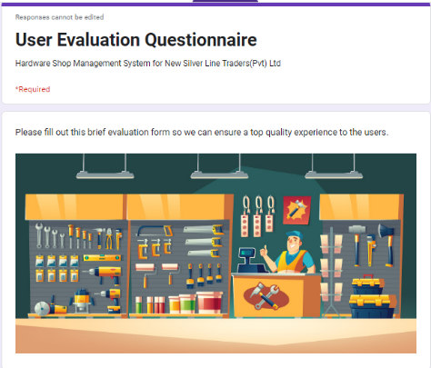

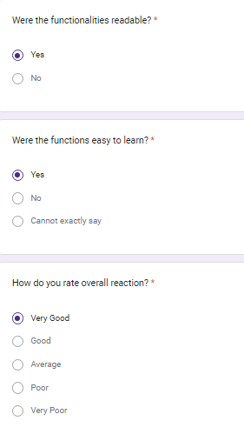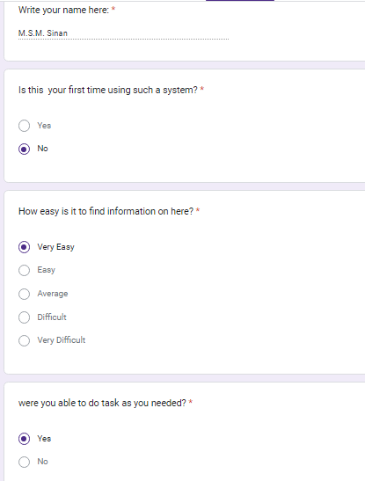

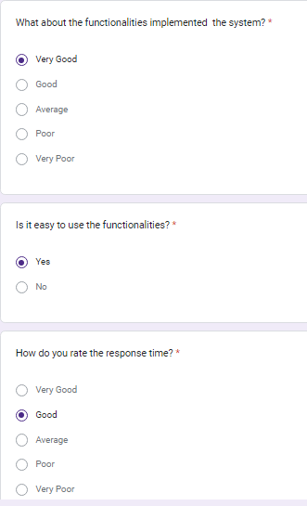

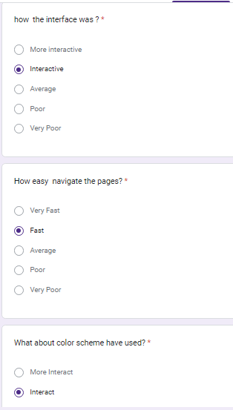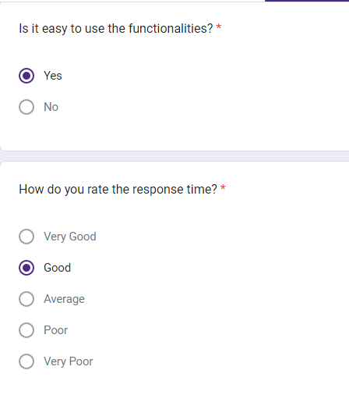

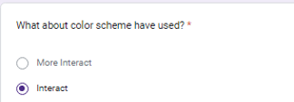

Figure 36-Internal User Evaluation Response

According to evaluation the user can adapt to the system without much effort and agreed to that system has come up with requirements that requested

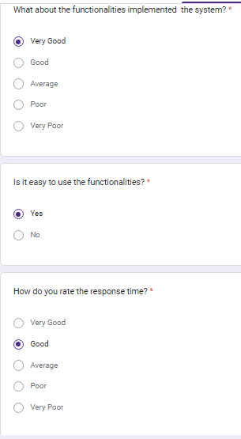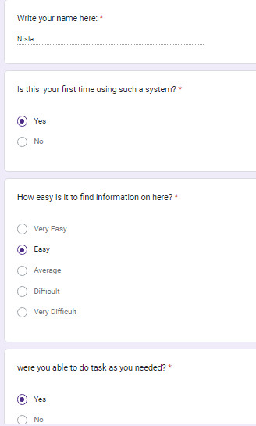At the second phase got the evaluation response from novice user which is called as external user. The response user as below;

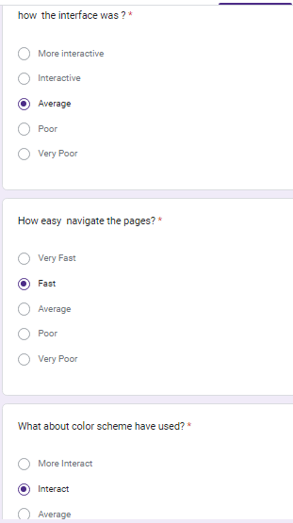

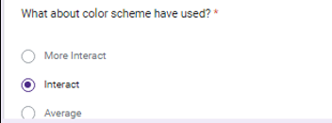

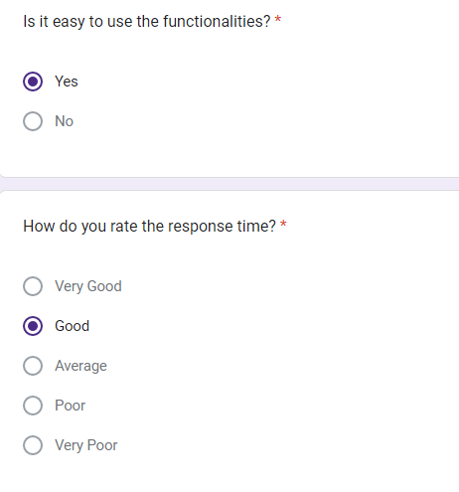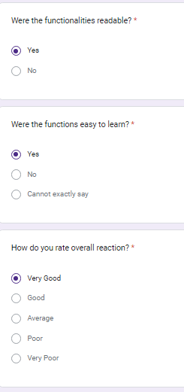

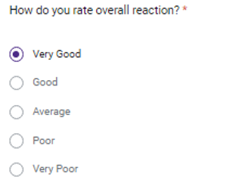

Figure 37-External User Evaluation Response

According to the statistics, it’s clear that, most of the internal as well as external users can adapt and can continue working with the system, without or less effort.

## **End User Feedback**

Qualitative and quantitative data from users on their likes, dislikes, impressions, and requests about the system is called as feedback. Collecting and making sense of user feedback is critical for businesses that wish to make improvements based on what their users need. Some of suggestions in the evaluation form are as follows;

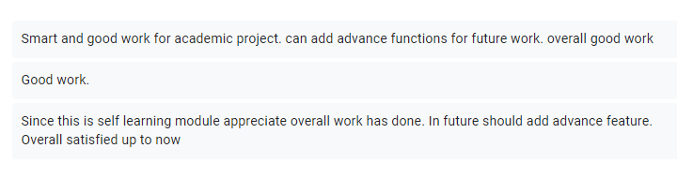

Figure 38-User Feedback

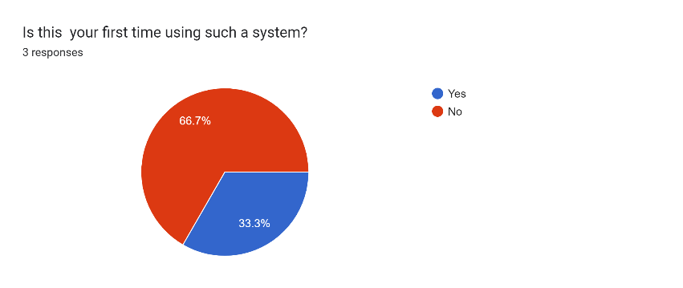When considering about the feedback in internal and external users the client also had required to advance features in future. Overall statistical feedback analyzation high client satisfaction in features for New Silver Line Traders. Since this is initial phase of switch from manual system to automate system simple management system requirement has met in the system. Some of summarization of statistical view of end user feedback as follows;

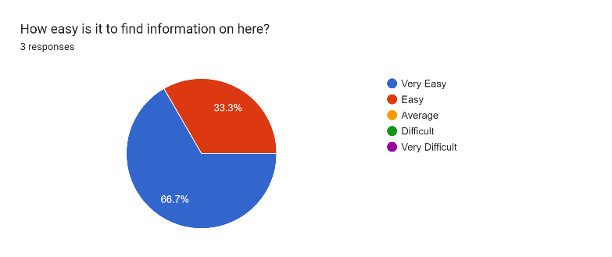

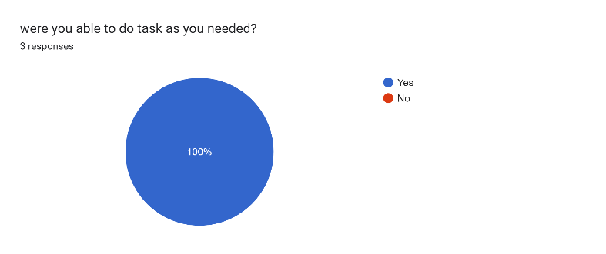

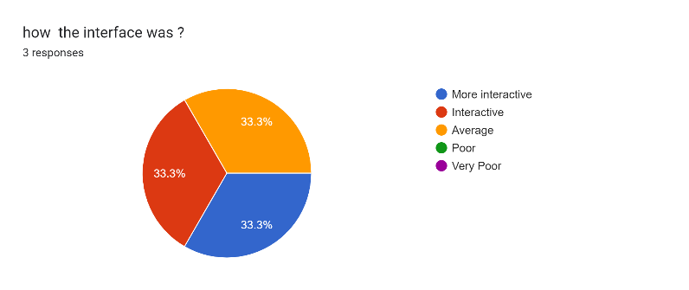

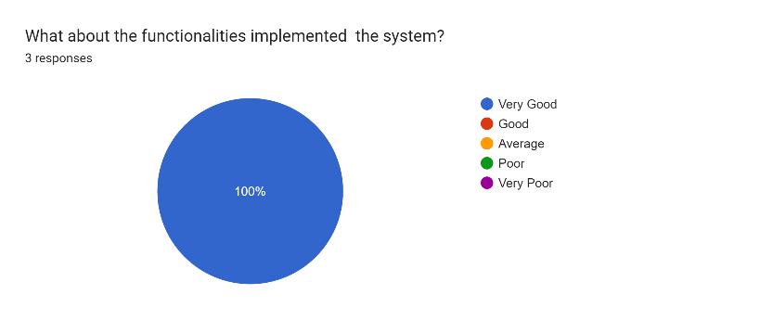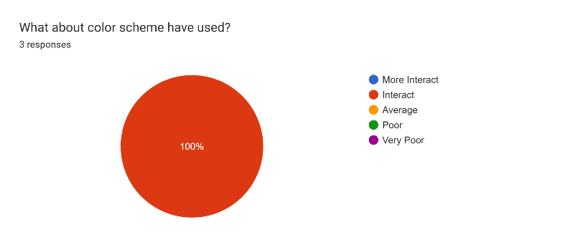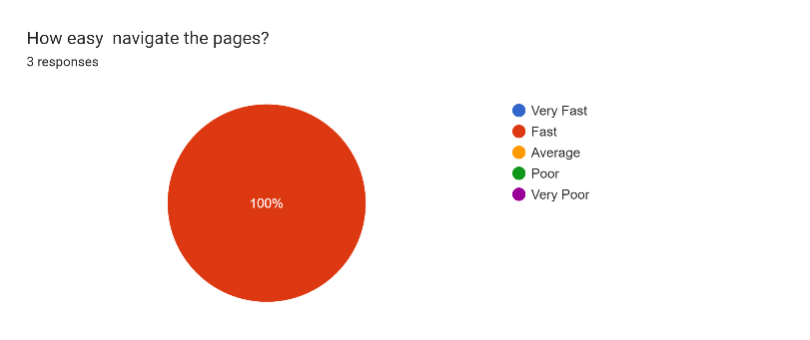

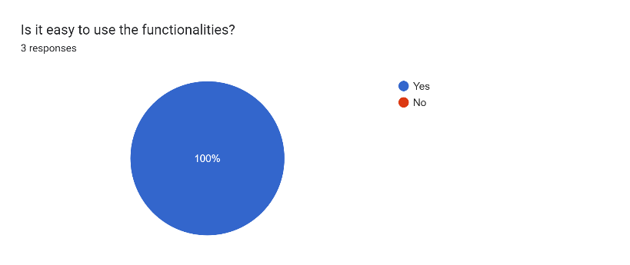

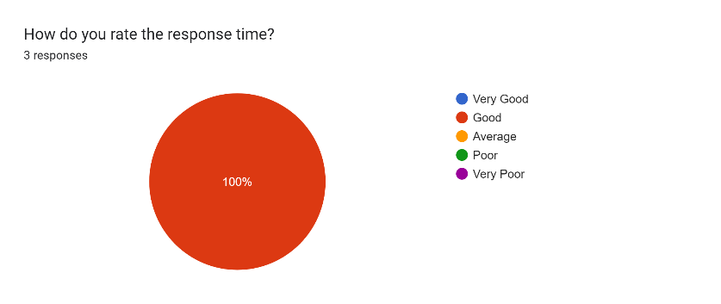

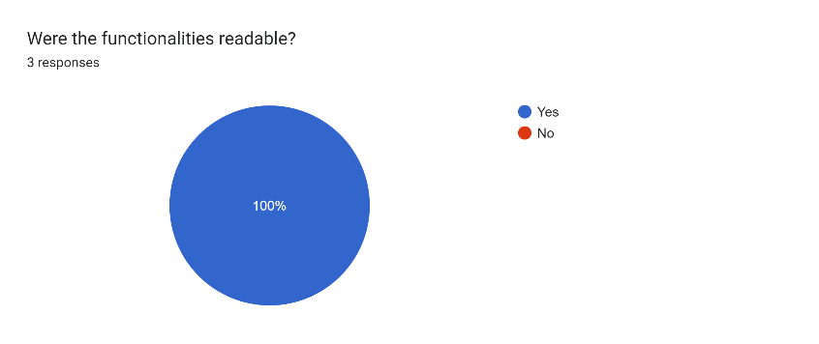

Figure 39-User Feedback Statistical Data

# Chapter 7 - Conclusion

## **7.1 Conclusion**

Hardware Shop Management System for New Silver Line Traders (Pvt) Ltd is the individual project which focus Management System for the day-to-day operation. Their current processes are manual and mostly based on paper work, which is inefficient and time consuming. So, there should be a proper mechanism to manage their day-to-day activities. Technology has a solution in terms of management system. The Hardware Shop Management System can address this issue and increase the efficiency and the effectiveness of this process.

Hardware Shop Management System helps to reduce common human errors, and speed up the normal operations in an efficient and effective ways. All day-to-day activities such as invoice management, salary management, sales management have been automated through this system. Required functional and non-functional requirements are identified in the analysis phase and brought towards the implementation stage successfully by completing all agreed modules with client requirements. At the end, small changes were made to the features of the system including send email through system for suppliers, login email OTP verification which were requested by the client. It’s clear that the client satisfied with the developed system.

## **7.2 Critical Evaluation**

Firstly, a domain analysis was carried out in order to gain insight into the domain in question in New Silver Line Traders (Pvt) Ltd. Then feasibility study was carried out in order to test whether developing such system will be helpful than going for commercial or open-source solution. It was found that developing this custom system will be very useful and needed for the New Silver Line Traders due to small scalable business and cost through feasibility study.

Then a requirement gathering was a huge challenge and much effort was made to collect accurate and appropriate requirements and requirement analysis supported the accuracy. Although there are commonly used techniques like interviewing, questionnaire, observing the working environment are used commonly in this project was used interviewing as a discussion session as a google meet with Mr. Sinan (The owner of New Silver Line Traders Pvt Ltd) to collect, understand, validate and finalize the client requirements.

ER diagram, use case diagram, database design, class diagram and other appropriate diagrams and initial sketches of user interfaces were developed to understand and design the system.

Python programming language was chosen developing the system which is most familiar, have lots of supported technical details and huge community to support and also its flexibility compared to other languages. Object Oriented methodology, RUP modelling also used as best practices. SQL Server Management Studio was used for database designing with appropriate queries in order to make this development more realistic. Different pre-defined packages used in this system.

Testing was the final work in order to test, whether the system produces what we have expected. For testing the test cases are developed and tested parallel when implementing the system in order to avoid unexpected errors and results, which may lead to extra work.

## **Limitations**

Due to academic project this system has some limitations. This management system has focused almost every function related management wise. In here not consists individual employee profile. Because this is a hardware shop, they wanted to manage only managerial task and they have few employees therefore having individual account is additional cost to maintain. This system has not integrated google map for locations. Because if integrate google map API have make payment for it.

## **Future Work**

Proposed system had time constraints. Therefore, the functionalities of the system were developed in accordance with agreed client requirements. A few suggestions for future enhancement of the system are follows.

* Add Google map location when Add home address, company address it should display in the map as well.
* Develop innovative attendance management.
* When reduce the quantity of product automatically place order to supplier via the system.

## **Lesson Learnt**

It was a great experience for me to practically apply the theories and lessons learned into a working computerized system, on this degree program. It helped me a lot on how to deal with real customers and how to coordinate and collaborate with them in order to make the system a success. An also;

* Proper planning should be there in order to manage the project and to reduce the risk of project failure.
* Searching for solutions to problems, helped a lot to learn and improve programming language.
* I had to learn new technologies when developing this system specially Python, Python NumPy, its work, data science Python tool, Pyplot for graphical representation etc. which are not in the academic curriculum. It helped me to increase self-learning.
* Finding and fixing errors on time is much important while developing, since a minor error which was postponed will lead unexpected major errors and propagate where it will take hours to debug it. Nearly took 1 week to complete automate email sending code correctly
* Also, I have learned to write and present reports in an organized and standard way to interested parties who wish to read

# References

|  |  |
| --- | --- |
| [1] | K. D. Kanchev, "Employee Management System," Vaxjo University, 2006. |
| [2] | R. Leist, "An Introduction to SQL Tutorial: How to Wrtie Simple Queries," Hubspot, 21 March 2022. [Online]. Available: https://blog.hubspot.com/marketing/sql-tutorial-introduction. [Accessed 11 September 2022]. |
| [3] | J. Lewis, "Responsibilities of Day-to-Day Record Keeping," 2018. |
| [4] | J. C. M. Baraka, "Inventory management concepts and implementations: a systematic review," *Supply Chain Management,* 22 July 2022. |
| [5] | J. C. M. Baraka, "Inventory management concepts and implementations: a systematic review," p. 36, 10 July 2022. |
| [6] | Fran, "Employee Management System," Sweden, 2006. |
| [7] | R. Regan, "Top 12 Employee Management Software Solutions 2023," 2023. |
| [8] | T. Technology, "Billing System: All the basics," Triends Company, 05 April 2022. [Online]. Available: https://tridenstechnology.com/billing-systems-101-all-the-basics-you-need-to-know/. [Accessed 08 March 2023]. |
| [9] | G2 Company, "Software and Services Related to Billing Software," 2023. |
| [10] | "Top 15 Supply Chain Management," 2022. |
| [11] | A. Meher, "Searching Algorithms in Python," Dev Genius, 2022. |
| [12] | G. Batra, "Learning Pycharm It's Advantages and Disadvantages," *Pycharm,* p. 11, 2023. |
| [13] | P. Vasekar, "Python smtp client," *smtplib,* p. 1, 2021. |
| [14] | I. Sommerville, Software Engineering-8th Edition, Addison- Wesley, 2007. |
| [15] | Techopedia , "What Does System Requirements Mean?," *System Requirements,* p. 01, 2015. |
| [16] | "Requirements," 12 June 2016. [Online]. Available: http://www.en.wikipeadia.org/wiki/fucnctional_requirement,. [Accessed 18 03 2023]. |
| [17] | "Requirements," 12 June 2016. [Online]. Available: http://www.en.wikipeadia.org/wiki/Non-functional_requirement,. [Accessed 18 March 2023]. |
| [18] | I. E. Team, "What Is a Feasibility Study? Definition, Benefits and Types," 11 March 2023. [Online]. Available: https://www.indeed.com/career-advice/career-development/feasibility-studies. [Accessed 22 March 2023]. |
| [19] | L. A. California State University, "Scope and Feasibility - Scope and Feasibility The Project," *Scope Feasibility,* p. 01, 2015. |
| [20] | J. L. w. &. L. D. Bentley, Systems Analysis and Design Methods-7th Edition, 2007. |
| [21] | 12 June 2016. [Online]. Available: http://www.en.wikipeadia.org/wiki/Database_design,. [Accessed 25 March 2023]. |
| [22] | d. team, "General Review of Microsoft SQL Server Management Studio (SSMS)," 02 March 2021. [Online]. Available: https://blog.devart.com/general-review-of-microsoft-sql-server-management-studio-ssms.html. [Accessed 26 Marcch 2023]. |
| [23] | A. Chola, "Python SQL Server Integration using Pyodbc: 5 Easy Steps," 22 Febuary 2022. [Online]. Available: https://hevodata.com/learn/python-sql-server-integration/. [Accessed 02 04 2023]. |
| [24] | J. D. langen, "Sending Emails With Python," *Geting Started Python,* p. 01, 2019. |
| [25] | "Quick Reads," 12 July 2022. [Online]. Available: https://www.activestate.com/resources/quick-reads/what-is-matplotlib-in-python-how-to-use-it-for-plotting/#:~:text=Matplotlib%20is%20a%20cross%2Dplatform,embed%20plots%20in%20GUI%20applications.. [Accessed 02 April 2023]. |
| [26] | "Evaluation," 21 September 2016. [Online]. Available: https://en.wikipedia.org/wiki/Evaluation. [Accessed 02 April 2023]. |

# Appendices

# Appendix A - SYSTEM DOCUMENTATION

System documentation serves as the technical specifications for the IS and how the objectives of the IS are accomplished.

|  |  |
| --- | --- |
| Requirements | Description |
| Processor | Intel(R) Core (TM) i5-2450M CPU @ 2.50GHz 2.50 GHz is required to develop. |
| RAM | Minimum 8.00GB capacity RAM is suitable to store entire data |
| Device | Any types of devices (Desktop, Laptop) can be used. Dell, Hp, Samsung, etc (Any manufacturing devices are suitable to the successful implementation) |
| Router | 4G-LTE wireless network router for laptop, network cable is needed for PC (Any manufacturing router is allowed) |
| Storage | Pycharm Application Space |

Table 6-System Requirement

# Appendix B - DESIGN DOCUMENTATION

**Use Case Diagram with Detailed Information**

Following are the use case diagrams in detail. It is important to understand and get a clear idea about a module and explained briefly.

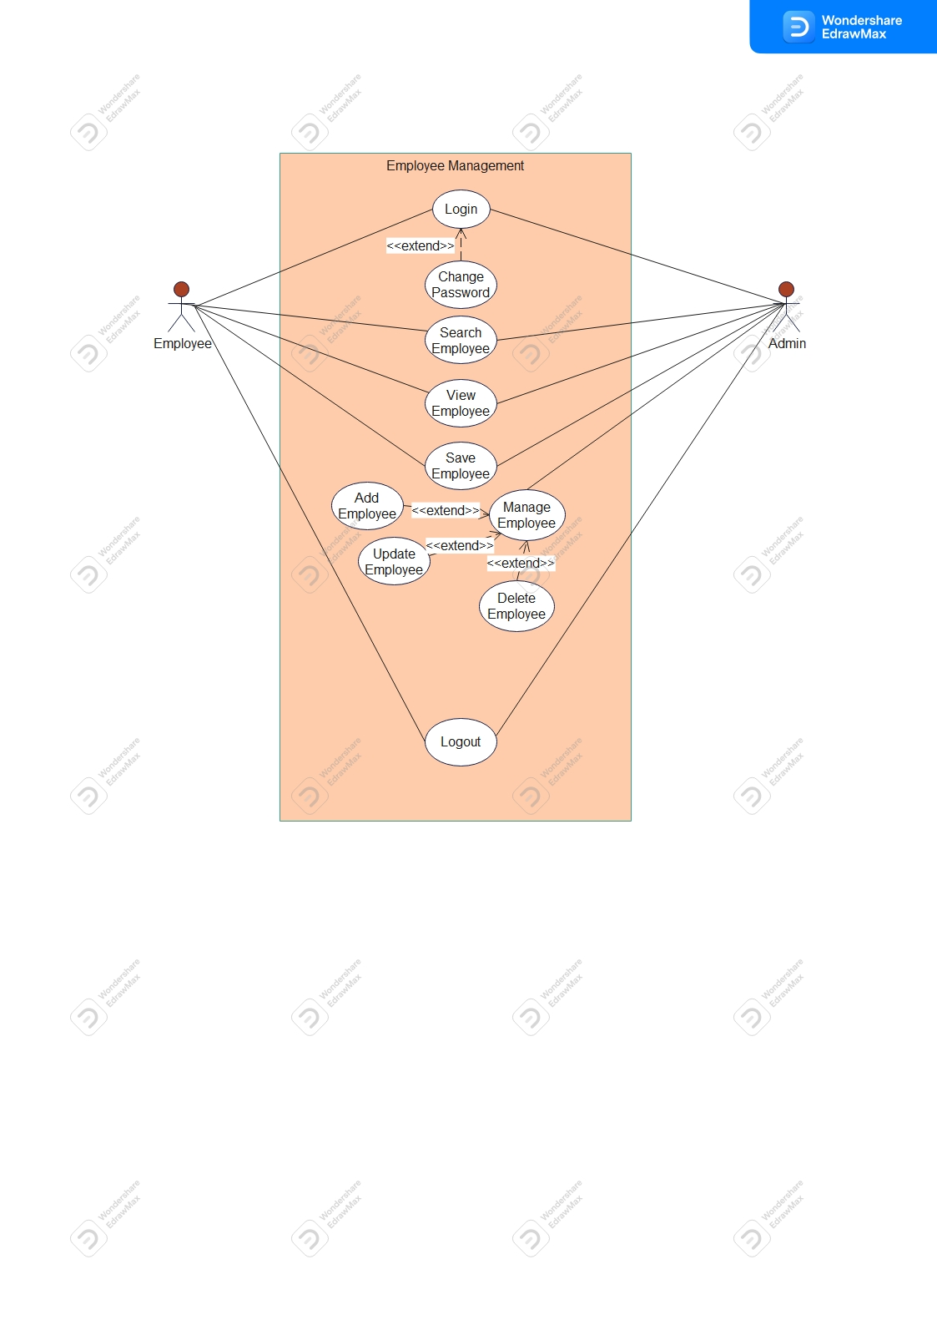**Use Case Diagram for Employee Management**

Figure 40-Appendix B- Use Case Diagram for Employee Management

As explained in previous flow charts once correct login admin is allowed to add, update, delete, search employee details and employee who has assigned to the HRM can search the details and make report and get summary of percentage of departments etc.

|  |  |  |  |
| --- | --- | --- | --- |
| **Use Case Name** | Add Employee | | |
| **Actor** | Administrator | | |
| **Description** | Administrator can add employee information when recruit | | |
| **Pre-Condition** | Administrator should be logged into the system | | |
| **Typical course of Action** | **Action** | **System Response** |
| Click on add button with empty entry fields | Display error message |
| Enter relevant details and click add button | Display employee has been added successfully. |
| **Alternate Courses** | If the entered details are wrong, show error message “employee has not been added”. | |
| **Conclusion** | This use case concludes when the user details stored in the database | |
| **Post Condition** | Employee details stored in the database and should able to login with relevant privileges based on user login type. | |

Table 7-Use Case Description for Add Employee

|  |  |  |
| --- | --- | --- |
| **Use Case Name** | Delete Employee | |
| **Actor** | Administrator | |
| **Description** | Administrator can delete employee information when click on the button | |
| **Pre-Condition** | Administrator should be logged into the system | |
| **Typical course of action** | **Actor Action** | **System Response** |
| Search particular employee by click on ‘search ‘button | Display employee records in the table |
| Click on record in the table | Displays data in each entry field |
| Click on ‘Delete’ button | Displays message box whether confirm the delete record |

|  |  |  |
| --- | --- | --- |
|  | Click on yes in the box | Display employee deleted successfully |
| **Alternate Courses** | Display error message employee record has not been deleted. | |
| **Conclusion** | This case concludes when the user account got deleted | |
| **Post Condition** | Particular employee record not in the database. Cannot access anymore. | |

Table 8-Use Case Description for Delete Employee

|  |  |  |
| --- | --- | --- |
| **Use Case Name** | Update Employee | |
| **Actor** | Administrator | |
| **Description** | Administrator can change employee information when needed | |
| **Pre-Condition** | Administrator should be logged into the system | |
| **Typical course of action** | **Actor Action** | **System Response** |
| Search particular employee by click on ‘search ‘button | Display employee records in the table |
| Click on record in the table | Displays data in each entry field |
| Change the needed details & click on ‘Update’ button | Displays message box whether confirm the update record |
| **Alternate Courses** | Display error message employee record has not been updated. | |
| **Conclusion** | This case concludes when the user account got updated | |
| **Post Condition** | Particular employee’s new record valid for future functionalities. | |

Table 9-Use Case Description for Update Employee

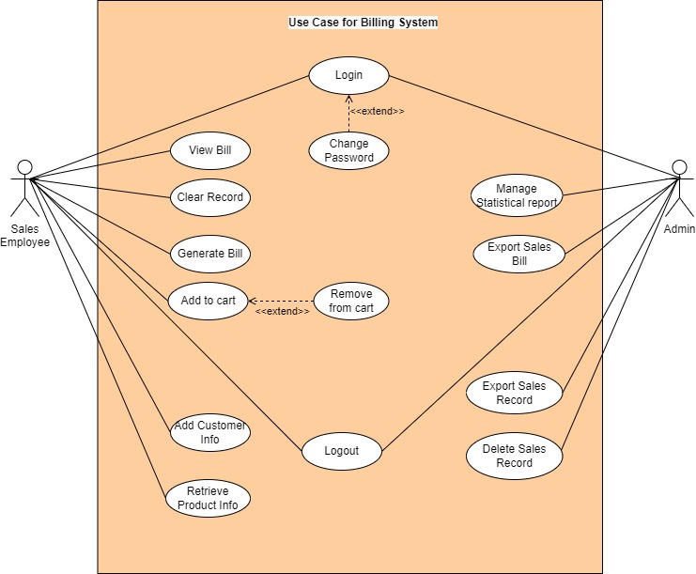**Use Case Diagram for Billing System**

Figure 41-Appendix B- Use Case Diagram for Billing System

Once logged into the system sales employee who is in the cashier is assigned to add product to the bill, print bill, retrieve products etc. The admin user can manage graphical static report, save bill list, view bills, delete records from the list etc.

|  |  |  |
| --- | --- | --- |
| **Use Case Name** | Generate Bill | |
| **Actor** | Sales Employee | |
| **Description** | Sales employee can generate the bill when purchase by customer. | |
| **Pre-Condition** | The user should be logged into the system | |
| **Typical course of action** | **Actor Action** | **System Response** |
| Click on product row in the table | Display on relevant field |
| Click on add cart button | Display product name, quantity price in cart. |
| Click on Bill button | Display message box bill printed successfully. |

|  |  |
| --- | --- |
| **Alternate Courses** | Display error message bill not printed. |
| **Conclusion** | This case concludes when the bill generated |
| **Post Condition** | Billing details stored on database |

Table 10-Use Case Description for Generate Bill

|  |  |  |
| --- | --- | --- |
| **Use Case Name** | Delete Bill Records | |
| **Actor** | Administrator | |
| **Description** | Administrator can delete the record when click on the button | |
| **Pre-Condition** | The administrator should log into the system | |
| **Typical course of action** | **Actor Action** | **System Response** |
| Search billing record by clicking on ‘search’ button | Display record in the table |
| Click on delete button | Display message box whether confirm the record to delete. |
| Click on yes button | Display message box bill record deleted successfully. |
| **Alternate Courses** | Display error message when cannot remove record. | |
| **Conclusion** | This case concludes when the bill deleted | |
| **Post Condition** | The record removed from database cannot access anymore. | |

Table 11-Use Case for Delete Bill

*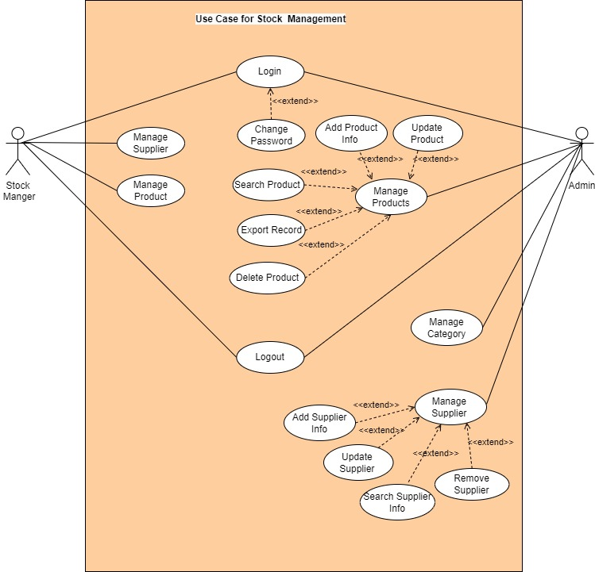***Use Case Diagram for Inventory Management**

Figure 42-Appendix B- Use Case Diagram for Inventory Management

The admin user can manage product, suppliers, categories by adding, updating, deleting, etc. The stock manager has access when needed to connect with supplier and to get stock product count.

|  |  |  |
| --- | --- | --- |
| **Use Case Name** | Manage Supplier | |
| **Actor** | Administrator | |
| **Description** | Administrator can add, update, delete the record when click on the buttons | |
| **Pre-Condition** | The administrator should log into the system | |
| **Typical course of action** | **Actor Action** | **System Response** |
| Fill the entry fields and click on add button | Display message supplier has added successfully |
| Search supplier details by click on the search button | Display the record in the table |
| Click on a record in the table | Display records in each entry field. |

|  |  |  |
| --- | --- | --- |
|  | Modify the field if needed and click on update button | Display message box whether confirm the modification |
| Click on yes button | Display updated successfully message. |
| Click on delete button after click on a row in the table | Display message box whether confirm the deletion |
| Click on ’yes’ button | Display message box record deleted successfully. |
| **Alternate Courses** | Display error message when cannot proceed with each task. | |
| **Conclusion** | This case concludes when the process is done | |
| **Post Condition** | All the fields are requested to be filled. | |

Table 12-Use Case for Supplier Management

|  |  |  |
| --- | --- | --- |
| **Use Case Name** | Manage Product | |
| **Actor** | Stock Manager | |
| **Description** | Allows manage product, if needed | |
| **Pre-Condition** | Should log into the system | |
| **Typical course of action** | **Actor Action** | **System Response** |
| Fill the entry fields and click on add button | Display message product has added successfully |
| Click on stat view button | Display graphical chart |
| **Conclusion** | This case concludes when the process is done | |
| **Post Condition** | All the fields are requested to be filled. | |
| **Alternate Courses** | Display error message when cannot proceed with each task. | |

Table 13-Use Case for Product Management

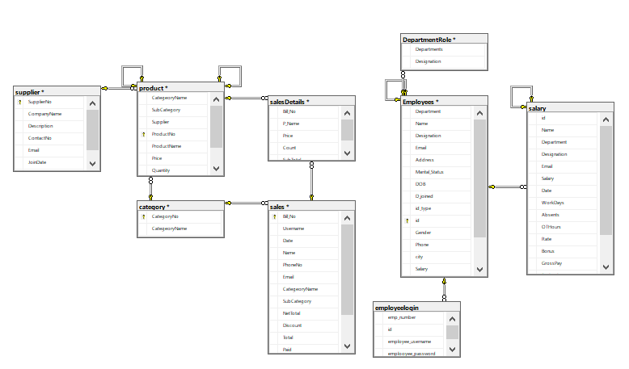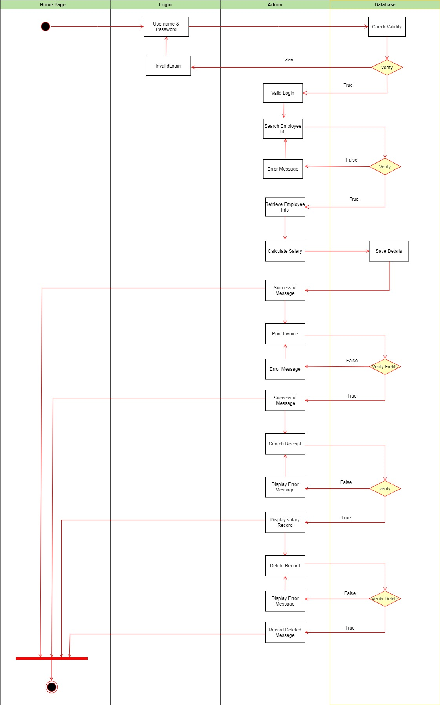**Activity Diagram for Salary Management**

In the salary Management the administrator is allowed to print salary slip and share with particular employee’s email. Once logged into the system correctly particular authorized tasks’ accessibility is allowed.

Likewise, for each module different diagrams have been drawn.

Figure 43- Appendix B- Activity Diagram for Salary Management

# Appendix C - USER DOCUMENTATION

**Home Page**

The initial phase when open the application which is home page. It consists of company name as header and with the ‘Welcome!’ button which connects to the login page.

**Login Page**

Login page consists of username, password entry fields, login and clear button and then forgot password button. If username and password are correct connect to respective page or else it displays the error message.

**Login Page – Forgot Password**

If forgot password through the system it is allowed to change the password. To do that have to verify email.

After providing email and click on next button through the system send verification code and should verify in pop up message box. If it is correct only the user directs to change password page.

**Admin Page**

After correctly log into the page admin has access to each and every page including employee management, inventory, sales management, salary management etc.

**Employee Management**

Admin can add employee, update employee, delete employee record from the system. Employee add entry fields not directly shown. It categorized into sub categories as personal information, professional information and contact information. When search employee by Id it displays in the table. That record can export as excel sheet. Finally, all the records are graphically represented as a report to get management decisions. It is display on another window.

**Salary Management**

It is allowed to retrieve employee information. For selected employee can calculate the salary based on allocated working. After calculate salary it prints invoice when clicking on print invoice button. That invoice can send through email by clicking on send email button. Admin can search record and export table data. For management decisions system generate graphical static view as a report in another window.

**Inventory Management**

Inventory management consists of dashboard window and four sub navigations which directs to other pages. Main dashboard displays the summary of the stock. It shows total number of suppliers, products, category and employees. If there are a smaller number of totals of these system displays alert message with reed highlight which remind to connect relevant person.

**Supplier Management**

In the supplier management can add supplier, edit supplier information, remove supplier from the system. System will not directly allow to do these changes it consists of validations. When admin search supplier information it displays in the table that table data can export as excel file and also the management report which consists of graphical representation. And also, it is allowed to send email to relevant supplier.

**Product Category**

The admin user, stock manager can manage product category information. It consists of add product category, change product category, remove category or clear entry fields. Due to different category this window supports to verify the available categories.

**Manage Product Details**

The system retrieves product category from category window under drop down list. And also, retrieves supplier names from supplier window. Then can add product information by clicking on ‘Add’ button. Update button allows do modification. The system doesn’t allow to modify directly at first has to search product through search bar. Then displays record in the table. Once click on a row it displays within field then only can modify record. The record can be deleted from the system. The user can export list of products in here as well. This window connects with another window to display the management report.

**Manage Sales**

To manage sales, report this window has been created. The system allows to export bills which were printed by sales employee. After search bill through date, bill no or customer mobile no system displays relevant record in the table then it can be deleted or save the bill. For managerial purpose it displays graphical view of static data which in the able.

**Billing System**

Sales employee has to print the bill. At the initial phase add product to the cart table. Once calculate it has to click on total button. Once calculate total purchase amount can print the bill. The system records all the bill data in the database. The bill cannot delete by sales employee. Once correctly search bill no or bill printed date it displays previous bill. Each function has designed parallelly but integrated at once.

**View Employee Information**

HR department provides access to view employee information with authorized login. In here user can search employee information by id, department of available designation. Meanwhile system allows to export table data for further decision making. The system provides graphical representation based on available employees under different departments. The chart consists in another page.

# Appendix D - MANAGEMENT REPORTS

Management reports are produced based on available records of each management. These reports are the most important part of the system, which summarizes the entire system data into meaningful and useful information, which can be mainly used for decision making regarding the progress and improvement of the shop. The admin is assigned to manage each report.

**Employee Management**

Below figure represent the graphical view of percentage of employees available under department, available positions and basic salary flow changes among the employees. It supports to get decisions of employees when allocate tasks. This repot can print or save as well. This is changed based on available data.

 Figure 61 – Management Report – Employees by Departments

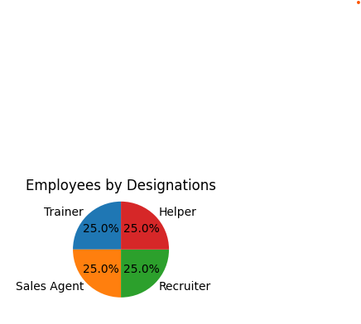

Figure 62 – Management Report - Employees by Designation

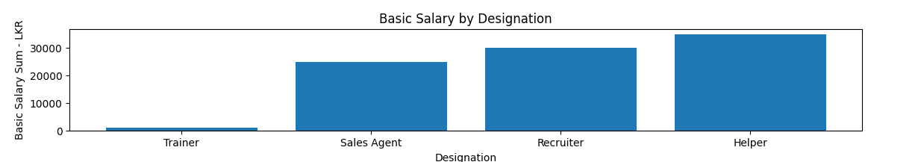

Figure 63-Management Report – Basic Salary on Designation

**Salary Management**

Once search the salary information system generates reports based on monthly report, each employee salary calculation. It supports to get decisions monthly wise as well as individual performance. Following figure is shown that;

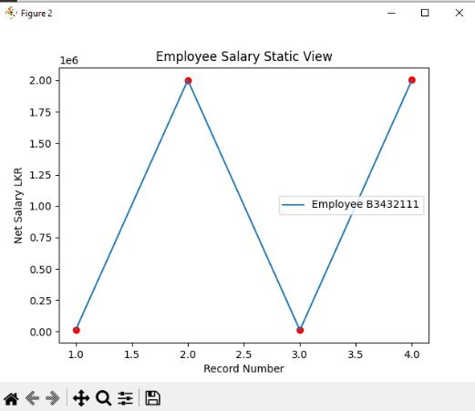

Figure 64- Management Report – Individual Monthly Salary Report

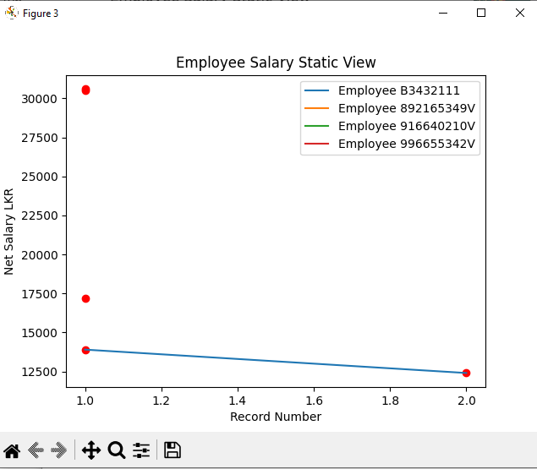

Figure 65-Management Report - Employees Salary Report

**Supplier Management**

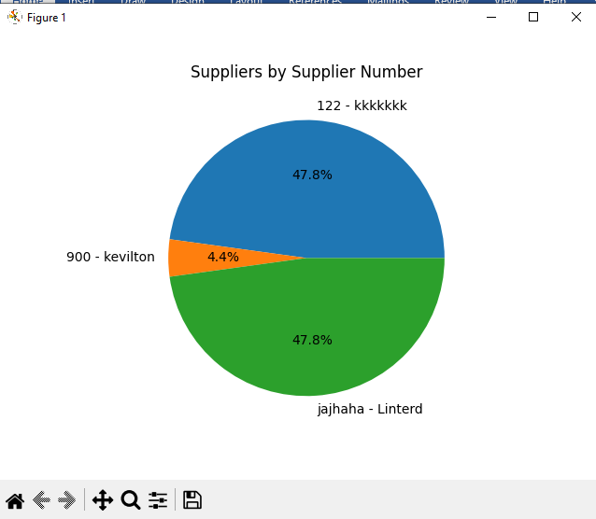Through the system it displays the available suppliers in the shop. Below graphical representation is suppliers;

Figure 66- Management Report - Supplier Report

**Product Management**

To get management decisions based on product quantity and price using graphical representations are more important. It displays product availability through the system.

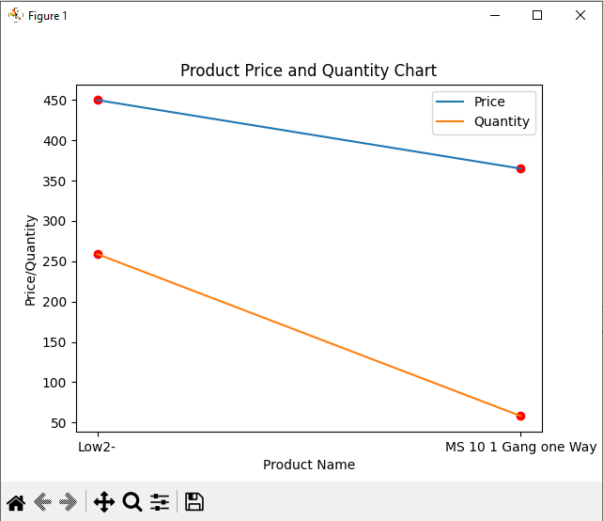

Figure 67-Management Report - Product Report

**Sales Management**

To analyze the sales history and get decisions based on previous sales record this graphical statistical view is more important. In here consider billing purchase amount each Tay.

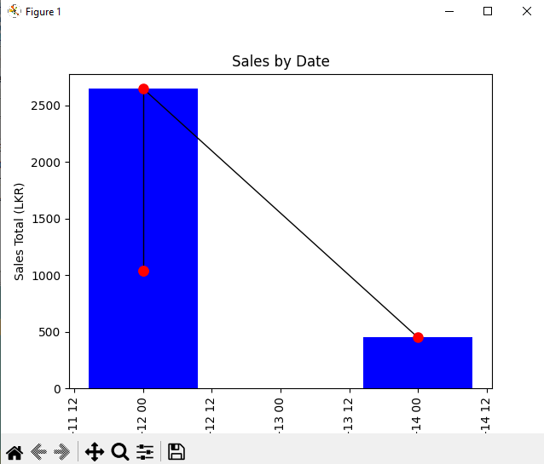

Figure 68- Management Report - Sales Report

**View Employee**

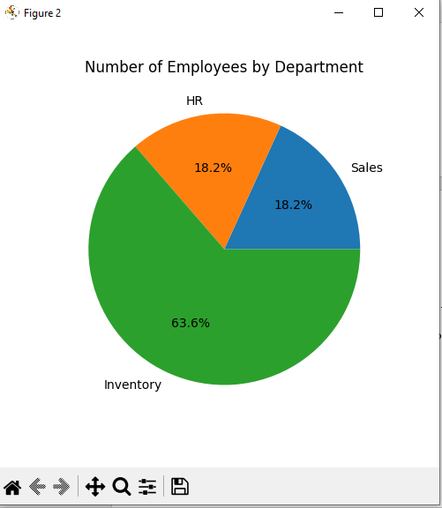The system displays employees record based on department and designation. It provides available department and position. It supports to focus whether recruit new employees for the department.

Figure 69- Management Report - View Employee Report

To get decisions based on tasks there are multiple ways to represent the graphical view as a chart.

# Appendix E - TEST RESULTS

**Test Name: Login Authentication**

Tested by- Nahda.

Table 14-Test Results-Login Authentication

|  |  |  |  |  |  |  |  |
| --- | --- | --- | --- | --- | --- | --- | --- |
| Test _id | Test Scenario | Test Case | Pre-Condition | Test Data | Expected Result | Actual Result | Status |
| TC_101 | Verify Login | Enter valid username & password |  | Username-Nusla  Password-nusla900 | Direct to employee view page. | Direct to the Billing System Page. | Pass |
| TC_102 | Enter valid username& invalid password | Username-Nusla  Password-nusla800 | Display error message. Not allow to connect next page | Receive error message | Pass |
| TC_103 | Enter invalid username & valid password | Username-Nisl  Password-nusla900 | Display error message. Not allow to connect next page | Receive error message | Pass |

|  |  |  |  |  |  |  |  |
| --- | --- | --- | --- | --- | --- | --- | --- |
| TC_104 |  | Enter invalid username & password |  | Username-Nisl  Password-nusla100 | Display error message. Not allow to connect next page | Receive error message | Pass |
| TC_105 | Blank entry fields & click login button | Username, Password- keep blank | Display error message. Not allow to connect next page | Receive error message ‘please enter both username and password’ | Pass |

**Test Name: Employee Management Admin View**

Table 15-Test Results-Employee Management Admin View

|  |  |  |  |  |  |  |  |
| --- | --- | --- | --- | --- | --- | --- | --- |
| Test _id | Test Scenario | Test Case | Pre-Condition | Test Data | Expected Result | Actual Result | Status |
| TC_201 | Verify Add Employee | Click on ‘Job Info’ button. | Login to admin page | Click on the button | Display job information filling form | Direct to the form filling window | Pass |

|  |  |  |  |  |  |  |  |
| --- | --- | --- | --- | --- | --- | --- | --- |
| TC_202 |  | Click on ‘Personal Info’ button. |  | Click on the button | Display Personal information filling form | Direct to the form filling window | Pass |
| TC_203 | Click on ‘Contact Info’ button. | Click on the button | Display Contact information filling form | Direct to the form filling window | Pass |
| TC_204 | Click on the “Add” button without filling any form fields. | Click on ‘Add’ button | Display Error message ‘all fields are required’ | Received the error message as expected. | pass |
| TC_204 | Enter license number without ‘B’ to id | Enter ‘01234567’ | Display error message need ‘B’ letter for license | Pop up message ‘enter B at the beginning of license’ | Pass |
| TC_204 | Enter old NIC without letter V | Enter ‘2324567890’ | Display error message ‘V’ letter should be at the end | Pop up message ‘enter letter V at the end of NIC | Pass |

|  |  |  |  |  |  |  |  |
| --- | --- | --- | --- | --- | --- | --- | --- |
| TC_205 |  | Enter numbers not equals to 10 digits for mobile number |  | Enter ‘232456789’ | Display error message mobile number should have 10 digits | Pop up message as expected | Pass |
| TC_206 | Use same id number to add new employee | Enter ‘198560303961’ | Display error message cannot use exist id | Pop up database exception error message | Pass |
| TC_207 | Fill all the entry fields | Enter valid data | Display employee successfully added message | Pop up successfully added message | Pass |
| TC_208 | Verify Update Employee | Change employee record | Existing employee record | Change mobile number of ‘Erandika’ | Display confirmation message and updated message | Pop up message box successfully updated | Pass |
| TC_209 | Verify Delete Employee | Remove employee record | Existing employee record | Select record of Erandika. Click on delete button | Display confirmation message and deleted message | Pop up successfully deleted message | Pass |
| TC_210 | Verify Search Employee | Search employee record | Existing record | Search B2345111 number | Display record in the table | Display as expected | pass |
| TC_211 | Search wrong id number | Search B2345101 number | Display error message | Display search id not in the record | pass |

**Test Name: Salary Management**

Table 16-Test Results- Salary Management

|  |  |  |  |  |  |  |  |
| --- | --- | --- | --- | --- | --- | --- | --- |
| Test _id | Test Scenario | Test Case | Pre-Condition | Test Data | Expected Result | Actual Result | Status |
| TC_301 | Verify Calculate Salary | Click on print invoice button with empty fields | Login to admin page | Click on the button | Display error message all fields are required. | Pop up error message as expected | Pass |
| TC_302 | Click print invoice for existing invoice | Click on the button | Display error message cannot print receipt for existing number | Pop up error message as follows | pass |
| TC_303 | Print successful salary invoice | Fill all the entry fields | Display successful message | Pop up receipt printed successfully message | Pass |
| TC_304 | Verify Delete Record | Click on delete button | Existing record | Select a row data from the table. | Display successfully deleted record message | Pop up message box as expected | Pass |

|  |  |  |  |  |  |  |  |
| --- | --- | --- | --- | --- | --- | --- | --- |
| TC_305 |  | Click on delete button with empty fields |  | Empty fields | Display error message all fields are requested | Pop up message box as expected | Pass |
| TC_306 | Verify Send Email | Click on send email button | Existing saved record | Selected a row in a table click on send email button | Display sent successfully button. | Received ‘Salary Receipt Sent Successfully’ message | Pass |

**Test Name: Supplier Management**

Table 17-Test Results-Supplier Management

|  |  |  |  |  |  |  |  |
| --- | --- | --- | --- | --- | --- | --- | --- |
| Test _id | Test Scenario | Test Case | Pre-Condition | Test Data | Expected Result | Actual Result | Status |
| TC_401 | Verify Add Supplier | Click on add button with empty fields | Login to the page | Click on ‘Add ‘button | Display error message all fields are required. | Pop up error message as expected | Pass |
| TC_402 | Enter invalid email | Enter ‘kcom’ | Display error message to enter valid email | Pop up message box ‘enter valid email’. | Pass |

|  |  |  |  |  |  |  |  |
| --- | --- | --- | --- | --- | --- | --- | --- |
| TC_403 |  | Enter invalid company name |  | Enter ‘km’ | Display error message to enter valid name | Pop up message box ‘enter valid name. | Pass |
| TC_404 | Enter valid details | Enter valid data, click on ‘Add button’ | Display supplier successfully added message | Pop up successfully added message | Pass |
| TC_405 | Verify Update Supplier | Change selected supplier data | Existing supplier record | Change linterd email ‘lintered.com’ | Display supplier successfully added message | Received successfully added message | Pass |
| TC_406 | Verify Search Supplier | Search by supplier wrong number | Existing supplier record | Search supplier id wrong number ‘1234567890’ | Display error message id is not in the record | Received error message as expected | Pass |
| TC_407 | Search by supplier number correct number | Search supplier id correct number ‘122’ | Display correct supplier information | Received correct information | Pass |
| TC_408 | Verify Delete Supplier | Select supplier record | Existing supplier record | Select supplier record, click on delete button | Display deletes supplier information | Received delete message information | Pass |

**Test Name: Product Management**

Table 18-Test Results-Product Management

|  |  |  |  |  |  |  |  |
| --- | --- | --- | --- | --- | --- | --- | --- |
| Test _id | Test Scenario | Test Case | Pre-Condition | Test Data | Expected Result | Actual Result | Status |
| TC_501 | Verify Add Product | Click on add button with empty fields | Login to the page | Click on ‘Add ‘button | Display error message all fields are required. | Pop up error message as expected | Pass |
| TC_502 | Select category drop down | List of pre stored categories | Select ‘white series from the list | Should display sub categories of selected category | Sub category listed down of selected category | Pass |
| TC_503 | Complete the fields |  | Enter valid data to entry fields | Display successfully added message box | Pop up message box as expected | Pass |
| TC_504 | Verify Update Product | Click on update button | Existing product record | Keep fields are empty | Display error message all fields are required | Pop up error message box as expected | Pass |
| TC_505 | Make changes on selected supplier | Change quantity for 30000537 number | Display successfully updated message | Pop up successfully completed message | Pass |

|  |  |  |  |  |  |  |  |
| --- | --- | --- | --- | --- | --- | --- | --- |
| TC_506 | Verify Search Product | Click on search button | Existing product record | Keep fields are empty | Display error message all fields are required | Pop up error message box as expected | Pass |
| TC_507 | Click on a name in drop down list | Select category in drop down lists | Display the table within tree view | Display the record as expected | Pass |
| TC_508 | Verify Delete Product. | Click on delete button | Existing record | Select product record product no 30000537 | Display successfully deleted message | Pop up message box as expected | Pass |

**Test Name: Billing System**

Table 19-Test Results-Billing System

|  |  |  |  |  |  |  |  |
| --- | --- | --- | --- | --- | --- | --- | --- |
| Test _id | Test Scenario | Test Case | Pre-Condition | Test Data | Expected Result | Actual Result | Status |
| TC_601 | Verify Add Cart | Add products to the fields | Existing product record | Select low2 product row. Click add cart button | Display product in the cart table | Product display in the cart as expected | Pass |
| TC_602 | Add product without quantity | Product info | Empty quantity field | Display ‘quantity is required’ message | Pop up message box as expected | Pass |

|  |  |  |  |  |  |  |  |
| --- | --- | --- | --- | --- | --- | --- | --- |
| TC_603 |  | Add same product to cart | Product details | Add ‘low2’ product into the cart | Display product already exist in the cart message | Pop up message box’ product already present. Do you want to update| remove from cart list’ | Pass |
| TC_604 | Verify Print Bill | Fill all the fields | Product cart | Click on ‘Bill ‘button | Display Receipt printed successfully message | Display message box as successfully printed | Pass |
| TC_605 | Blank fields |  | Click on ‘Bill’ button | Display ‘please add product to the cart’ message box | Display error message as expected | Pass |
| TC_606 | Verify Save Bill | Print pdf | Printed receipt | Click on ‘Print’ button | Display waiting message | Pop up please wait while printing | Pass |
| TC_607 | Click on ‘Print’ button | Open new window to save pdf | Open new window as expected | Pass |
| TC_608 | Cancel printing | Display message box cancel printing | Pop up message box operation was cancelled | Pass |

|  |  |  |  |  |  |  |  |
| --- | --- | --- | --- | --- | --- | --- | --- |
| TC_609 | Verify Search Bill | Search printed bill | Existing billing record | Search bill number ‘528715’ | Display bill record in the table | Display record as expected | Pass |
| TC_610 | Search bill by date’11.04.23’ | Display bill record in the table | Display record as expected | Pass |
| TC_611 | Search bill by customer mobile number | Display bill record | Display record in the table | Pass |
| TC_612 | Search blank field | Empty field search | Display search record invalid | Pop up invalid search record message box. | Pass |

**Test Name: Category Management**

Table 20-Test Results- Category Management

|  |  |  |  |  |  |  |  |
| --- | --- | --- | --- | --- | --- | --- | --- |
| Test _id | Test Scenario | Test Case | Pre-Condition | Test Data | Expected Result | Actual Result | Status |
| TC_701 | Verify Add Category | Add data to the fields | Login to the page | Fill the entry fields click on Add button | Display successfully added message | Popup message box as expected | Pass |
| TC_702 | Add data to blank fields | Blank field click on Add button | Display all fields are required message | Pop up error message as expected | Pass |

|  |  |  |  |  |  |  |  |
| --- | --- | --- | --- | --- | --- | --- | --- |
| TC_703 |  | Enter invalid category name |  | Enter ‘nk’ as category name | Display ‘Enter valid name’ error message | Popup error message box as expected | Pass |
| TC_704 | Enter same category no to new category | Enter ‘c101’ again | Display warning message cannot be same number | Pop up database error handling message | Pass |
| TC_705 | Verify Update Category | Change selected category | Existing record | Change name as ’socket’ | Display successfully updated message once confirm the change | Pop up ‘category updated successfully’ | Pass |
| TC_706 | Change entry fields to blank | Keep blank field | Display all fields are required message | Pop up error message as expected | Pass |
| TC_707 | Verify Delete Category | Delete selected record | Existing record | Select ‘c102’ record. Click on remove button | Display product category successfully deleted message | Pop up deleted message as expected | Pass |

# Appendix F – CODE LISTING

**Employee Management Admin View**

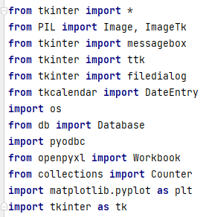In this code segment displays Add employee, Update employee, Search employee, Delete employee records. It consists of graphical representation as well. The list of employees in the table has sorted based on newly added record

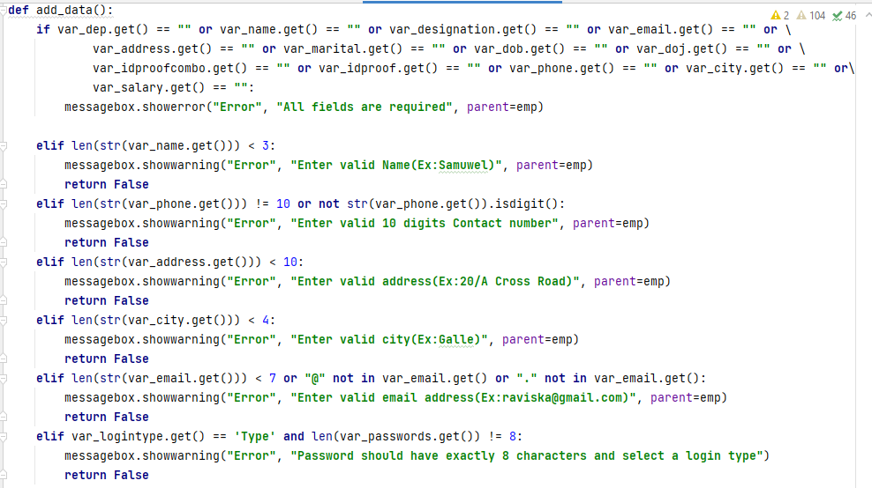

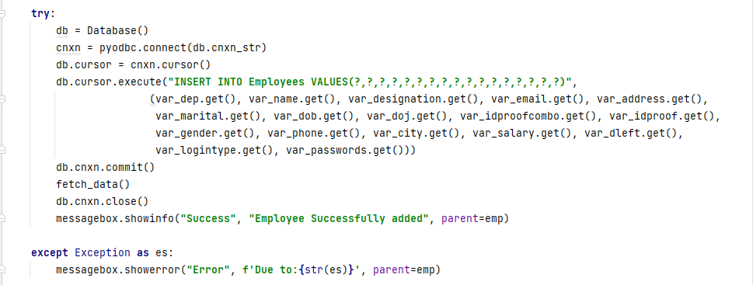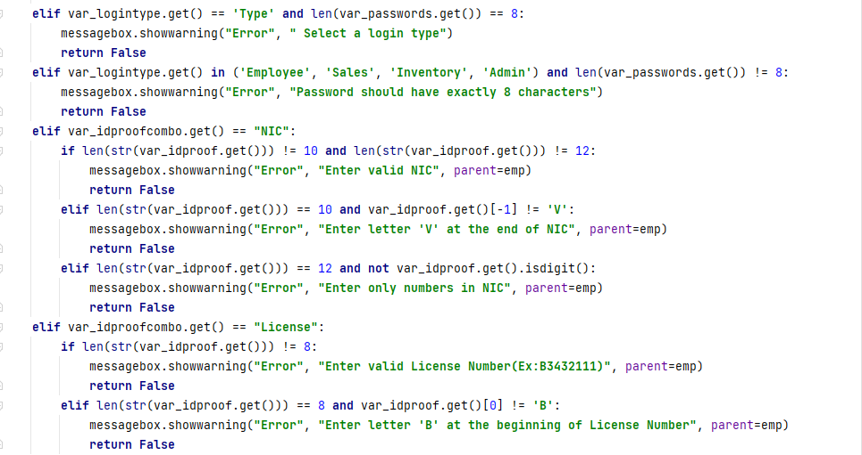



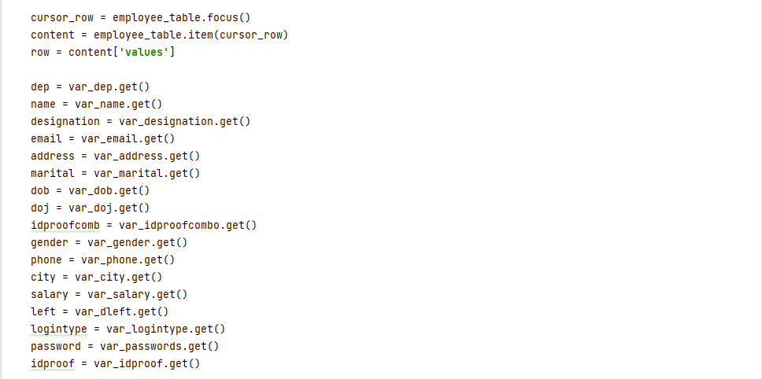

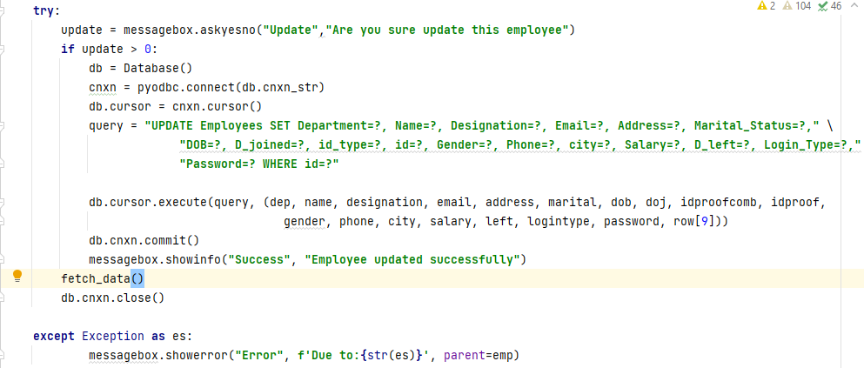

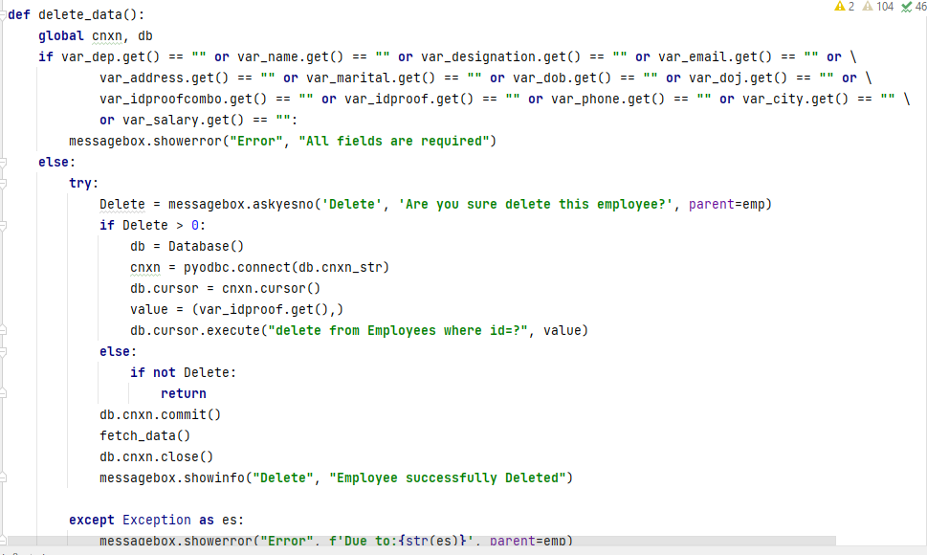

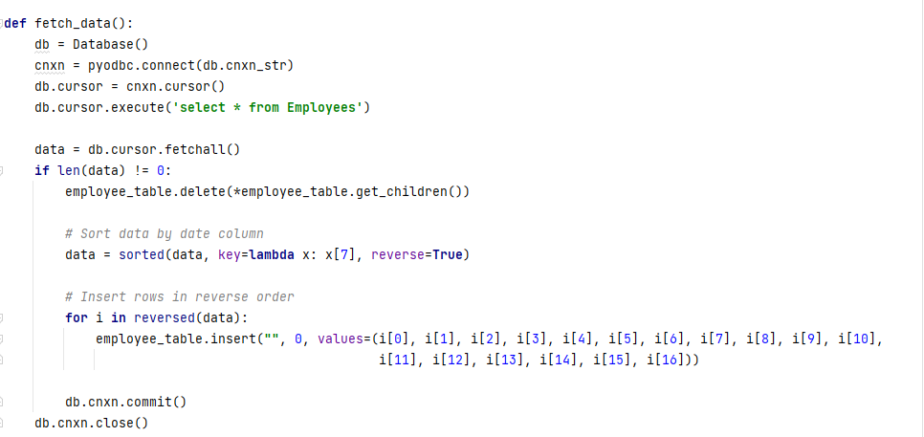

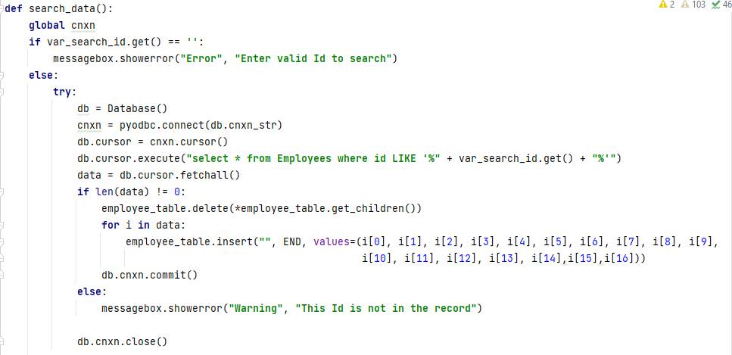

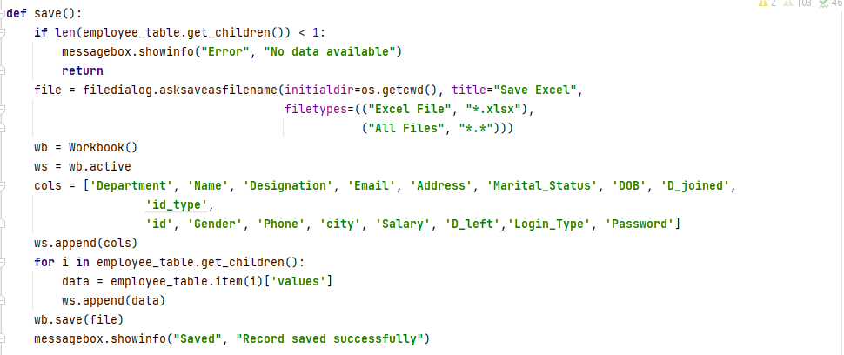

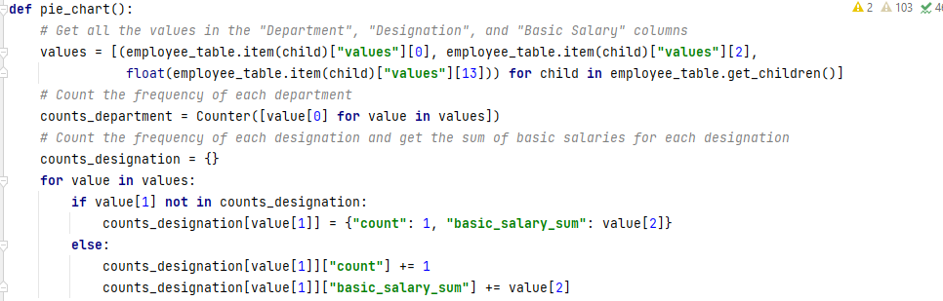

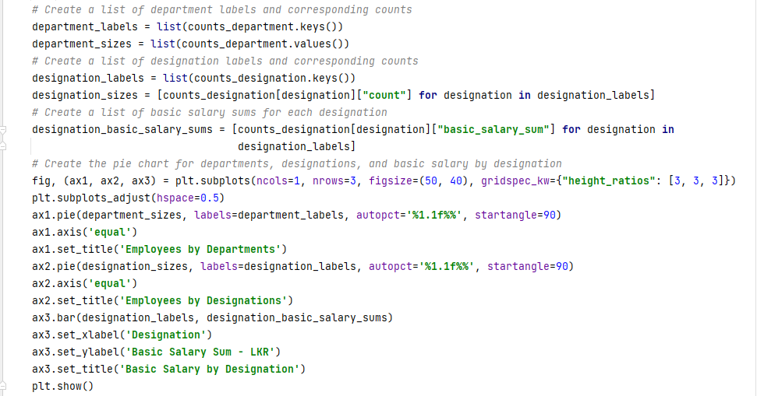

**Salary Management**

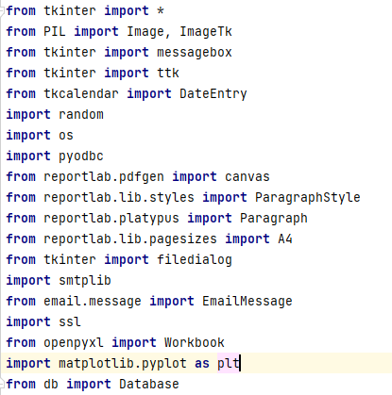In salary management calculate the salary of retrieved employee information. Once calculated the salary it prints the receipt and it can be shared via email. Also, salary receipt allows to print as pdf and entire record export into excel record. This salary record represents as graphical representation in order to get management decision.

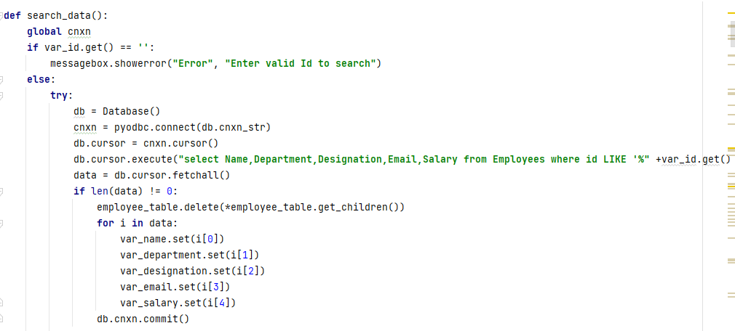

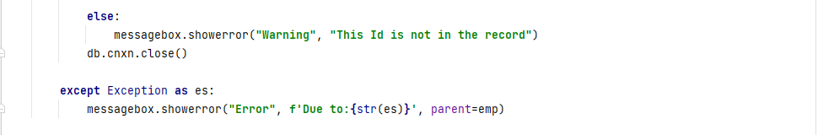

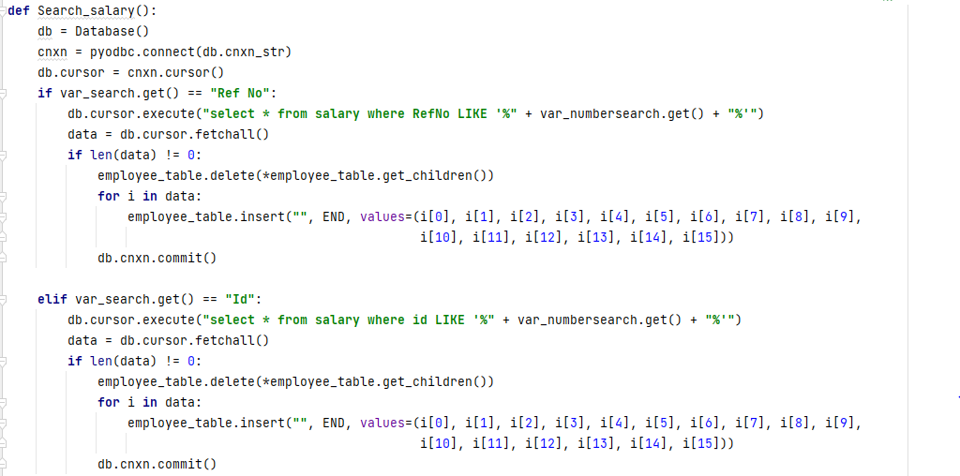

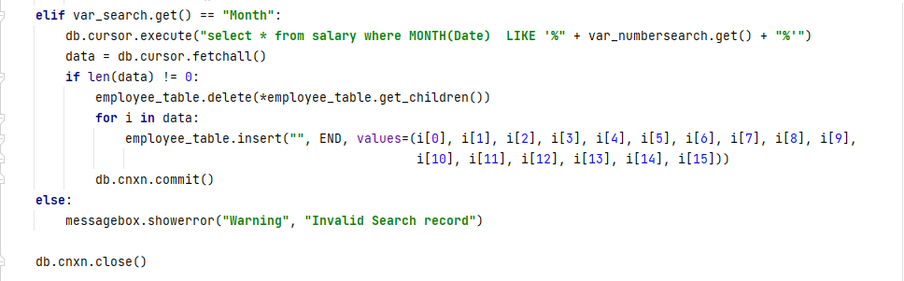

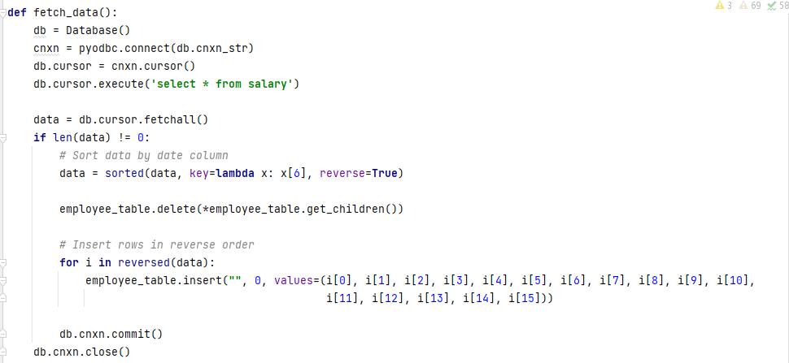

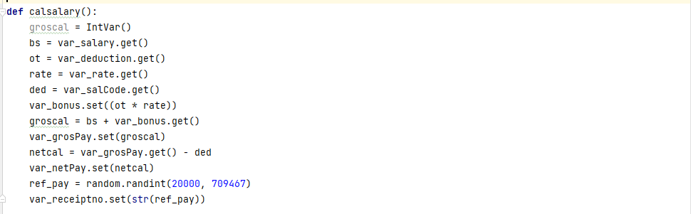

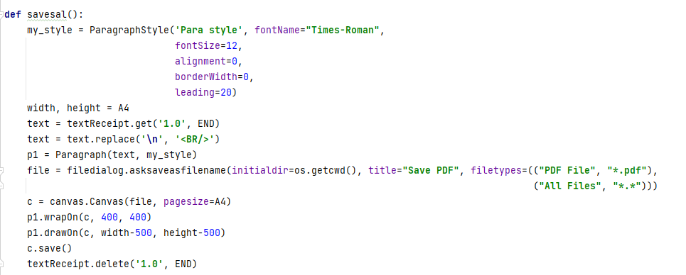

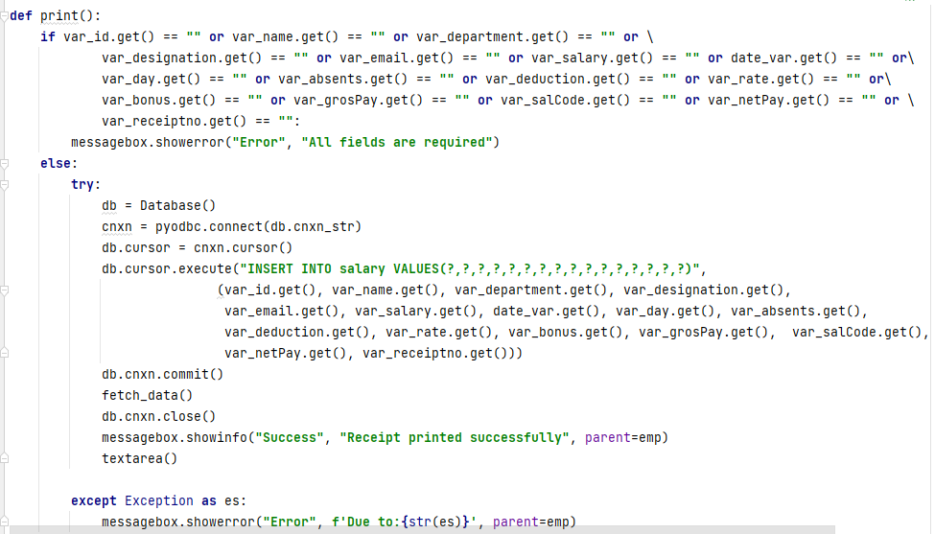

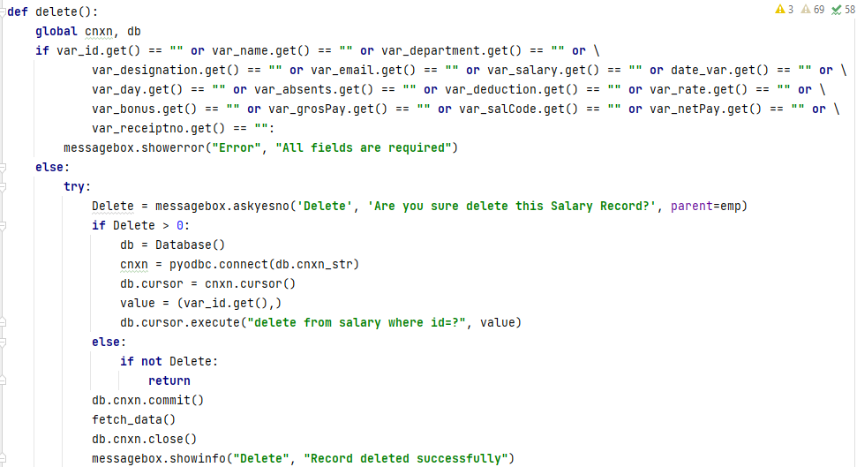



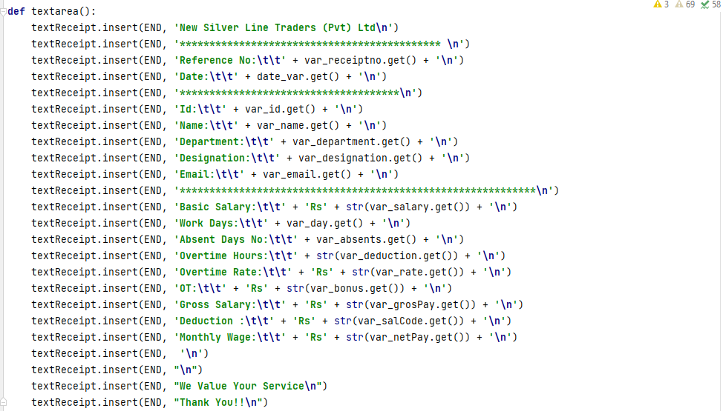

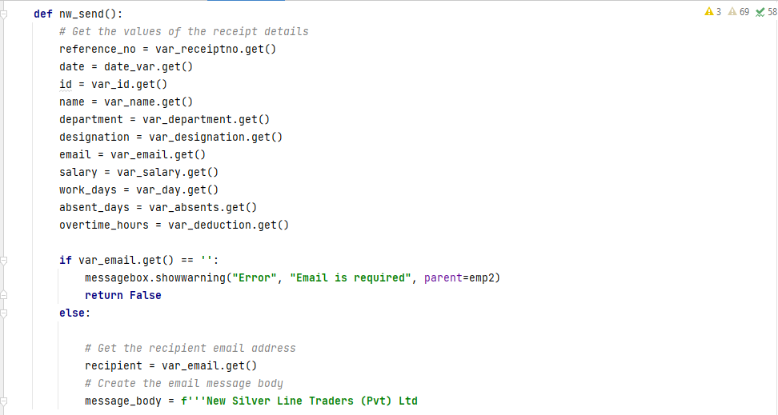

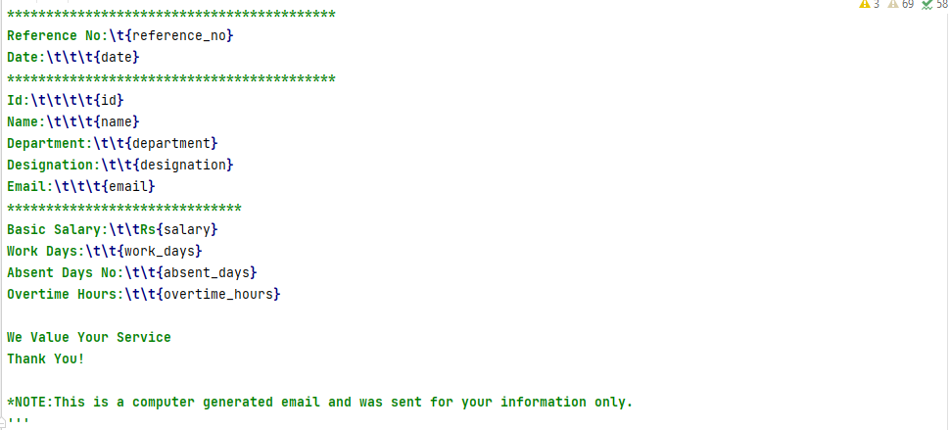

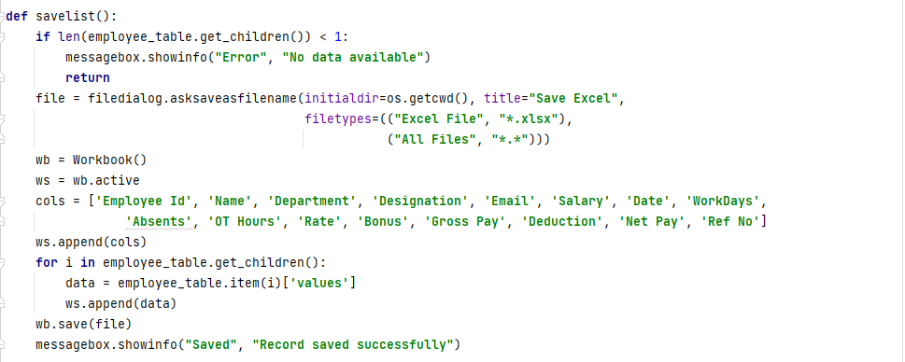

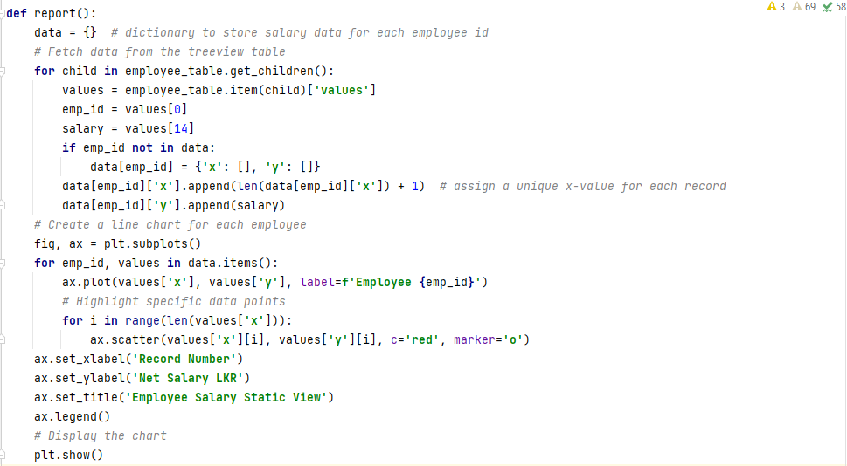

**Supplier Management**

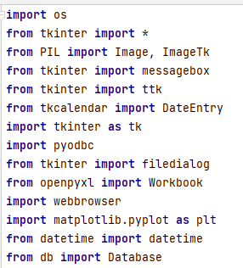In the supplier management it is allowed to save supplier information, update the information, search existing supplier record and delete supplier record. And also, through the system it represents the graphical view of table data to get the decisions. If supplier contract terminated though the system user can directly contact the supplier. Terminated supplier record highlighted in red color.

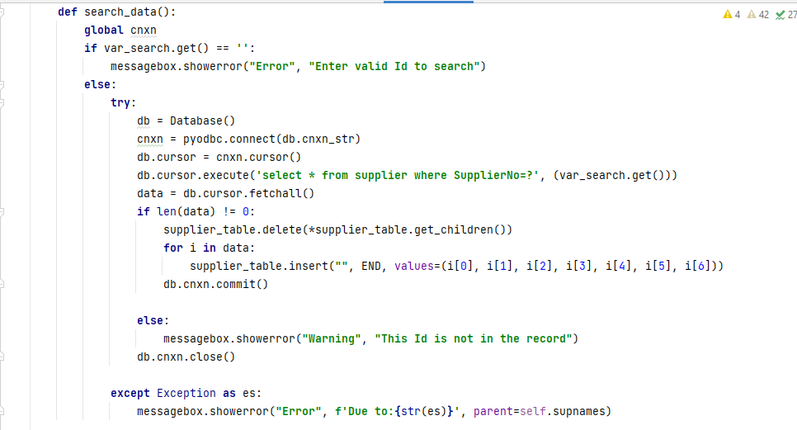

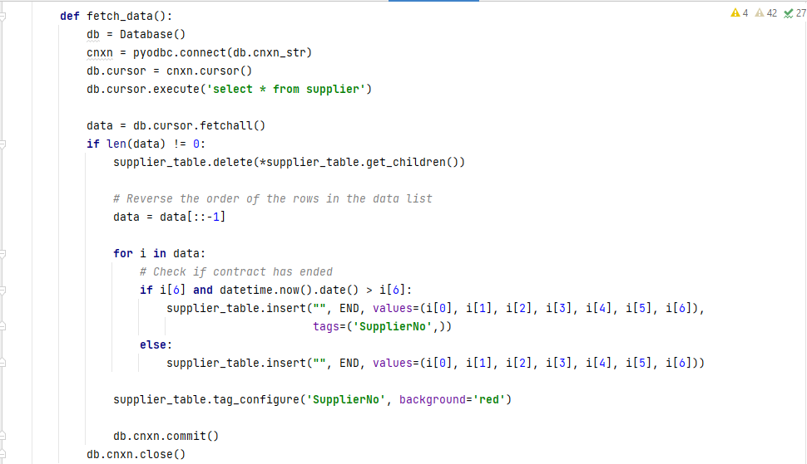

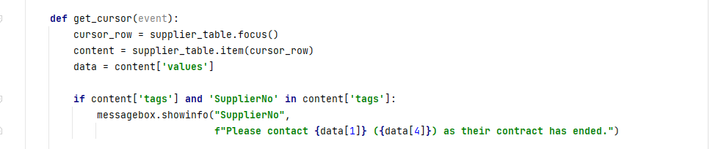

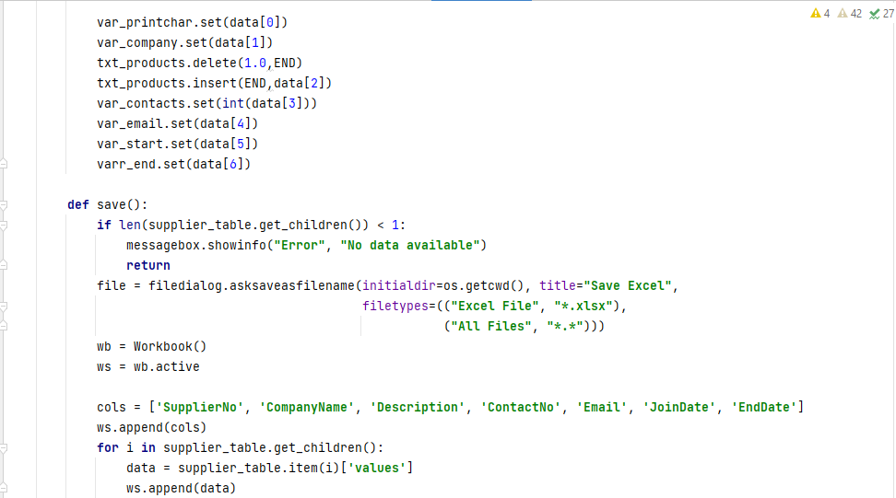

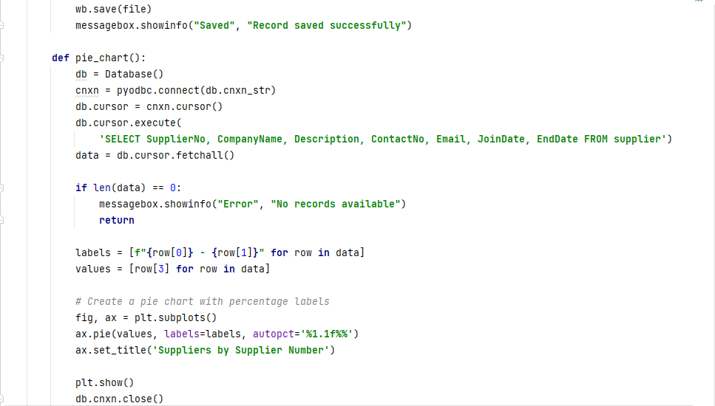

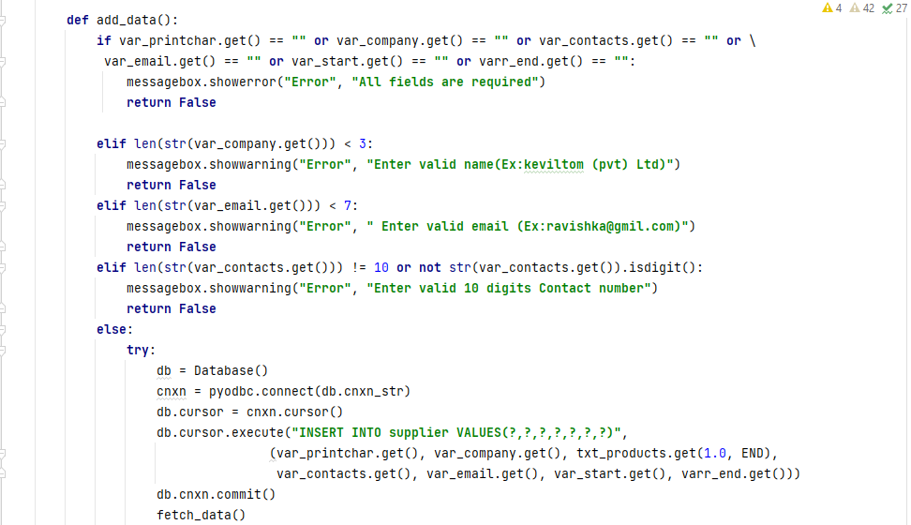

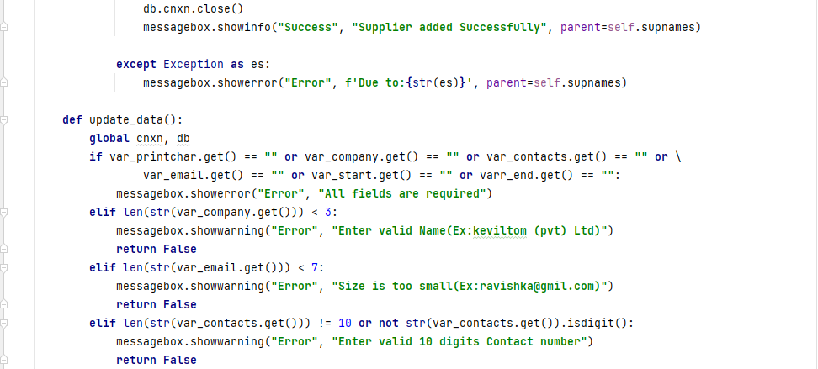

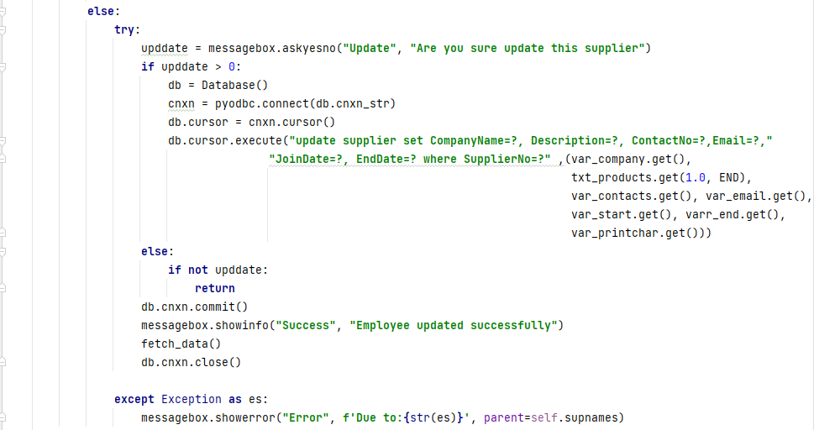

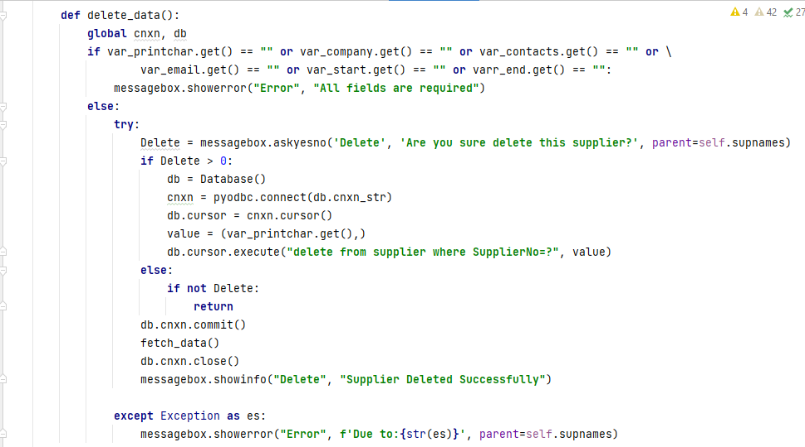

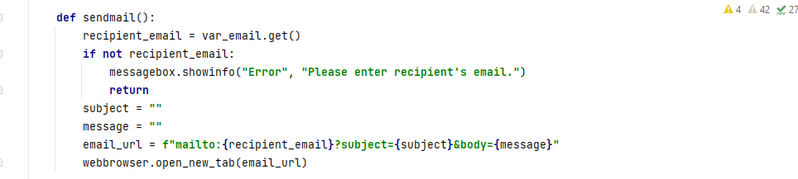

**Product Management**

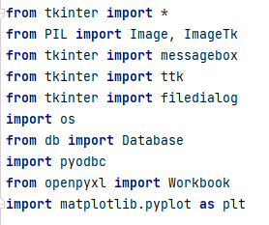The system provides to add products, update product, search product from existing record, view graphical representation to get decisions and delete existing product. When product is inactive the system displays error message of a smaller number of products.

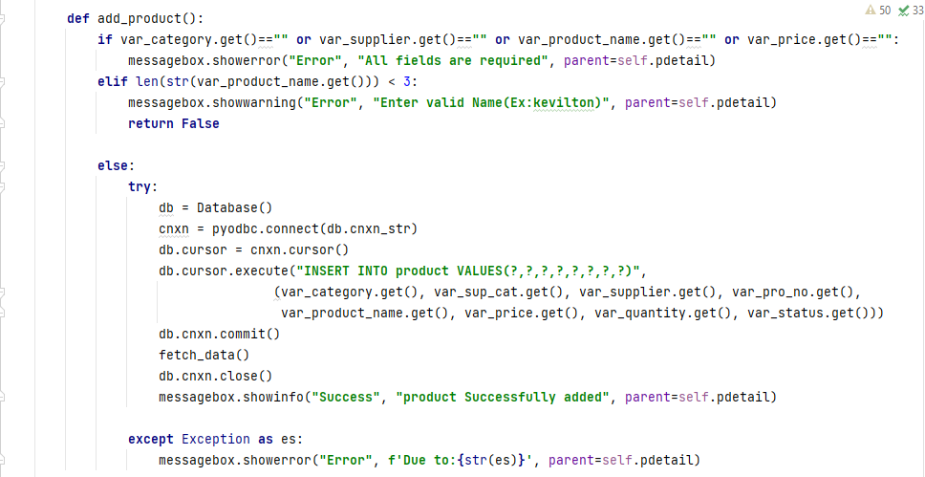

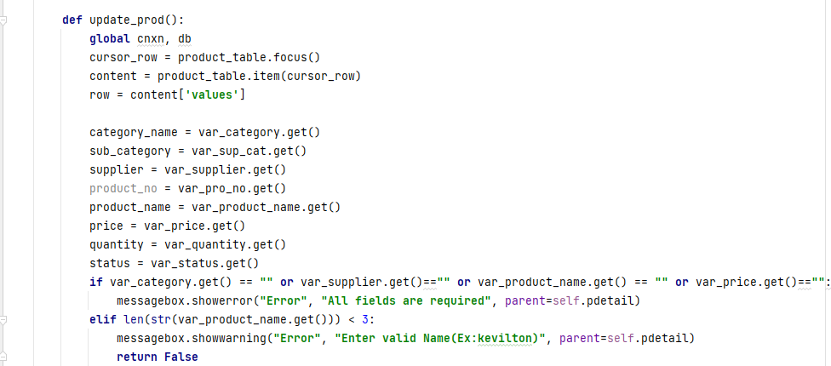

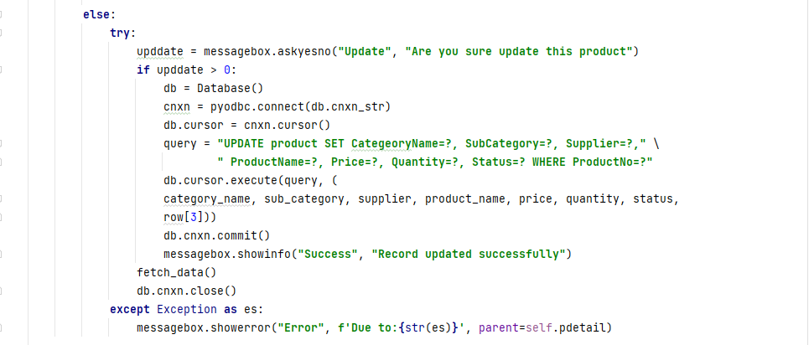

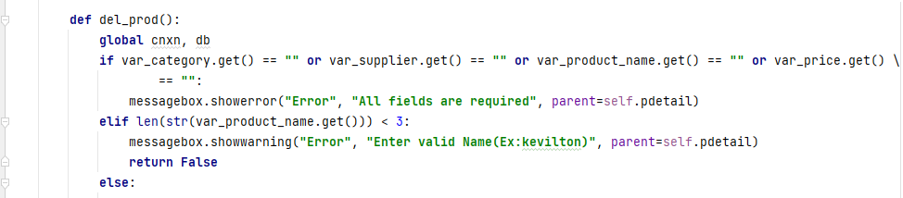

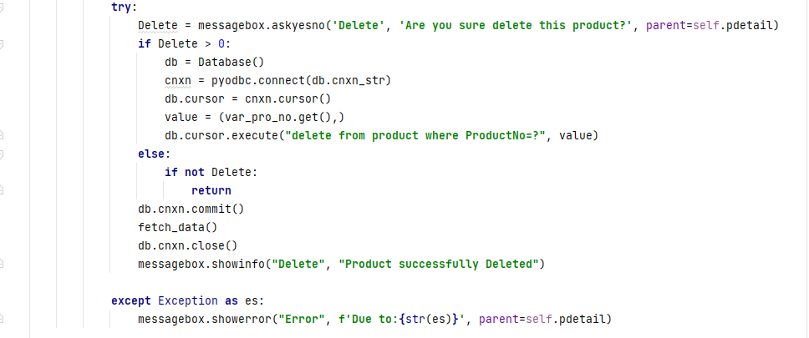

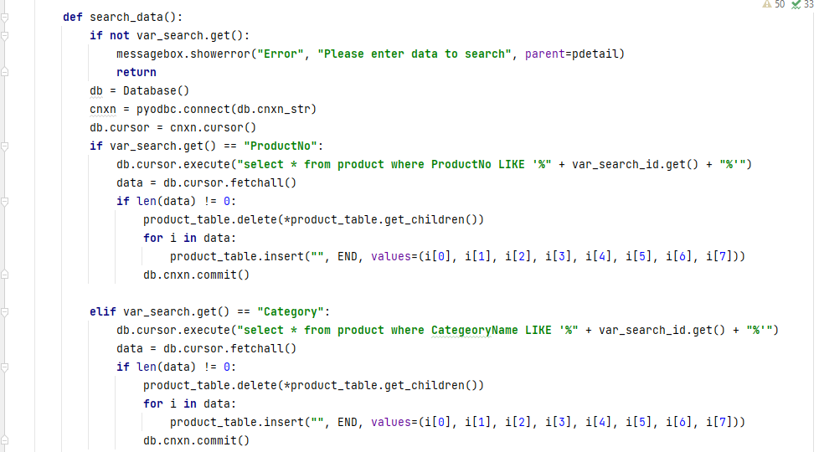

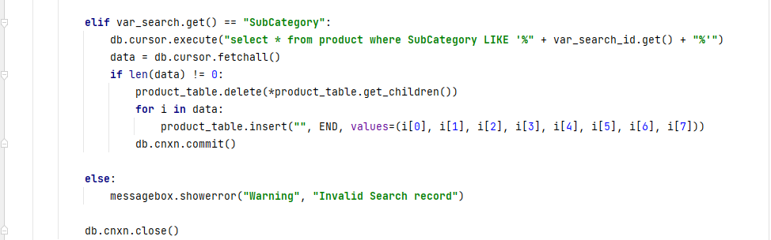

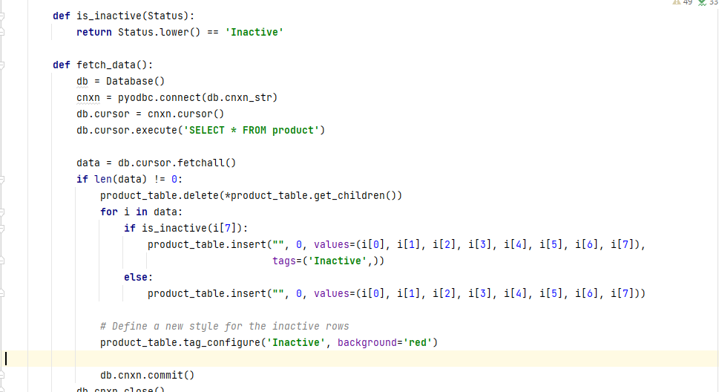

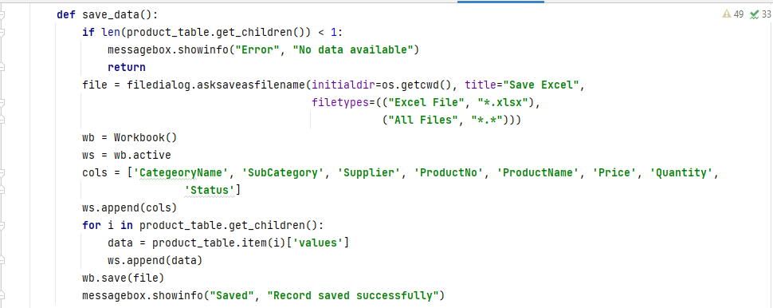

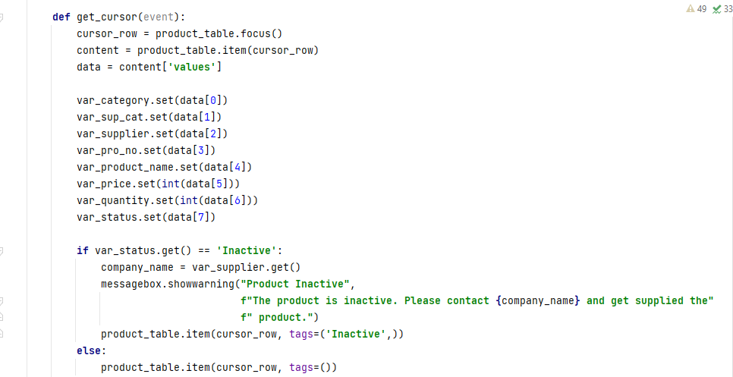

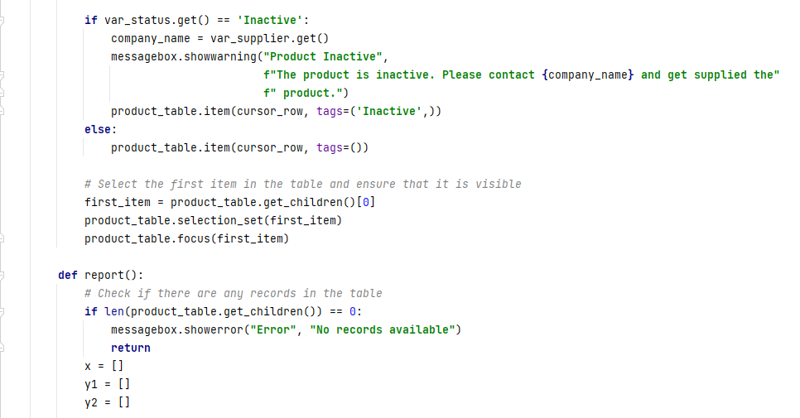

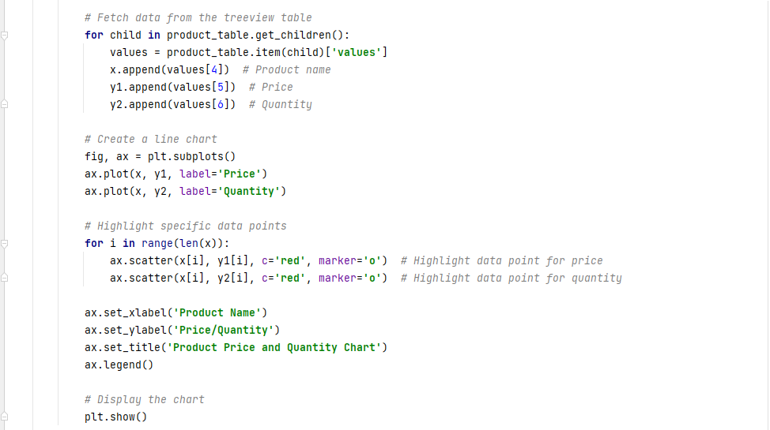

**Sales Report**

In this module system displays the all-billing reports. The user can search billing record and remove from the system. In here sales table and sales details table joined together. The system displays graphical representation of the billing record.

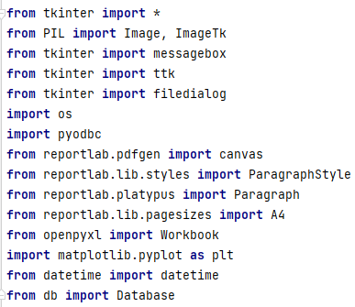

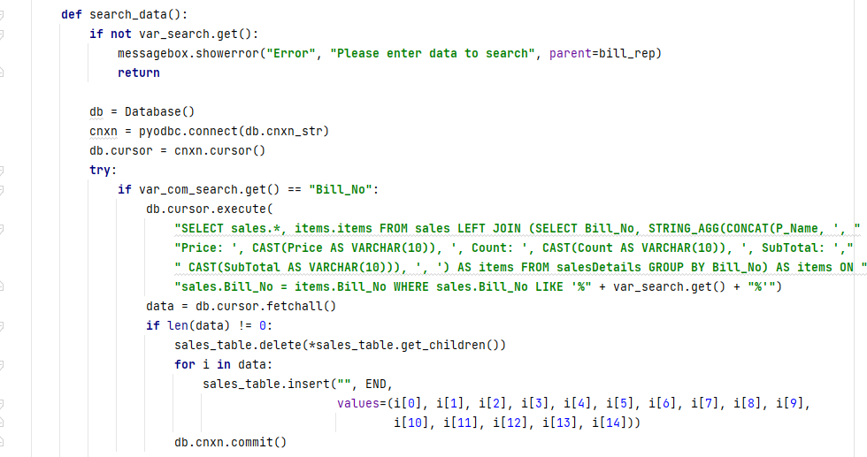

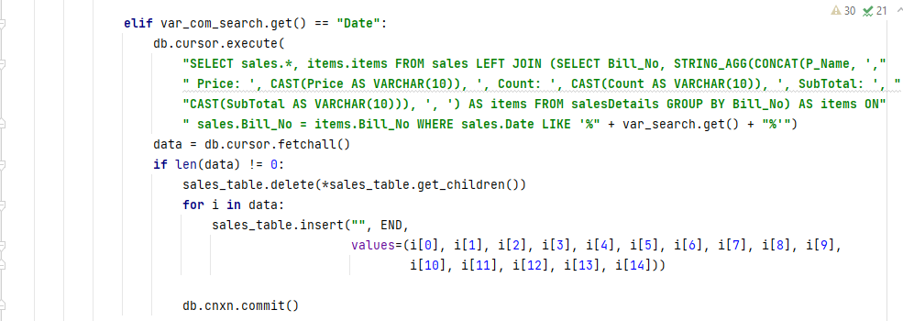

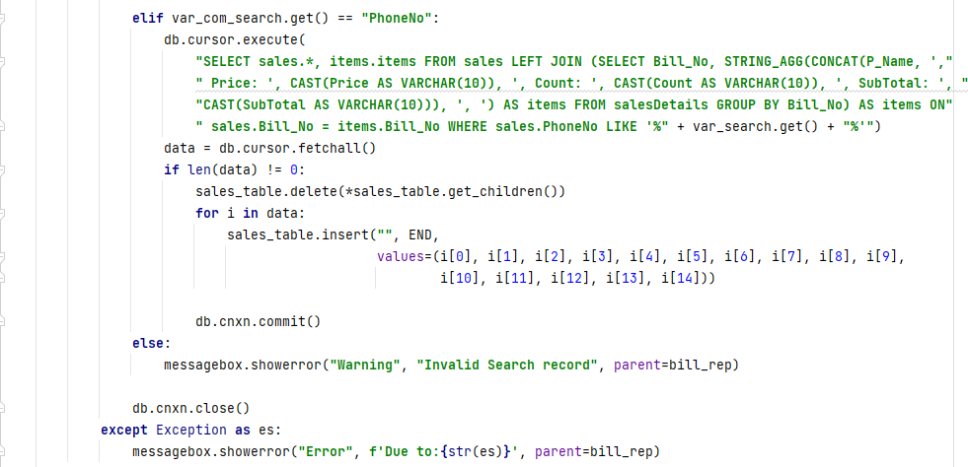

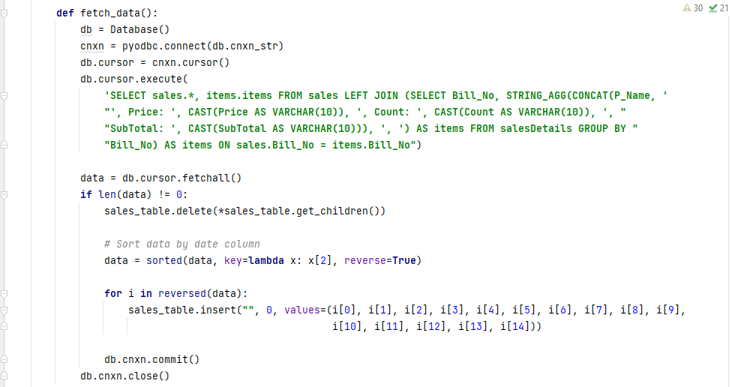

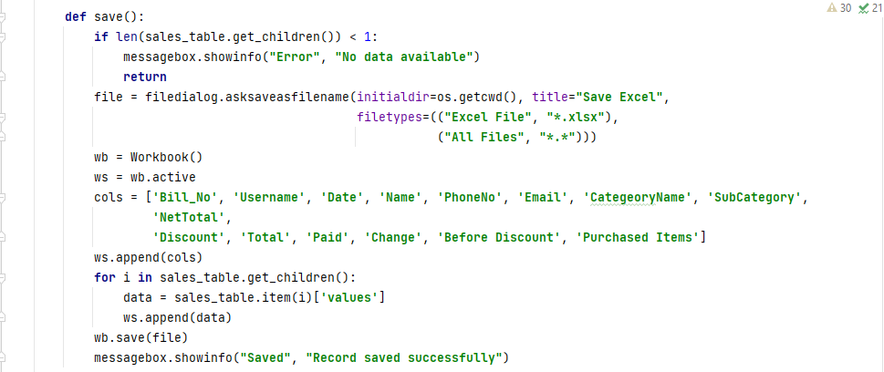

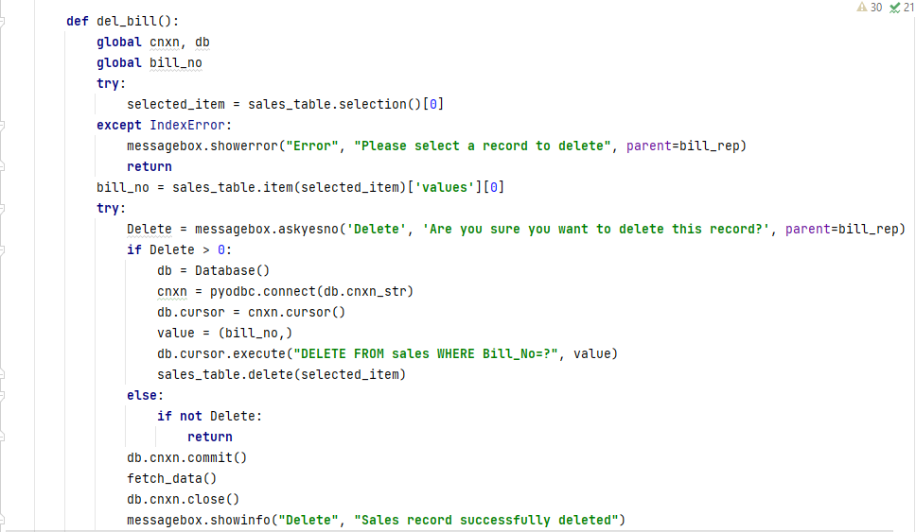



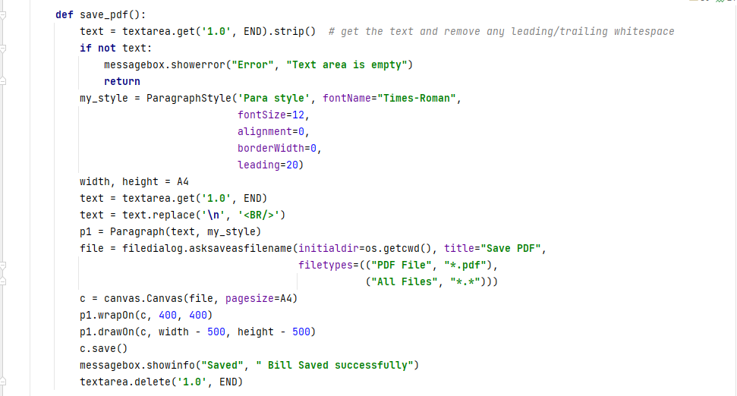

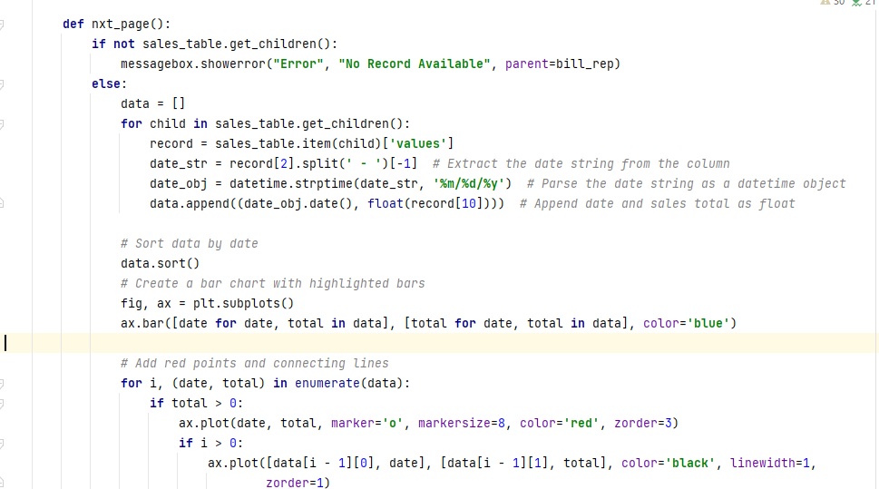



**Billing System**

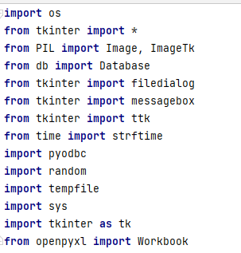Sales user can pint the bill. Before that has to add the products into the cart then calculate the purchase amount then print the bill. It can save as pdf record. The entire record can export if needed.

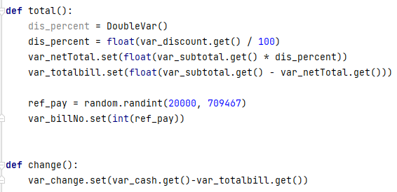

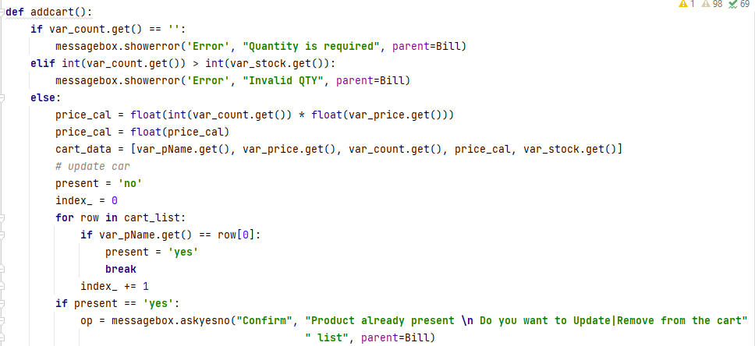

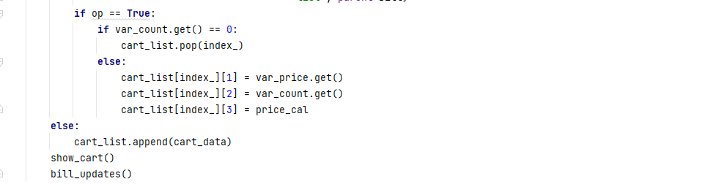

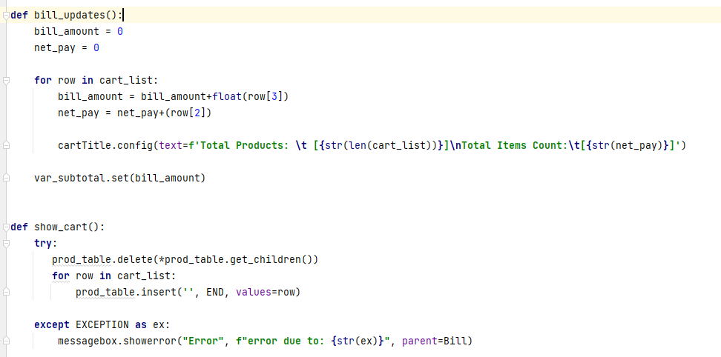

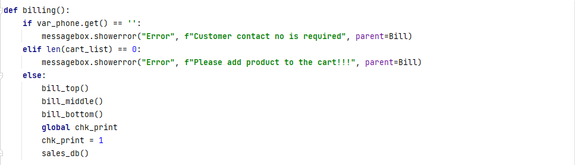

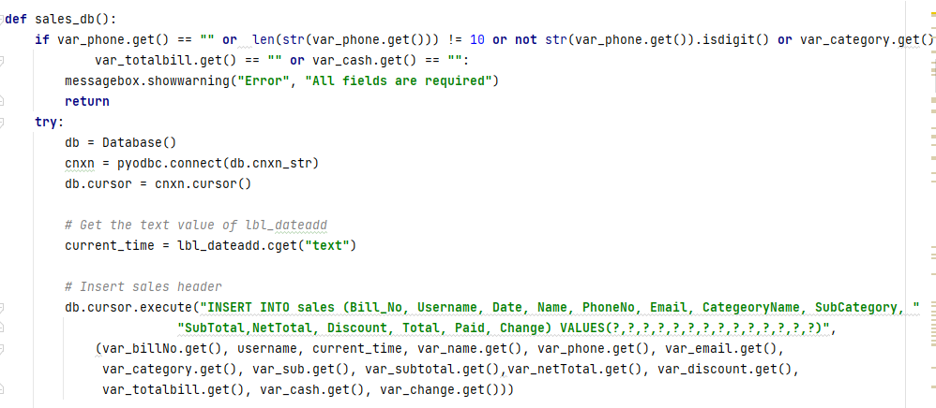

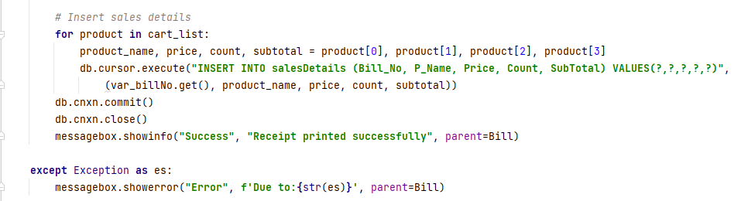

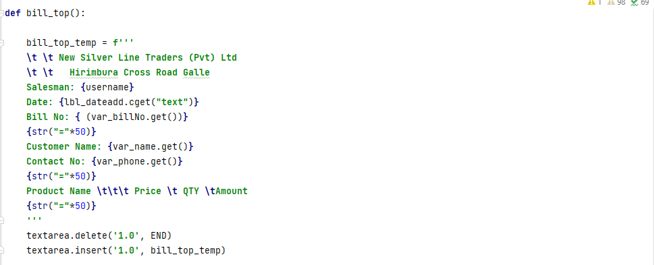

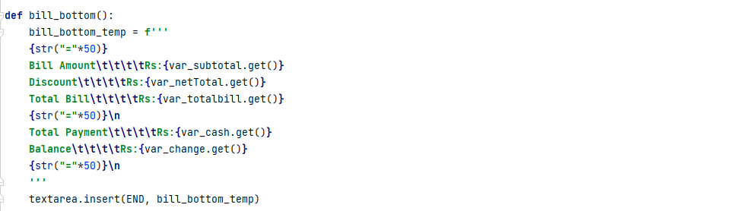

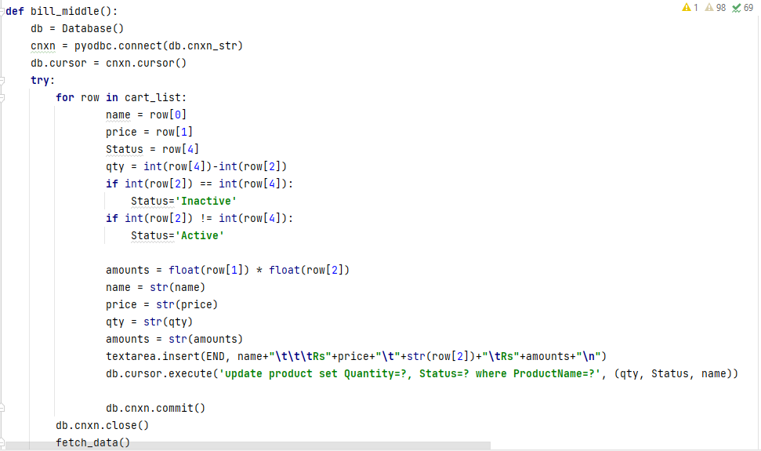

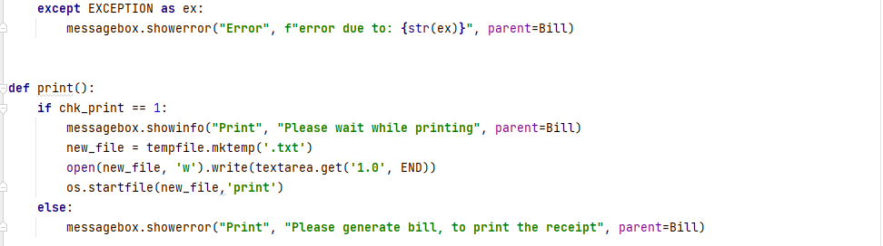

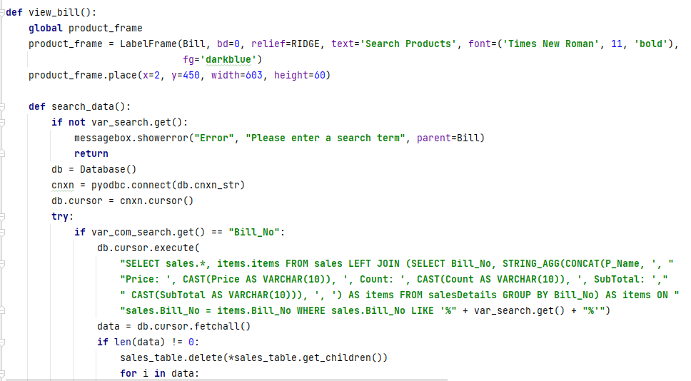

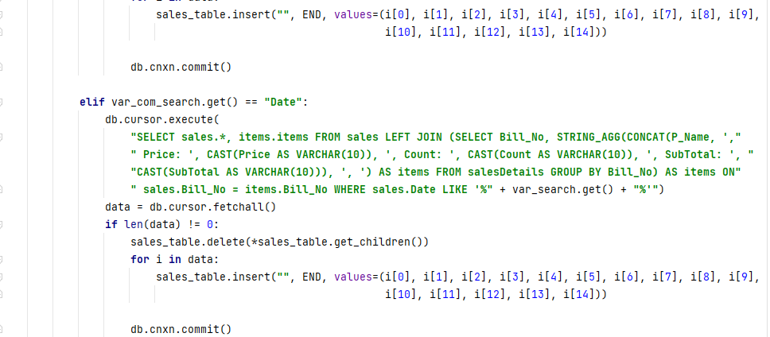

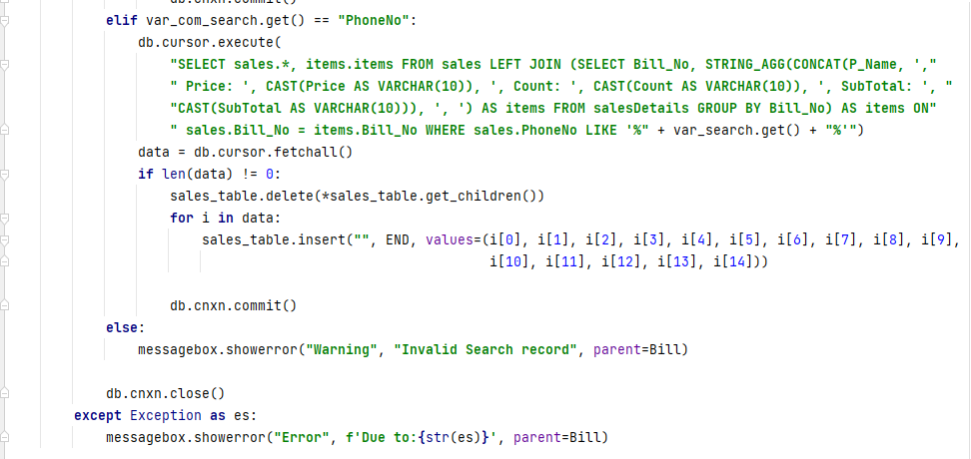



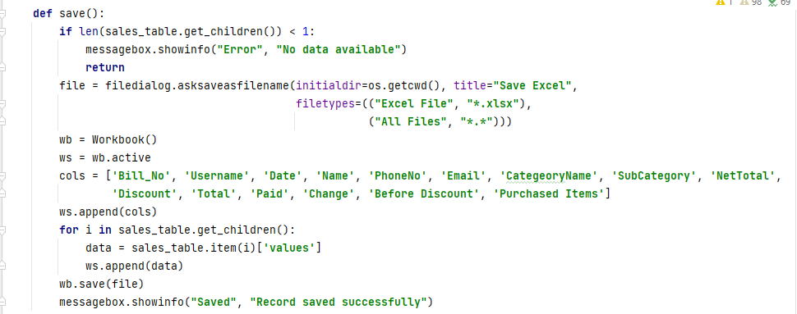

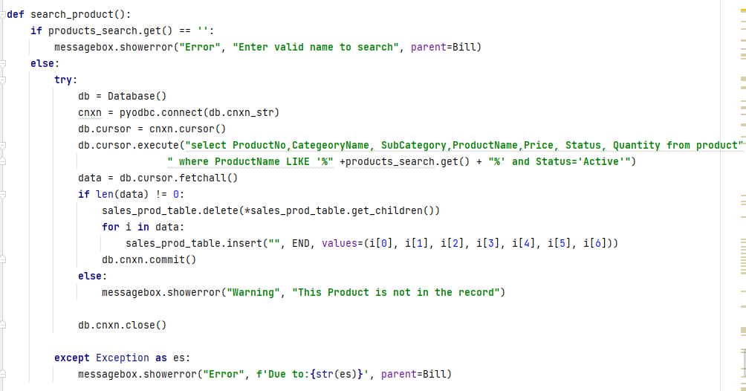

# Appendix G – SYSTEM EVALUATION FORM

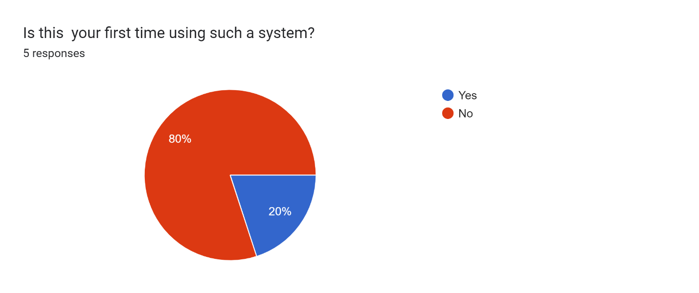

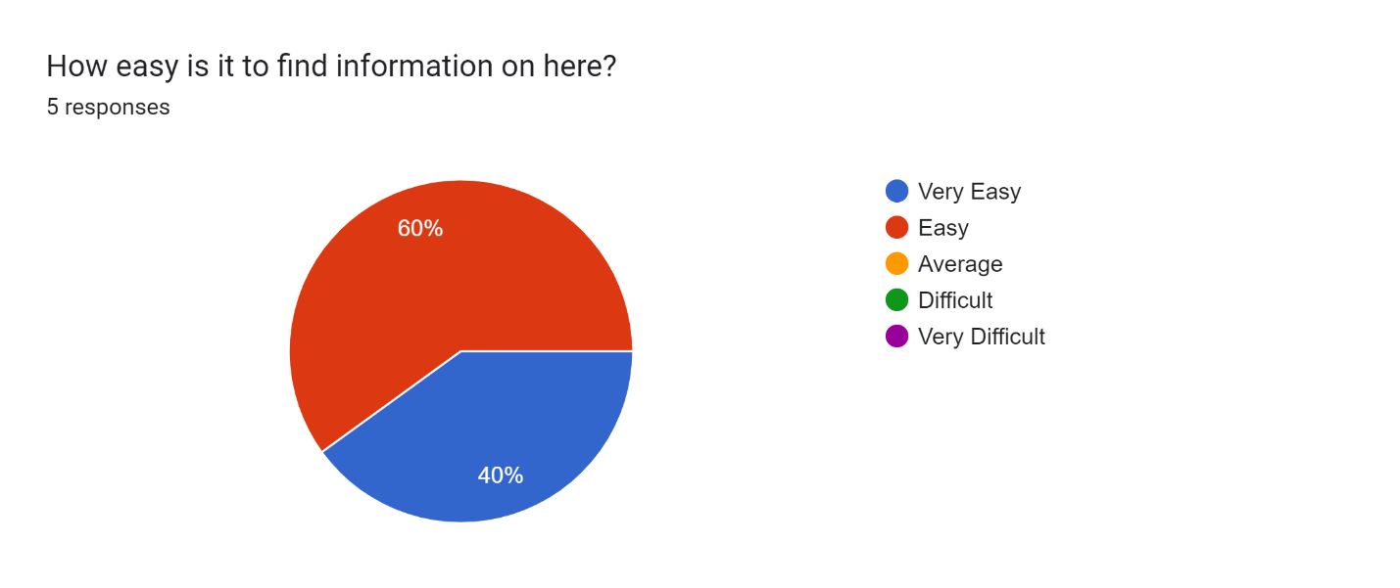

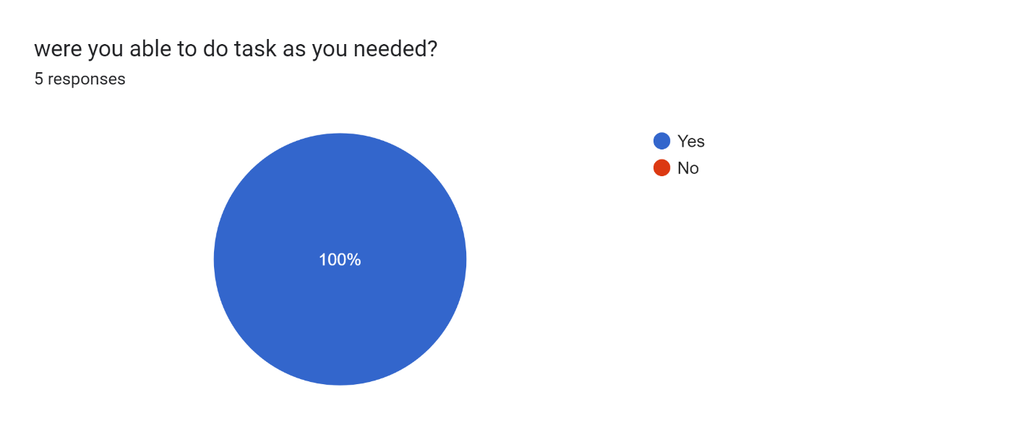

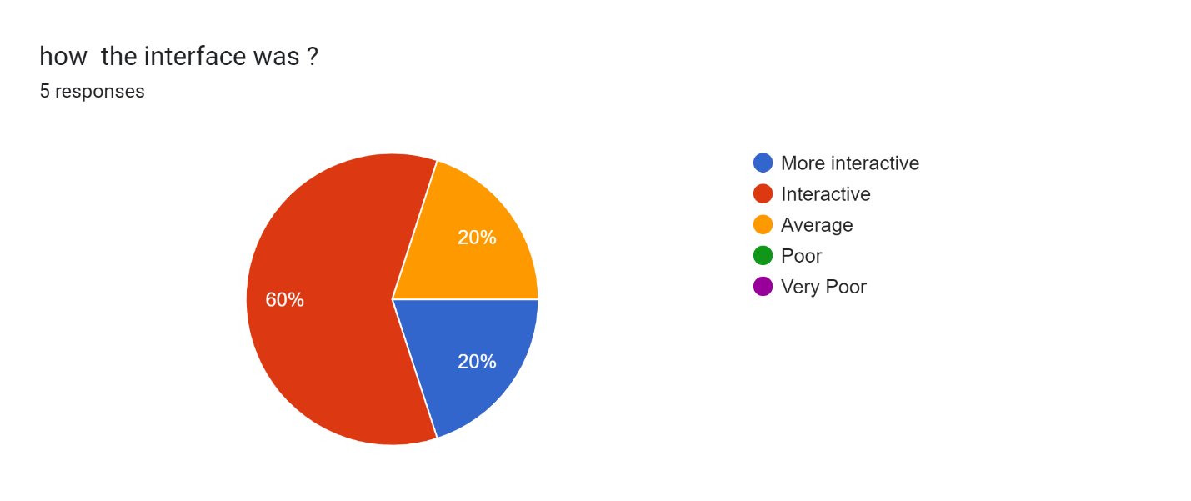

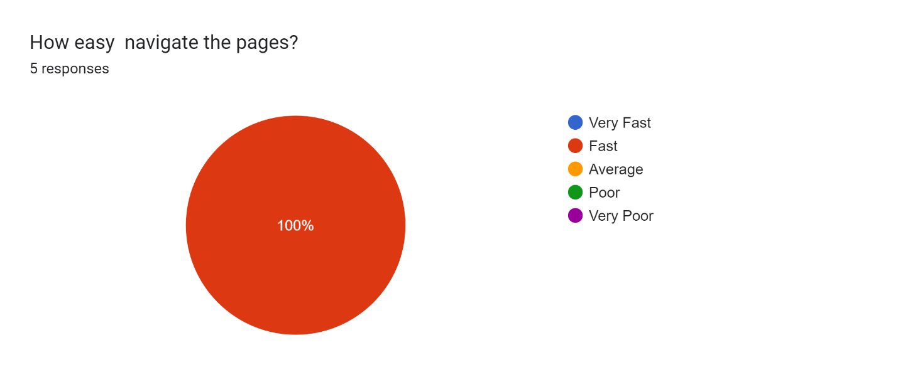

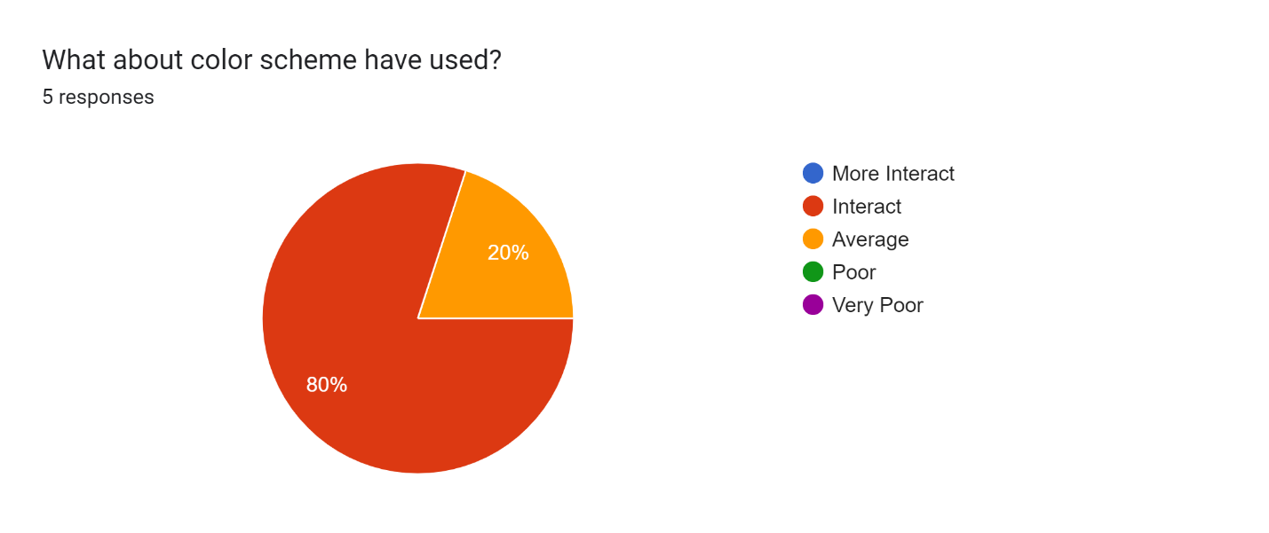

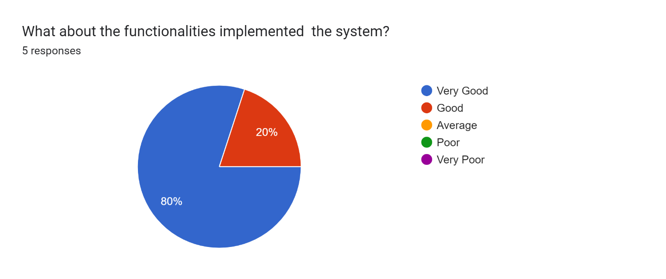

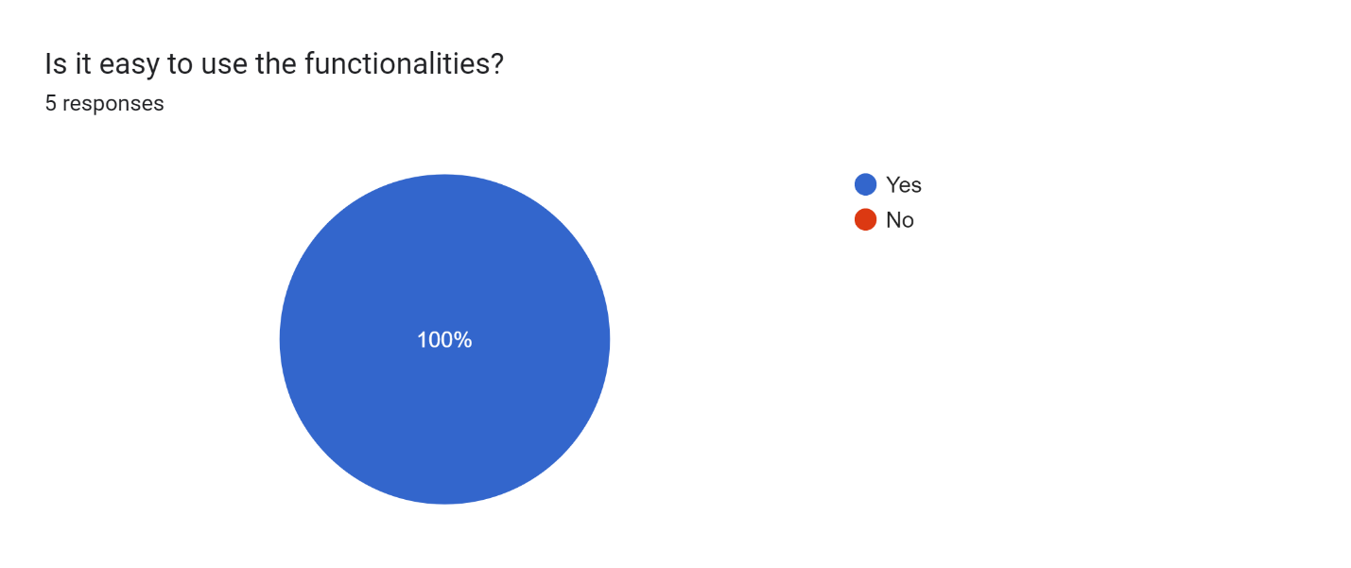

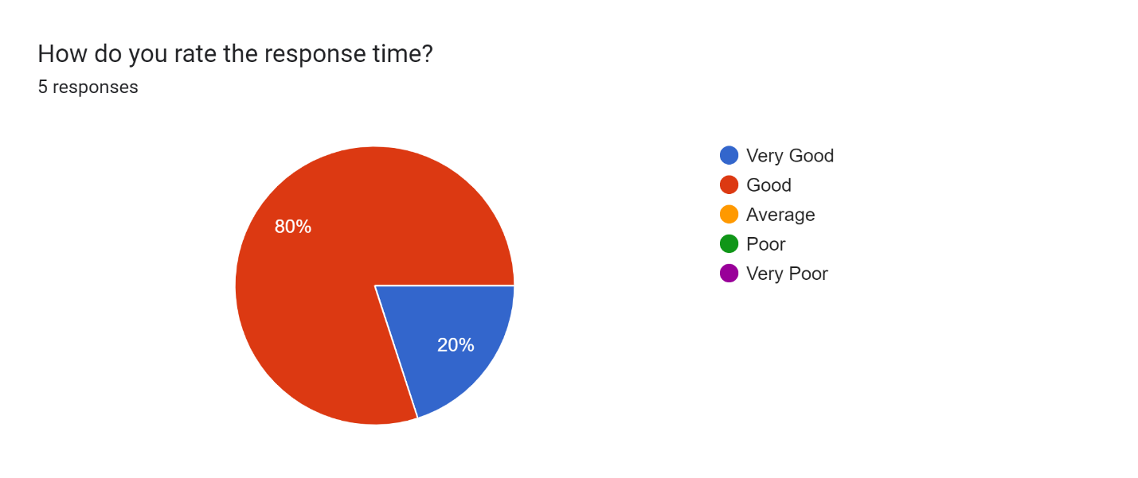

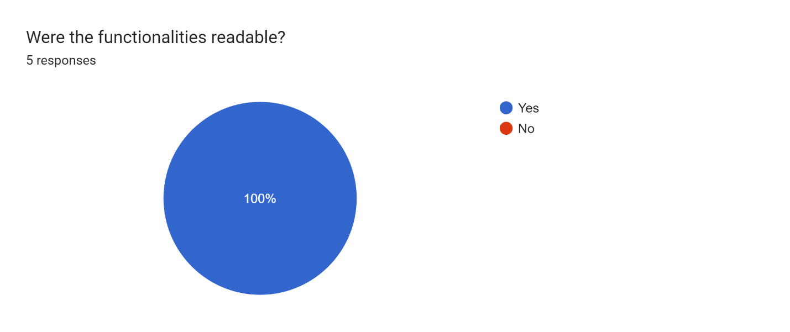

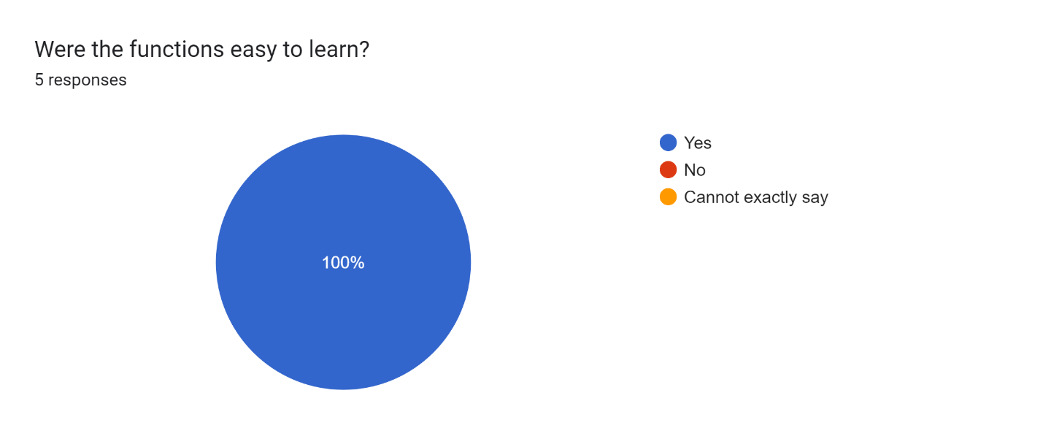

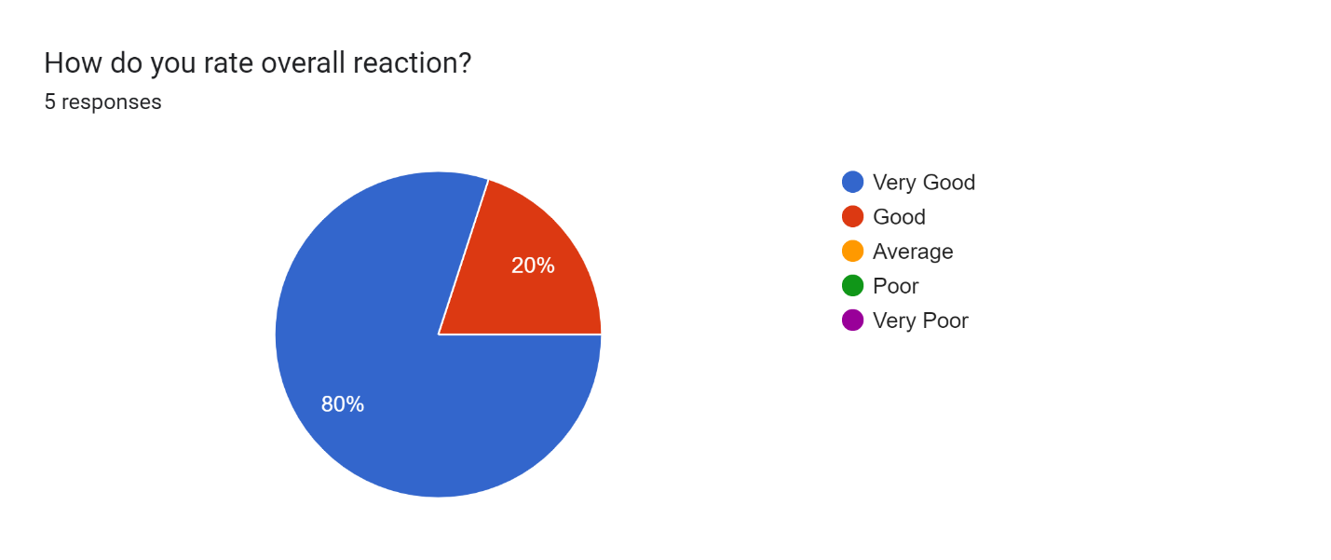

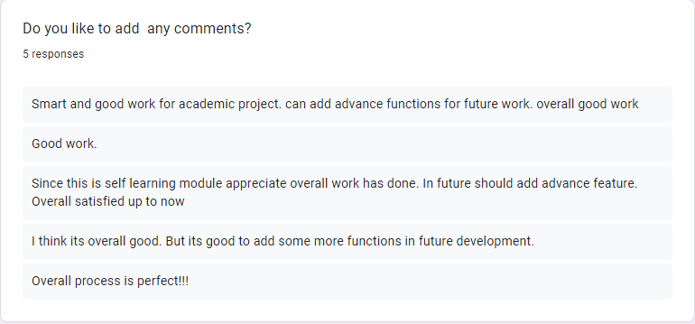

# Appendix H – CLIENT CERTIFICATE

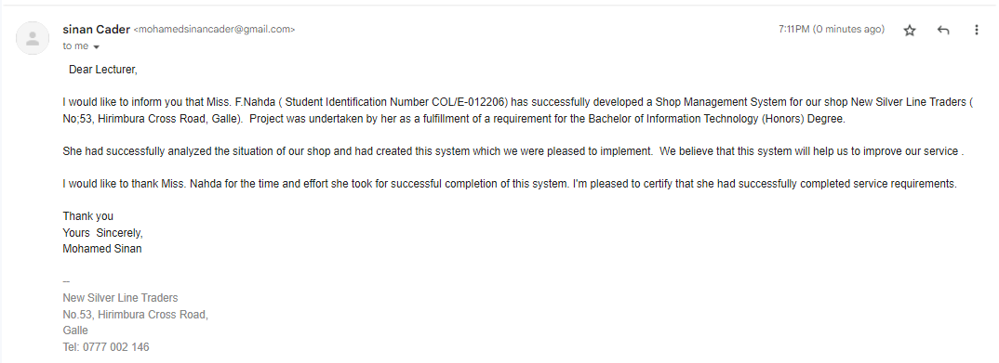

# Appendix I – INDIVIDUAL PROJECT 1 LOG SHEET

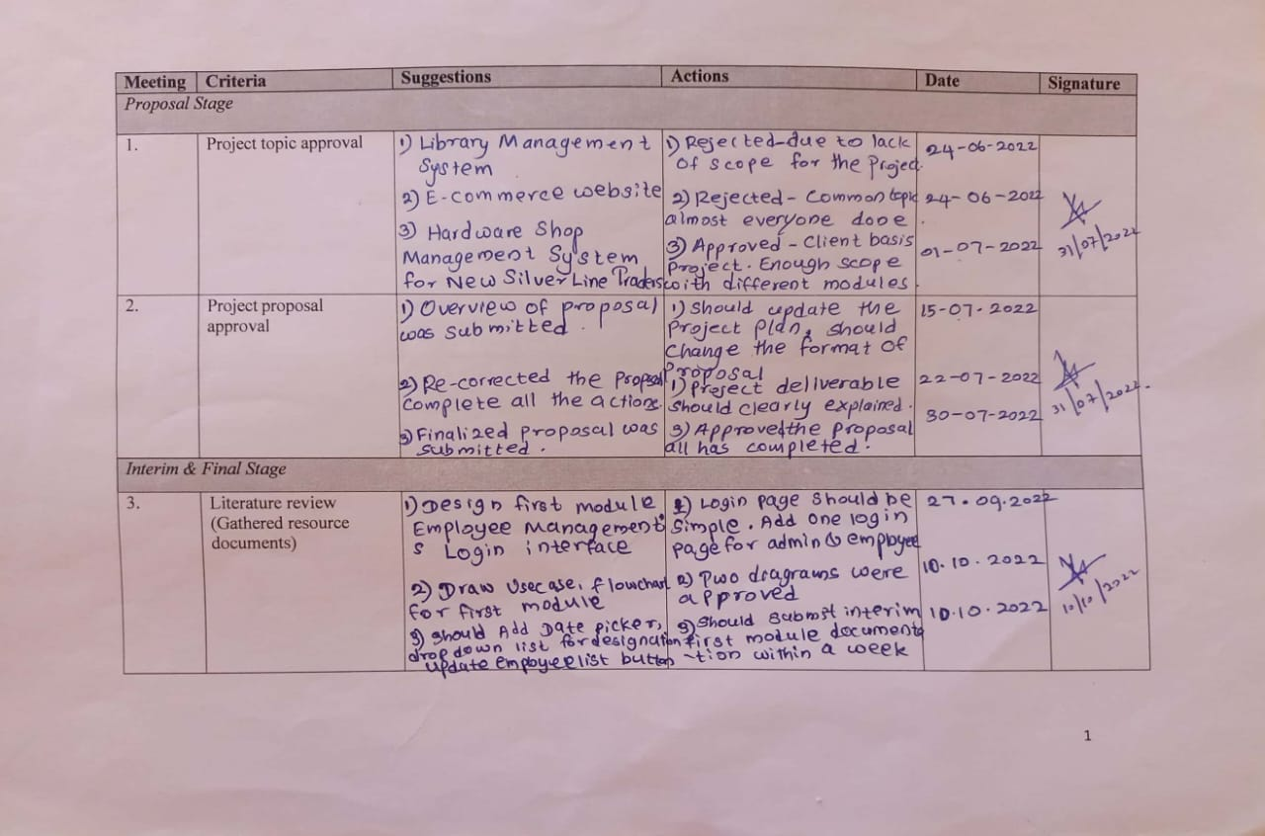

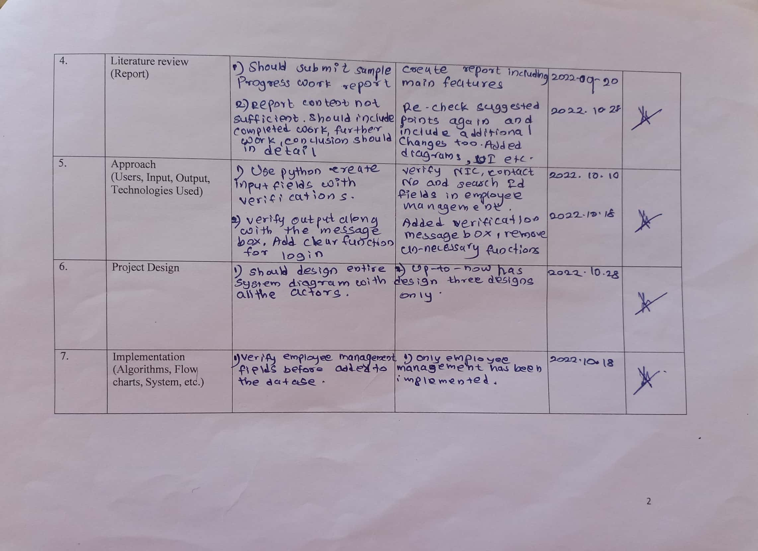

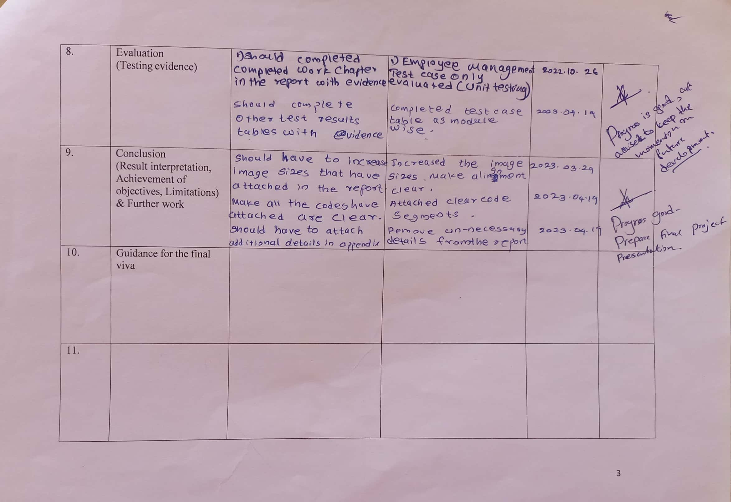

The last row of the above table which is ‘Guidance for the final viva’ will be filled before viva which will be commenced from first week of May 2023

# GLOSSARY

RUBS – Stands for Rational Utility Billing System

DBMS- Stands for Database Management System

Microsoft SSMS 18 - Stands for Microsoft Structured Query Language (SQL) Server Management Studio version 18 – one of the most popular database management systems can handle different types of data.

RUP – Stands for Rational Unified Process. Iterative Software Development Methodology. Developed by Rational Software Co-operation.

GUI – Stands for Graphical User Interface where connects the system with the end user.

IDE- Stands for Integrated Development Environment helps to integrate, debug and compile the code.

PC- Stands for PyCharm which is an IDE developed by Jet Brains. Most popular python development IDE.

Py ODBC -Stands for Python Open Database Connectivity. Developed by SQL Access group. DBMS are compliant with ODBC.

SMTP -Stands for Simple Mail Transfer Protocol – Used to transmit email using Python’s built in smtplib module.

# INDEX

Analysis, 3, 22, 49, 80

Billing System, iv, viii, 1, 2, 26, 31, 34, 36, 38, 47, 59, 68, 79, 85, 96, 102, 110, 131, 142

Conclusion, 3, 76, 83, 84, 86, 88

DBMS, viii, ix, x, 7, 18, 142

Design, 3, 33, 36, 38, 40, 44, 46, 47, 80

**Domain**, 5

**Employee Management**, iv, 2, 8, 25, 31, 34, 36, 47, 64, 67, 79, 82, 92, 98, 103, 114

Evaluation, 3, 38, 61, 70, 76, 80

**Feasibility**, 30, 31, 32, 80

Hardware Shop Management System, i, iv, 1, 3, 12, 16, 22, 26, 32, 35, 40, 76

IDE, 28

Implementation, 3, 7, 48

**Inventory Management**, 9, 15, 26, 38, 47, 87, 93

**Methodology**, 33, 34, 142

modules, iv, 2, 19, 25, 26, 31, 33, 34, 40, 45, 60, 61, 65, 66, 67, 76

OS, 19, 60

PyCharm, iv, 16, 17, 28, 48, 49, 142

**Pyodbc**, 18, 80

**Requirement**, 24, 81

salary, 1, 22, 23, 24, 26, 27, 30, 56, 57, 66, 68, 76, 89, 91, 93, 98, 99, 106, 117

Sales, 6, 10, 26, 47, 56, 59, 69, 85, 95, 96, 100, 128, 131

Security, 15, 23, 27, 50

smtplib, 19, 60, 79, 142

SQL, iv, 18, 20, 21, 28, 48, 50, 60, 66, 77, 79, 80, 142

Stock Management, iv, 1, 2, 31, 34, 36

**Supplier Management**, 11, 34, 36, 69, 88, 94, 99, 107, 121

**Testing**, 33, 36, 49, 61, 62, 63, 64, 65, 66, 70, 77

Tkinter, 20

UI, iv, viii, 12, 16, 47